Review on Synthesis and Biological Activity of Thiazole and its Derivatives



**International Journal of Research Development and Technology Vol.2, Issue.2, Year 2024 ISSN: 2584-0290**

**Web:** [www.ijrdt.com](http://www.ijrdt.com/)

# Vikas Kumar1, Dr. K.Saravanan2 1Phd scholar and Assistant Professor

**1Faculty of Pharmacy, Bhagwant Global University, Kotdwar**

# 2Principal of Faculty of Pharmacy, Bhagwant Global University, Kotdwar Corresponding authors

**E-mail:** [v.kumarvikas032@gmail.com](mailto:v.kumarvikas032@gmail.com)

## **********************************************************************************

***ABSTRACT-***

*The continuous review gives a blueprint of the natural activities of thiazole during the earlier years. It is heterocyclic blends, Thiazole, conceivably of the most generally perceived five-membered heterocyclic compound, has a nitrogen particle at position 3 and a sulfur bit at position 1. It is a critical arrangement of a gigantic number of made compounds. Its different pharmacological development is reflected in many clinically upheld thiazole- containing particles with, broad assortment of normal activities, similar to antibacterial, antifungal, antiviral, anthelmintic, antitumor, and quieting influences.*

***Keywords:-*** *Thiazole, synthesis, Heterocyclic Compound, derivatives, biological activities.*

## **********************************************************************************

### Introduction-

Nitrogen-containing heterocyclic blends expect a critical part in the medicine revelation process, as practically 75% of FDA (Food and Association) upheld little iota drugs contain no less than one nitrogen-based heterocycles (1).

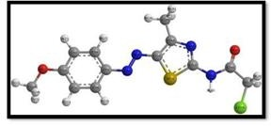

**Figure A:** 3D Structure of Thiazole

Thiazole, generally called 1, 3 - thiazole, has a spot with the get-together of combinations known as azoles and has sulfur and nitrogen particles in places

1 and 3, independently. The thiazole center is an astoundingly fundamental heterocycles in various naturally unique blends that makes it one of the extensively considered heterocycles1-3. Thiazole accepts urgent parts in numerous medicine structures.

Tiazofurin and dasatinib (Antineoplastic trained professionals), ritonavir (unfriendly to HIV drug), ravuconazole (antifungal subject matter expert) nitazoxanide (antiparasitic trained professional), fanetizole, meloxicam and fentiazac (moderating subject matter experts), nizatidine (antiulcer trained professional), and thiamethoxam (bug shower) are a couple of models for thiazole bearing things (2).

More than 18 FDA-embraced drugs contain the thiazole stage. Whenever no other decision is free, this thiazole subordinate was seen as effective against a grouping of multi-drug safe Gram- negative microorganisms, including Pseudomonas aeruginosa (P. aeruginosa). It is used to Treat tangled urinary parcel contaminations. Yet again alpelisib, sold under the brand name Pigray, is a substitute thiazole-based solution that was endorsed in 2019 for the treatment of express kinds of chest illness. Chest threatening development is potentially of the most unavoidable troublesome disorder on earth and the resulting driving justification behind illness passing, essentially in less advanced nations (3).

### Structural Characteristics-

With the sub-nuclear condition C3H3NS, thiazole, generally called 1, 3-thiazole, is a sensible to light yellow ignitable liquid with a pyridine-like fragrance. It is a five-membered ring with two nitrogen-and sulfur-containing vertices and three carbon-containing people. The numeration scheme for naming thiazole subordinates is displayed underneath (4).

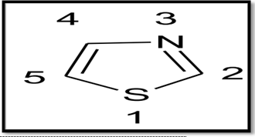

**Figure B:** The Structure of thiazole

Thiazoles are a class of regular combinations associated with azoles with a run of the mill thiazole moiety is a critical piece of vitamin B1 and epothilone. It is a sweet-smelling compound, satisfies Huckel's norm. Delocalization of singular arrangements of electrons from the sulfur particle completes the 6 π electrons. The resonation structures are Fig-C (5).

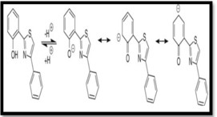

**Figure C:** Resonance forms of Thiazole

### Properties- Physical Properties:

* Thiazole generally pale-yellow flammable liquid.
* It has pyridine like odour.
* It is fairly soluble in ether and alcohol but sparinglysoluble in water.
* It has a boiling point of 116-118˚c and pka of 2.5 (conjugated acid).
* Its density is 1.2 gm/cm3 and its ionization potential is 9.50 Ev. It has a dipole moment of 1.61D.

### Chemistry of thiazole:

A consistent heterocyclic compound is conveyed by thiazole by using both an electron-giving get- together (-S-) and an electron-enduring bundle (C=N). The critical class of heterocycles known as thiazoles and their analogs, including oxazole, are made sure to have different normal properties. The azole compound isothiazole, which contains comparable particles (nitrogen and sulfur) but in a substitute position, is isomeric with the thiazole compound. Thiazole is dissolvable in alcohol and ether yet sensibly dissolvable in water. It has an edge of bubbling over some place in the scope of 116 and 118 oC and is a sensible, light yellow liquid. Thiazole is a heterocyclic ring that has six delocalized electrons from the sulfur particle's lone arrangements of electrons, according to Huckel's norm (6, 7).

As a result of their planar and sweet-smelling structure, which shows more unmistakable - electron delocalization than oxazole, thiazole subordinates are gainful model combinations for science research. By recognizing the engineered shift of the protons some place in the scope of

7.27 and 8.77 ppm in 1H NMR spectroscopy, the fragrant approach to acting of the thiazole ring was asserted. On account of the extension of various substituents at the C-2, C-4, and C-5 positions, the reactivity of the thiazole subordinates ring was anxious, which could require further essential idea. For instance, the methyl pack (electron giving social event) substituent noticeably impacted the thiazole ring's basicity and nucleophilicity when it was arranged at any circumstance on the ring (8, 9).

Regardless, when a solid electron-taking out pack, like a nitro bundle, was incorporated into the molecule, the basicity and nucleophilicity diminishes happen. Thiazole's adaptable construction blocks as bioactive substances lead to a capricious sub-nuclear plan. According to different assessments, the thiazole ring can be found in the vast majority of designed and typical things with a wide combination of regular

properties. One of the models is vitamin B1, generally called thiamine, which has an effect in the mix of acetylcholine and in this way typically maintains the tangible framework. The way that thiazole auxiliaries contained both hydrophobic (lipophilic) and hydrophilic (lipophobic) parts gave them an amphiphilic quality too (10).

This quality extends its ability to diffuse into the bacterial cell film for limitation development easily. Blends can effectively subdue Gram- negative and Gram-positive microorganisms with both hydrophilic and lipophilic sections by entering the organisms' telephone film. This penetration causes cytoplasmic material spillage, unsettling influence of the cell's physiology, and apoptosis (11).

### Biological Activities of thiazole derivatives:- Antifungal and Antibacterial Agents-

The resistance of developments and microorganisms towards the antimicrobial drugs is extending rapidly a direct result of the nonselective antimicrobial activities and a foreordained number of meds. To overcome what is happening, various thiazole containing particles are coordinated to fix bacterial and infectious illnesses.

Bera et al. organized pyridinyl thiazole ligand having hydrazone moiety by combining 2-bromo-4-methoxy acetophenone with 2-acetylpyridine thiosemicarbazone. They in like manner coordinated cobalt complex by treating this ligand with cobalt forerunner. Both the ligand and its marvelous were gone after for against bacterial properties towards gram positive infinitesimal organic entities including Bacillus subtilis, Streptococcus fecalis, Staphylococcus aureus and gram-negative microorganisms including Pseudomonas aeruginosa, Salmonella typhi, Escherichia coli, Klebsiella pneumonia and Proteus vulgaris (12).

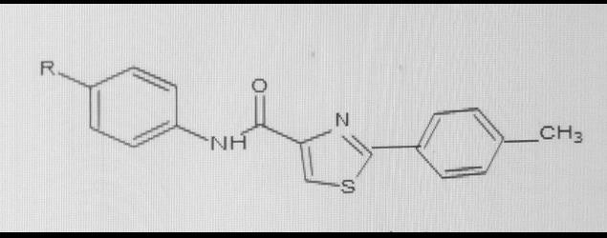

R = o-NO2, m-NO2, p-NO2, m-Cl, p-Cl, p-F

**Figure D:** 2-Phenylthiazole-4-carboxamideshaving

anticancer activities.

### Anti-diabetic Activity-

Bhagdev K. et al. coordinated and attempted a combination of subbed benzo-thiazole auxiliaries for hypoglycemic (antihyperglycemic) development. The ethoxybenzothiazole moiety in 2-(benzo[d]thiazol-2-ylmethylthio)- 6-

ethoxybenzothiazole was seen as fundamental for redesigning glucose transport and AMPK order in L6 myotubes. 2-(benzo[d]thiazol-2-ylmethylthio)- ethoxy benzo[d]thiazole basically worked on the speed of glucose digestion in L6 myotubesat pharmacologically appropriate core interests. The effect of 2-(benzo[d]thiazol-2-ylmethylthio)- 6- ethoxybenzo[d] thiazole in on blood glucose levels in diabetic KKAy mice showed decrease in blood glucose level (13)

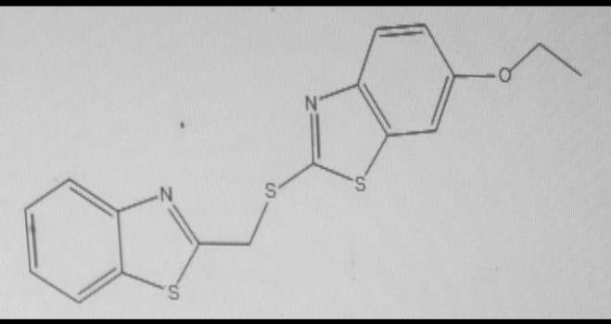

**Figure. E:** 2-(benzo[d]thiazol-2-ylmethylthio)- 6- ethoxybenzothiazole

### Anti-TB Activity-

Arshad M. et al. mixed a new bisthiazolyl auxiliary and attempted it for unfriendly to TB activity. These shrewd analogs were attempted against the Mycobacterium smegmatis MC2 155 strain. The basic displayed strong foe of tubercular feasibility at a piece of 30 mM. The SAR focuses on revealed that the presence of a fluoro-subbed phenyl ring is essential for lessening the M. smegmatis flood (14).

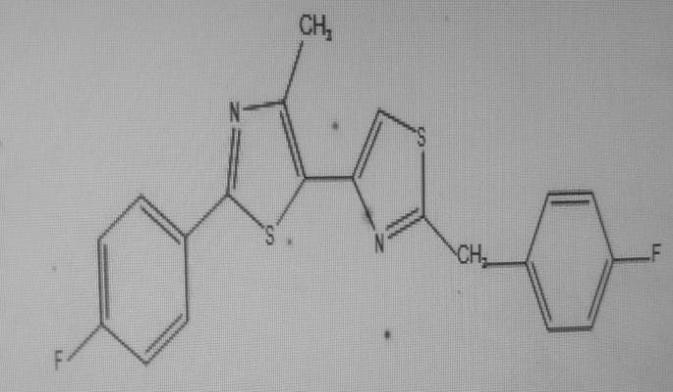 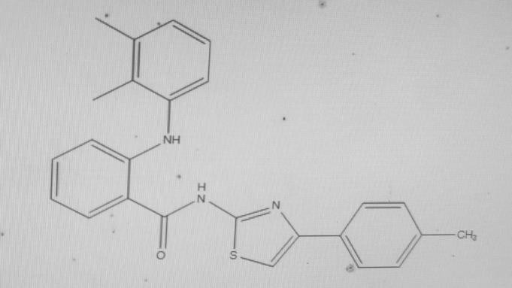

### Figure F Anti-Cancer Activity-

Kolageri S. et al. depicted the mix of fluorinated 2- aryl benzo-thiazole subordinates and their evaluation for antagonistic to development activity against illness cell lines MDA-MB-468 (mammary organ/chest tissues rising up out of metastatic site) and MCF-7 (human chest adenocarcinoma).The benzo-thiazole auxiliaries 4-(5-fluoro-1,3- benzothiazol-2-yl) phenol) and 3-(5-fluoro-1,3- benzothiazol-2-yl)phenol) with hydroxyl substituents on the third and fourth positions were all the more impressive to those containing alkoxy, methyl sulphonyl, and ethyl substituents on the Benzothiazole (15)

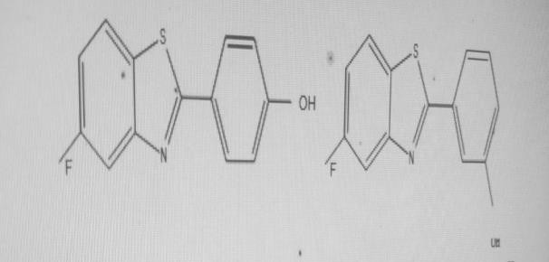

### Figure G: Anti-Inflammatory Activity-

Krishnan G. et al. made and joined a movement of 2, 4-disubstituted thiazole auxiliaries, which were pursued for moderating development in vitro using the egg whites denaturation system and diverged from the standard medication diclofenac sodium (16).

### Figure H:

**Anti-Tumor Activity-**

Kaur H. et al. consolidated 2-(4-(pyrazol-4-yl) thiazol-2-ylimino)- 1,3,4-thiadiazole auxiliaries, which have been perused up for anticancer suitability against human hepatocellular carcinoma cells (HepG2), human chest dangerous development cells (MCF-7) and human cell breakdown in the lungs cells (A549) in vitro (17).

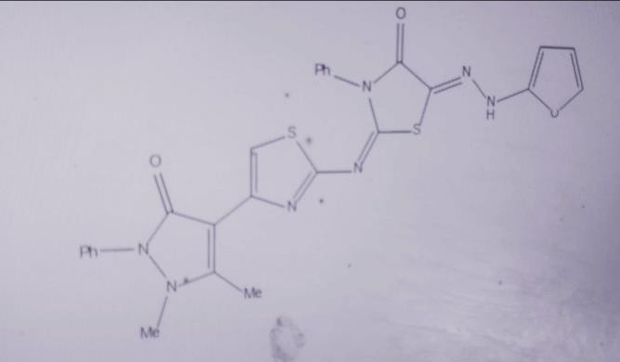

### Figure I: Anti-malarial Activity-

Yadav A. et al. arranged and organized thiazole compounds and attempted them for antimalarial development. The results have shown that an electron-taking out pack at the fourth spot of the associated phenyl ring of thiazole auxiliaries is normal for dealt with foe of malarial activity and a decent drug like profile, which can provoke the ascent of an expected supportive molecule in extra development (18).

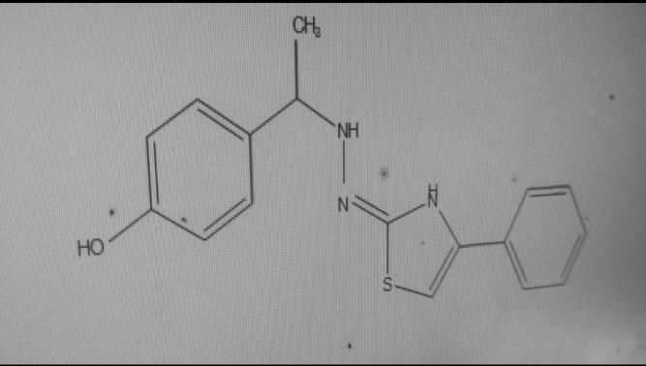

### Figure J: Antioxidant Activity-

Naminath H. et al. consolidated one more series of thiazole compounds and surveyed their malignant growth counteraction specialist works out. When diverged from customary ascorbic destructive, the molecule showed out and out higher feasibility against erythrocyte haemolysis (0.85%) (19).

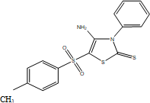

### Figure H:

**CONCLUSION-**

Thiazole center has involved a basic circumstance in the state of the art normal and supportive science due to its wide reach generally; Thiazole compounds are seen to have captivating natural components like anticancer and antimicrobial activities.

The presence of thiazole ring in numerous prescriptions such febuxostat, dasatinib and ravuconazole convince the logical specialists to design new thiazole systems.

It has been seen that changes to the thiazole moiety shown profitable natural capacities. More assessment is supposed to think about thiazole's reasonability rather than various issues.

### REFERENCES-

1. Namitha TH, Saranya S Nair, Dr. Arun Kumar, Dr. Vinod B, Dr. Daisy P A, A Review on Synthesis and Biological Activity of Thiazole and its Derivatives, Int. J. Pharm. Sci. Rev. Res., 70(1), September -

October 2021; Article No. 29, Pages: 189-

193.

1. Borcea AM, Ionuț I, Crișan O, Oniga O. An overview of the synthesis and antimicrobial, antiprotozoal, and antitumor activity of thiazole and bisthiazole derivatives. Molecules. Jan; 26(3): 624.
2. Vaishnavi R. Paithankar,Pravin R. Dighe, Nirmala V. Shinde, An Overview of Thiazole Derivatives and its Biological Activities, Int. J. Pharm. Sci. Rev. Res., ISSN: 0976 – 044X, 82(1), September – October 2023; Article No. 07, Pages: 42-47.
3. Hemaida AY, Hassan GS, Maarouf AR, Joubert J, El-Emam AA. Synthesis and Biological Evaluation of Thiazole-Based Derivatives as Potential Acetyl cholinesterase Inhibitors. ACS Omega. 2021; 6(29):19202–19211.
4. Abdu-Rahem LR, Ahmad AK, Abachi FT. Synthesis and Medicinal Attributes of Thiazole Derivatives: A Review. Systematic Reviews in Pharmacy, 12(1): 290-5.
5. Altıntop MD, Sever B, Akalın Çiftçi G, Turan-Zitouni G, Kaplancıklı ZA, Ozdemir
   1. Diverse biological activities of Thiazoles : A Retrospect. Eur J Med Chem. 2017; 48(11):01255.
6. De MGP, De OBM, Farias SE, De OC, Capistrano CN, Hernandes MZ. New 1, 3- thiazole derivatives and their biological and ultra structural effects on Trypanosoma cruzi. Eur J Med Chem. 2016; 121:387–

398. Avai[lable fro](http://dx.doi.org/10.1016/j.ejmech.2016.05.050)m: - [http://dx.doi.org/10.1016/j.ejmech.2016.05.0](http://dx.doi.org/10.1016/j.ejmech.2016.05.050) [50.](http://dx.doi.org/10.1016/j.ejmech.2016.05.050)

1. Jain N, Singh B. An Overview of Biological and Synthetic Aspects of Thiazole Derivatives in Heterocyclic Chemistry. World J Res Rev. 2016; 3(5):52–57.
2. Kaur H. a Review: Synthesis Schemes of Antimicrobial and Anticancer Thiazole Derivatives. J Glob Trends Pharm Sci.

2014; 5(2):1684–1691. Available from: [www.jgtps.com.](http://www.jgtps.com/)

1. Priya G. A Review on Substituted Thiazole Derivatives and Its Pharmacological Activities. Asian J Res Chem Pharm Sci. 2018; 6(2):73–80. Available from: - [www.uptodateresearchpublication.com](http://www.uptodateresearchpublication.com/)
2. Kushwaha N, Kushwaha SKS, Rai AK. Biological Activities of Thiadiazole Derivatives: A Review. Int J Chemtech Res. 2012; 4(2):517–531.
3. Pradip Bera, Paula Brandão, Gopinath Mondal, Harekrishna Jana, Abhimanyu Jana, Ananyakumari Santra, Pulakesh Bera, Synthesis of a new pyridinyl thiazole ligand with hydrazone moiety and its cobalt(III) complex: X-ray crystallography, in vitro evaluation of antibacterial activity, 2017; 134: 230-237.
4. Bhagdev K, Sarkar S. Benzo- thiazole: As an Antidiabetic Agent. 2021; 25(4):20269–20285.
5. Arshad MF, Alam A, Alshammari AA, Alhazza MB, Alzimam IM, Alam MA. Thiazole: A Versatile Standalone Moiety Contributing to the Development of Various Drugs

and Biologically Active Agents. Molecules. 2022; 27(13):1-54.

1. Kolageri S, Kamble S, Mallikarjun H, Inganal A. Recent Advances in Biological Activities With New Benzothiazole Derivatives: A Review. 2022; 9 (2):443–456.
2. Krishnan PG, Prakash KG, Chandra Sekhar KB. Synthesis, characterization and anti- inflammatory activity of certain novel 2, 4-disubstituted 1,3- thiazole derivatives. RasayanJ Chem. 2019; 12(1):366–371.
3. Kaur H, Goyal A. A Review on Thiazole as Anticancer Agents. Int J Pharm Drug Anal.2018; 6(5):509–522.
4. Yadav A, Verma P, Chauhan B, Mishra AP. Insilco Study, Synthesis of Thiazole Molecules as Possible Dihydrofolate Reductase Inhibitors Against Malaria. 2023; 14(3):1909– 1916.