

**International Journal of Research Development and Technology**

**Vol.2, Issue.2, Year 2024 ISSN: 2584-0290**

**Web:** [**www.ijrdt.com**](http://www.ijrdt.com/)

Formulation and Evaluation of Carvedilol Transdermal Patches for the Treatment of Hypertension

**Akash Sharma (Research Scholar), Mohammad Khalid Email id:** [**asharma23862@gmail.com**](mailto:asharma23862@gmail.com)

# **********************************************************************************

***Abstract:***

*Carvedilol is a drug used to treat high blood pressure. It has a 6 hour half-life & a 25% oral bioavailability due to 1st pass metabolism. Frequent dosage was required because the daily maximum dose of cartedilol is 50mg. To improve patient compliance & drug's absorption, carvedilol transdermal patches were developed. Using the solvent casting technique, various formulations were produced by varying the ratios of HPMC, Methyl Cellulose, and PVP. The tested formulations were evaluated for weight variation, patch thickness, folding toughness, drug content, rates of moisture absorption & loss, in-vitro drug release, among other things. It was feasible to evaluate how altering the concentrations of HPMC (X1) & PVC (X2) would impact the results using a 32 full factorial design, i.e. Tensile strength & proportion of medicine released in 20 hours (Q20) are dependent variables. Regression analysis & analysis of variance were performed on dependent variables. To increase the features of its release, it is conceivable that carvedilol might be turned into transdermal patches. The combination HPMC, Methyl Cellulose, & PVP (3:1) F7 was shown to be best for controlled release because it released 84.36% of medication in 24 hours. To boost absorption and prolong the duration of transdermal patch therapy for hypertension, medicine had to be administered over undamaged skin at a controlled rate. The advantages the skin has over many other routes of drug administration include capacity to avoid issues with gastric discomfort, gastric emptying rate, prevent hepatic first-pass metabolism hence enhancing the bioavailability of drug, and reducing the danger of systemic side effects.*

***Keywords:*** *Transdermal Patch, Moisture Absorption, Hypertension, Enhancing the Bioavailability*

# **********************************************************************************

## Introduction:

Transdermal drug delivery systems (TDDS) have garnered increased interest as a means of drug administration through the skin, both for local therapeutic effects on diseased skin and systemic delivery of drugs. The skin offers several advantages over other routes of drug administration, including the ability to bypass issues like gastric irritation, variability in gastric emptying rates, and hepatic first-pass metabolism. Carvedilol, a drug primarily acting through beta- adrenoceptor blockade and vasodilatation, is well suited for transdermal delivery due to its characteristics, such as low molecular mass, high lipid solubility, efficacy at low plasma concentrations, and susceptibility to first-pass metabolism. In this study, various matrix patches were developed using different ratios of hydrophilic and hydrophobic polymers, namely HPMC K4M and Eudragit RS-100, to deliver Carvedilol. The aim was to achieve controlled release of the drug across intact skin, thereby enhancing bioavailability and providing prolonged hypertension control compared to oral therapy. Physicochemical characterization and in-vitro permeation studies through rat skin were conducted to evaluate the performance of the patches. Hypertension is a significant concern in modern

medical practice, and Carvedilol, with its multiple cardiovascular actions, is used for its treatment. The reduction in blood pressure achieved with Carvedilol is a result of its pharmacological effects. The development of transdermal patches containing Carvedilol aims to offer sustained release, reduce systemic side effects, minimize fluctuations in plasma drug levels, and alleviate the pain associated with injections. These patches have the potential to improve patient compliance and therapeutic outcomes in the management of hypertension [1-5].

## Materials and Methods: Procurement of Drug & Chemicals:

Carvedilol was collected as a gift sample from Finecure Pharmaceuticals Ltd, Malsa Road, Shimala Pistore, Uttarakhand, India and it was analyzed visually for physical appearance. HPMC, Methyl Cellulose, Dimethyl Sulfoxide, Dimethyl Formamide, Tween-80, Polythylene Glycol, Dibutyl Pthalate, Chloroform, Methonol, etc was received as a gift sample from Finecure Pharmaceuticals Ltd, Malsa Road, Shimala Pistore, Uddham Singh Nagar and Uttarakhand, India.

## Pre-formulation Studies:

**Physical Appearance of Drug:**

Carvedilol was collected as a gift sample from Finecure Pharmaceuticals Ltd, Malsa Road,

Shimala Pistore, Uttarakhand, India & it was analyzed visually for physical appearance. It was usually defined on the basis of organoleptic properties such as colour, odour & taste. All these physical domains were compared with announced in official study (Indian Pharmacopoeia, 2007).

## Identification of Drug:

**Melting Point:**

The drugs melting point's was obtained by using a capillary fusion technique. A capillary tube was taken it nearby the burner flame, & then sealed at one side. The open side of the capillary tube was pushed into a little number of drugs, or the tube was tapped softly. This procedure was copied a lot of times. Then the capillary tube was kept in the melting point assurance apparatus or noticed the temp. At which sample modify its state from solid to liquid. The examination was achieved in triplicate. The temp. At which starts to melt was notable with help of the thermometer and it was correlated with the previous reported value [6-7].

## Identification of Carvedilol by Visible Spectrophotometrically Methods:

10mg of drug (Carvedilol) was dissolved in 10ml of Potassium hydrogen phthalate pH 7.4 buffer and diluted with methanol up to 100ml. 1ml sample of the solution was diluted up to 10ml with 10% v/v Potassium hydrogen phthalate 7.4 buffer. After the dilution the solution was investigated in the UV spectrophotometer b/w 200/400nm. The UV spectra of the drug was taped and compared with reported abs. max [Prajapati ST et. al., 2011].

## Scanning of Carvedilol in Different Solvent Method:

10mg of Carvedilol was dissolved in 100 ml of other solvents such as water, methanol, and Potassium hydrogen phthalate 7.4 buffer or a solution of 100μg/ml were prepared as a stock solution. From this solution of 0.5ml, 1ml, 2ml, 3ml, 4ml, 5ml, 6ml, 7ml, 8ml, 9ml, 9ml was taken or the volume was made up to 10 ml with equal solvents. These solutions to make solution conc. 5μg/ml, 10μg/ml, 20μg/ml, 30μg/ml, 40μg/ml, 50μg/ml, 60μg/ml, 70μg/ml, 80μg/ml, 90μg/ml, 100μg/ml. The final solution was scanned by using UV-visible spectrophotometer. The observation was fulfilled in ternary manner or abs. max were noted [8].

## Preparation of Curve of Carvedilol:

10mg Carvedilol was dissolved in 50 ml of appropriate solvent (i.e. water, methanol, and Potassium hydrogen phthalate 7.4 buffers) and the solvent was mixed regularly beside a clear solution formed. The clear solution was mainly classified up to 100 ml with same solvent. 1 ml of this solution carries 100μg of Carvedilol. Again 1 ml of this solution was mainly mixed up to 10 ml with respective solvent system to form 10μg/ml solution. Now 1ml, 2ml, 3ml, 4ml, 5ml, 6ml, 7ml, 8ml, 9ml, 10ml of mixed solution were taken and mainly

diluted to 10 ml with respective solvent solution. After the dilution the solution were determined diluted solutions was examine using a UV spectrophotometer at greatest them every experiment was carried out in triplicate form and a concentration Vs abs. was scheme for preparation of calibration curve and R2 were regulate [9].

## Solubility Study:

Solubility of the drug was proved, because solubility of drug is directly proportional to the drug free from the formulation commonly drug absorbed into the blood stream. The solubility of drug was studied in the dissimilar solvents like water, ethanol, H2O, Dimethyl Formamide, DMSO, Benzyl Alcohol & Phenol. Standard buffers solutions were develop as per the procedure given in IP 2007. The solubility of Carvedilol was set by adding excess amount of drug in flask with respective solvent system and kept under agitated and black conditions at 25 degree Celsius in a h2o bath shaker for 24 hours & examine after 24 hours [Shalu rani et al, 2011].

## Partition Co-efficient of Carvedilol:

The partition coefficient is a measure of lipophilicity of a molecule, which can be used to calculate its capability to cross biological membrane. The oil water partition coefficient is mainly conceded and by using two immiscible solvents and the almost suitable and mainly solvent like ethanol, methanol, ethyl acetate, and ether & alcohol are in use with water for examining the partition coefficient of molecules or drug deliberate. Mix flask method is most common way to examine partition coefficient [Rao VJ et. al., 2010].

## Procedure:

The partition coefficient of the carvedilol was executed by taking same volumes of methanol or water solvent system in a separating tube. Exactly weighted 10 mg of drug delivery was taken and mixed it in immiscible solvent system like 25 ml distilled water and 25 ml methanol. This solution of methanol and distilled water was taken in separating tube and continuous mixed for 10 minutes and permit it to stand for 1 hr**.** After 1 hr both the surface of solvents were separated, and centrifuged for 10 minutes at 2000rmp. It was examine by UV-spectrophotometer to get the partition coefficient and regulate the amount of drug after suitable dilution. Every sample determines in triplicate from & average value was calculated. Coefficient of drug in layer of methanol and layer of water phase was calculated by using the following partition coefficient formula mention below:

Partition coefficient (K) = Conc. in organic phase / Conc. in aqueous phase

## Drug Excipients Interaction Studies:

Drug and excipients interactions compatibility studies were move out on the basis of physical and

chemical compatibility data was calculated study. Where as physical compatibility data was calculated in table form and FTIR and DSC studies confirmed the molecular level of interaction of drug with other excipients, which was mention in FTIR spectra and DSC analysis part [10].

## FTIR Study:

In the formulation of transdermal patches polymer and drugs may communicate as they are in much near contact with one another, which could show to the instability of drug. Pre-formulation studies concerning the polymers and interactions are consequently very difficult in selecting suitable polymers. FTIR a spectroscopy was employed to ascertain the compatibility b/w Carvedilol and the selected polymers. The pure drug, polymers, physical mixture off drug and polymers and formulation were subjected to FTIR studies by FTIR spectrophotometer to monitor the interactions of drug with excipients were move b/w the value of 4000cm-1 to 450 cm-1 wave number. FTIR spectrum of Carvedilol was collated with FTIR spectra of Carvedilol with polymer. The pure drug and drug with excipients were search separately [kumar D et. al., 2010].

## DSC studies:

The thermal analysis of pure Carvedilol, PVP, HPMC, transdermal patches (blank or medicated patches), and physical mixture of drug and polymer and fraction were move out b dissimilar scanning calorimetry (DSC) equipped with thermal analysis data system (Mettler Toledo). Sample weighing 1- 2mg were heated in flat - bottomed sealed aluminium pans over a temperature range of 30 to 300℃ at a constant rate of 10℃/min under nitrogen purge (50 ml/min) [kumar D et. al., 2010].

## Formulation of Transdermal Patch: Development of Blank Transdermal Film:

The formulation of drug free films was developed by solvent casting method employing glycerol as a substrate. The casting solution was developed by mixed appropriate polymers and plasticizers and these were contains in suitable solvents with the help of magnetic stirrer until a homogeneous mixture was formed. The solutions were then poured into the Petridis and permit to dry and to control the solvent evaporation rate an inverted flask over the Petridis was put on it and left for one day without any disturbance at room temperature. The films could do recover intact by slowly lifting from the petriplates and packed in the desiccators until used [Madhulatha et. a., 2013].

**Table.1:** Formulation of Carvedilol Patches

|  |  |  |  |  |  |  |  |  |
| --- | --- | --- | --- | --- | --- | --- | --- | --- |
| Dimethyl  Sulfoxide | 2 | 4 | 6 | 2 | 4 | 6 | 2 | 4 |
| Dimethyl Formamid  e | 0.2 | 0.4 | 0.6 | 0.2 | 0.4 | 0.6 | 0.2 | 0.4 |
| Polyethyle  ne Glycol | 4 | 6 | 8 | 4 | 6 | 8 | 4 | 6 |
| Dibutyl  Pthalate | 1 | 2 | 3 | 1 | 2 | 3 | 1 | 2 |
| Methanol | 10 | 10 | 10 | 10 | 10 | 10 | 10 | 10 |
| Chlorofor  m | 0.2 | 0.3 | 0.4 | 0.2 | 0.3 | 0.4 | 0.2 | 0.4 |
| Tween-80 | 0.2 | 0.2 | 0.2 | 0.2 | 0.2 | 0.2 | 0.2 | 0.2 |

## Experimental Design:

A 32 full factorial design was used in the present study. In this design 2 independent factors were assessed each at 3 levels and the experimental trials were executed for all possible combinations. The 2 independent formulation variables analysed during the study were proportion of HPMC (X1), and PVP. The selected factors with the actual and coded levels as per the design are show in table. The higher, lower and the intermediate levels of each factor are coded as +1,-1 and 0 respective drug release (y1), total 50% drug release in hr (y2) and folding endurance of patches (y3) [Kumar S et.al., 2010].

## Design of Formulations Variables and Development of Medicated Patches:

The medicated patches were arranged by solvent casting technique employing glycerol as a substrate. The casting solution were arrange by mixed proper polymers, drug, plasticizers and permeation enhancer were include in fit solvent according to factorial plan and solution was mixed using magnetic stirrer till to get the clear homogeneous combination. The solution was then poured into the Petridis and permit drying and solvent evaporation was maintained by placing an invert funnel over the Petridis. These were left at room temperature for single day. The patches could be recovered entire by slowly lifting from the Petridis and packed in aluminum foil or kept in the freezer till used [11-15].

## Evaluation of Transdermal Patches: Weight Variation:

These patches from each batch were correctly weighed by using a digital weighed by using a digital weighing balance. The average weight and the standard deviation values were calculated from the individual weight [Raju R et. al., 2010].

## Thickness of the Patches:

The thickness of the transdermal films was measured at three different points using a screw gauge and the average thickness values were calculated for each formulation [Raju R et. al., 2010].

|  |  |  |  |  |  |  |  |  |
| --- | --- | --- | --- | --- | --- | --- | --- | --- |
| **Ingredient**  **s (mg)** | **F1** | **F2** | **F3** | **F4** | **F5** | **F6** | **F7** | **F8** |
| Carvedilol | 12 | 12 | 12 | 12 | 12 | 12 | 12 | 12 |
| HPMC | 15  0 | 15  0 | 15  0 | 15  0 | 15  0 | 15  0 | 15  0 | 15  0 |
| Methyl  Cellulose | 5 | 10 | 15 | 5 | 10 | 15 | 5 | 10 |

## Folding Endurance:

Folding endurance was measured to examin the capacity of the films withstands to rupture. Folding endurance of patches was examined by folding a small strip of the film. (2cm x 2cm) continues at

the same place without breaking and it's calculated as the folding endurance value of the film [Raju R et. al., 2010].

## Drug Content:

A particular film was (1cm x 1cm) was break and mixed in enough amount of phosphate buffer saline. The volume was made up to 10ml & 1ml with a withdrawn from this solution and further diluted to 10ml after adding suitable reagent and dilution the solution was filtered by whitman's filter membrane, and the absorbance of the solution was found out at 251nm by using UV-vis spectrophotometer. From the abs. & dilution part. The drug content in the film was calculated. Average drug content of 3 transdermal films was examined [Yogesh M et. al., 2010].

## Percentage Moisture Absorption:

The film were weighted correctly and placed in the desiccators containing 100ml of saturated solution of aluminium chloried. The individual films were weighed frequently and the patches were taken out, after 3 days or until a fixed weight of film was attain. The percentage of moisture uptake was calculated as the difference b/w final and initial weight with respect to initial weight [Yogesh M et. al., 2010].

Percentage of Moisture Absorption = Final weight - Initial weight / Initial weight x 100

## Percentage Moisture Loss:

The patches were weight correctly are kept in a desiccators contain activated silica. The individual files were weighed frequently and the patches were taken out, after 3 days or until a fixed weight of film was attain. The percentage of moisture loss was calculated at the difference b/w initial weight and final weight [Yogesh M et. al., 2010].

Percentage of Moisture Loss = Initial weight - Final weight / Initial weight x 100

## In-vitro Drug Release Study:

In-vitro drug release studies were performed by using a Franz diffusion cell with a receptor compartment capacity of 25ml. The cellophane membrane was used for the determination of drug release from the prepared transdermal matrix type patches. The semi-permeable cellophane membrane was mounted between the donor & receptor compartment of diffusion cell. The prepared transdermal patch was placed on the cellophane membrane. The receptor compartment of the diffusion cell was filled with phosphate buffer pH

7.4 containing 30% PEG. The whole assembly was fixed on a hot plate magnetic stirrer & solution in receptor compartment was constantly and continuously stirred using magnetic beads & temperature was maintained at 32 ±0.5°C, because the normal skin temperature of human is 32°C. The samples were withdrawn at predetermined time up to 24 hrs & analyzed for drug content at wavelength of 242nm using a Shimadzu UV-1700 double-beam spectrophotometer (Shimadzu, Kyoto,

Japan). The receptor phase was replenished with an equal volume of phosphate buffer at each sample withdrawal. Cumulative percentage drug release was calculated using an equation obtained from a calibration curve [Yogesh M et. al., 2010].

## Results and Discussion: Preformulation Study:

**Physical Appearance of Drug:**

**Table.2:** Physical Appearance of Drug

|  |  |  |
| --- | --- | --- |
| **Parameter** | **Standard** | **Result** |
| **Colour** | White or All Most  White | White |
| **Odour** | Pungent | Odorless |
| **Taste** | Bad taste | Bad taste |
| **Melting Point** | 113-119°C | 115°C |

## Identification of Carvedilol by UV- Spectrophotometric:

**Table.3:** Abs maxima of Carvedilol in Potassium hydrogen phthalate 7.4

|  |  |  |  |
| --- | --- | --- | --- |
| **Solvent** | **Conc. (**µ**g)/ml** | µ**max (nm)** | **Abs.** |
| Potassium hydrogen  phthalate 7.4 | 80 | 284nm | 0.9604 |

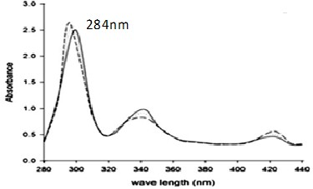

**Fig.1:** UV spectrum of Carvedilol in Potassium hydrogen phthalate 7.4

**Table.4:** Calibration data for Analysis of Carvedilol in methanol at λ284

|  |  |  |  |
| --- | --- | --- | --- |
| **S.No.** | **Conc. (µg/ml)** | **Abs.** | **Standard Deviation** |
| 1 | 5 | 0.120 | ±0.002 |
| 2 | 10 | 0.232 | ±0.002 |
| 3 | 20 | 0.356 | ±0.03 |
| 4 | 30 | 0.546 | ±0.002 |
| 5 | 40 | 0.626 | ±0.001 |
| 6 | 50 | 0.768 | ±0.004 |
| 7 | 60 | 0.798 | ±0.007 |
| 8 | 70 | 0.832 | ±0.006 |
| 9 | 80 | 0.890 | ±0.0014 |
| 10 | 90 | 0.912 | ±0.0016 |
| 11 | 100 | 0.956 | ±0.0018 |



**Fig.2:** Calibration Curve of Carvedilol at 284nm wavelength



120 y = 9.7727x - 8.1818

100

80

60

40

20

0

R² = 0.9984

Concentr ation (µg/ml)

1 2 3 4 5 6 7 8 9 1011

## Solubility Study:

Solubility of Carvedilol was checked in various solvents.

**Table.5:** Determination of drug solubility in various solvents

## Process of Determination of Partition Coefficient:

**Table.6: Partition Coefficient**

|  |  |  |  |
| --- | --- | --- | --- |
| **S.No** | **Drug (mg)** | **Methanol (ml)** | **H2O**  **(ml)** |
| 1 | 10 | 40 | 40 |
| 2 | 20 | 40 | 40 |
| 3 | 30 | 40 | 40 |

## Observation and Calculation of Partition Coefficient:

**Table.7: Calculation of Partition Coefficient**

## FTIR Study:

Fig. 2 gives the spectra of the pure drug (Carvedilol), HPMC, Methyl Cellulose, Dimethyl Sulfoxide, Dimethyl Formamide, Tween 80, Polythylene Glycol, Dibutyl Pthalate and optimized tablets. FTIR spectrum of carvedilol showed characteristic bands at 3416.05 (overlapping of – OH & –NH stretch), 3021.2 (aromatic C-H stretch) 1504.53 (aromatic C=C stretch) and 1243.77cm–1 (aromatic C-N stretch). HPMC exhibited absorption peaks at 3420.72 (H-bonded O-H stretch), 2878.43 (C-H aliphatic stretch) and

1012.92cm–1 (C-O stretch). Tween-80 exhibited absorption peaks at 3020.72 (C-H-bonded, O-H stretch), 2679.23 (C-O-H aliphatic stretch) & 1042.92cm–1 (C-O stretch). Polythylene Glycol, Dibutyl Pthalate exhibited absorption peaks at 3520.62 (H-bonded O-H stretch), 2476.40 (C-H aliphatic stretch), 2286.16cn-1 (C-H Aromatic Bending). 1898.65cm-1 (C-O-C stretching) and 1012.92cm–1 (C-O stretch). Dimethyl Sulfoxide spectrum showed disappearance of the peak at 3212.08cm–1 & the presence of all other carvedilol peaks with decreased intensity compared to the drug alone. Optimized tablets showed same peaks as HPMC with slight variation. No additional peak was observed to indicate the absence of any chemical interaction between the drug and Methyl Cellulose, Dimethyl Sulfoxide. Optimized formulations exhibited the characteristic peaks of carvedilol with no additional peaks observed in the spectra, indicating retention of chemical identity of carvedilol, as shown in Fig. 2. However, the intensity of peaks corresponding to the drug was reduced or peaks were broadened in the formulations possibly due to the Patches of the drug with the carrier, i.e., HPMC in melt drug and possibly due to addition of other excipients. The FTIR data indicate the absence of chemical interaction between carvedilol and the excipients used.

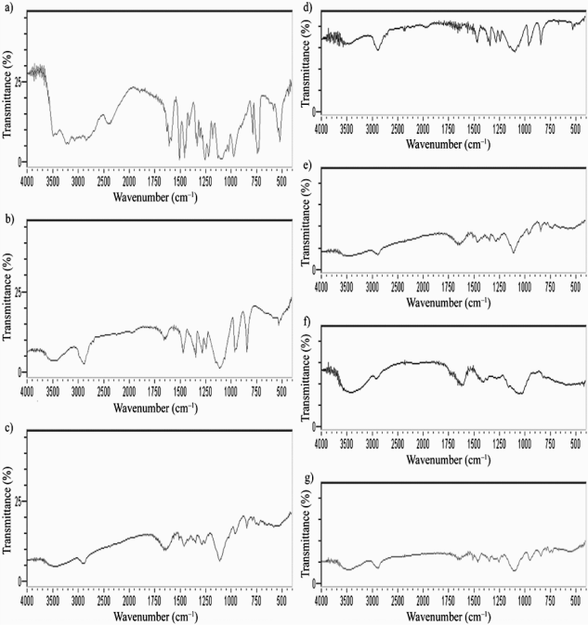

**Fig.3:** FTIR spectra of: a) Carvedilol, b) HPMC, c) Methyl Cellulose, d) Dimethyl Sulfoxide, e) Dimethyl Formamide, f) Tween 80, g) Polythylene Glycol

|  |  |  |
| --- | --- | --- |
| **S. No.** | **Solvent** | **Descriptive Term** |
| 1 | Ethanol | Soluble |
| 2 | Water | Slightly Soluble |
| 3 | Dimethyl  Formamide | Soluble |
| 4 | DMSO | Soluble |
| 5 | Benzyl alcohol | Poorly Soluble |
| 6 | Phenolic | Poorly Soluble |

|  |  |  |  |  |
| --- | --- | --- | --- | --- |
| **S.No.** | **Conc. of drug in metha nol**  **(µg/ml)** | **Conc. of drug in H2O (µg/ml)** | **Po/W= Conc. of CH3OH/H2 O** | **Aver age Po/w** |
| 1 | 0.8212 | 0.244 | 4.02 |  |
| 2 | 0.8100  56 | 0.244 | 4.01 | 4.05 |
| 3 | 0.8365 | 0.244 | 4.10 |  |

**Differential Scanning Calorimetry (DSC) Study:** The Differential Scanning Calorimetric study was carried out using Mettler Toledo Differential Scanning Calorimeter. Samples were placed in an aluminum crucible and the DSC thermograms were recorded at heating rate of 100℃/ min in the range 30 to 3000C.

|  |  |  |  |  |
| --- | --- | --- | --- | --- |
| F7 | 1 | -1 | 400 | 800 |
| F8 | 1 | 1 | 400 | 600 |

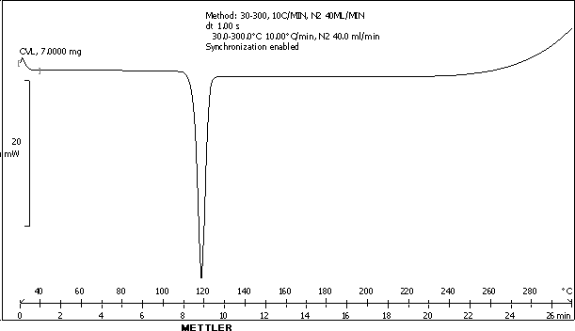**Fig.4:** DSC curve of pure Carvedilol

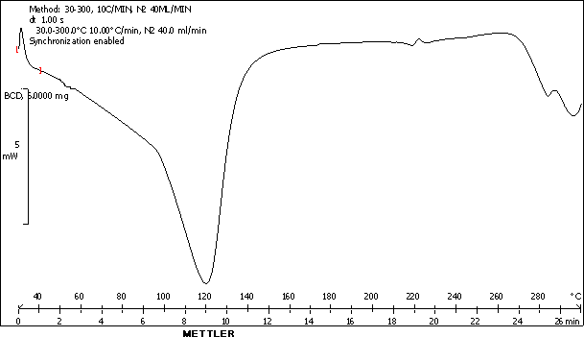

**Fig.5:** DSC curve of PVP

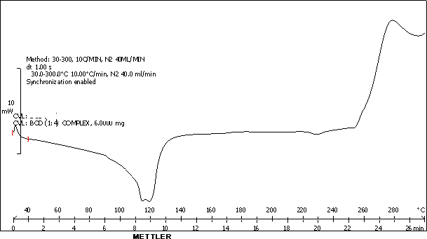

**Fig.6**: DSC curve of HPMC - Carvedilol

Above Figure shows the DSC thermo grams of drug, PVP and drug: HPMC (1:4). DSC studies revealed that endothermic peaks for pure Carvedilol and HPMC were obtained at 117.37°C and 112.46°C respectively. Thermogram of Drug: HPMC complex showed complete disappearance of sharp peak of Carvedilol and shift in endothermic peak of HPMC. This indicates successful complexation of Carvedilol with HPMC. Thus, DSC studies confirm interaction between drug and HPMC.

## Experimental Design:

**Table.8:** Design layout for 32 Full Factorial Batches

A statistical model incorporating interactive and polynomial terms was used to evaluate the responses: Y=b0 +b1X1 +b2X2 +b12X1X2 +b1 1X1 2 +b2 2X2 2 , where Y is the dependent variable, b0 is the arithmetic mean response of the 9 runs and any bi is the estimated coefficients for the related factor Xi. The main effects (X1 and X2) represent the average result of changing one factor at a time from its low to high value. The interaction term “X1X2” shows how the response changes when the two factors change simultaneously. The polynomial terms (X1 2 and X2 2) are included to investigate nonlinearity.

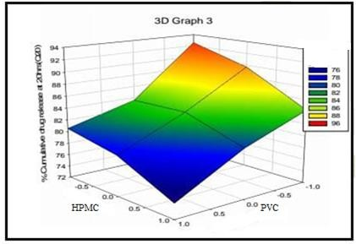

**Fig.7:** Response surface plot for at 20 hrs

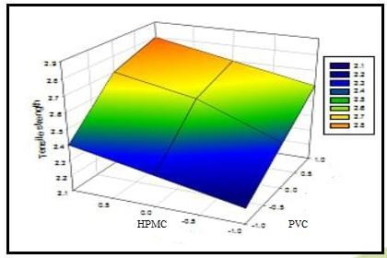

**Fig.8:** Response surface plot for Tensile Strength

## Evaluation of Transdermal Patches:

**Physical Appearance of Transdermal Patches:** The Carvedilol transdermal patches were homogeneous, clear and smooth when prepared. Table.9 lists the various patch parameters that have been evaluated.

**Table.9:** Evaluation of Transdermal Patches

|  |  |  |  |  |
| --- | --- | --- | --- | --- |
| Batch | Code Value | | Actual Value (mg) | |
| Code | X1 (HPMC) | X2 (PVP) | X1 (HPMC) | X2 (PVP) |
| F1 | -1 | 1 | 150 | 400 |
| F2 | -1 | 0 | 150 | 500 |
| F3 | 0 | 1 | 150 | 600 |
| F4 | -1 | -1 | 300 | 700 |
| F5 | 0 | 0 | 300 | 800 |
| F6 | 0 | 1 | 300 | 700 |

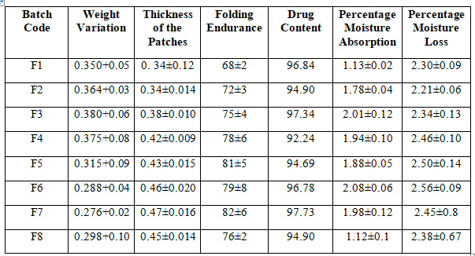

*Data expressed (±SD); n = 3

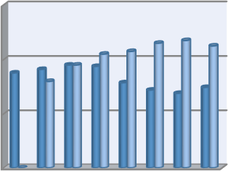

0.6

0.4 0.3501.36040.3.038.8375 15

0.420.430.460.470.45

0.32

Weight

0.2

0

0.30.2808.2706.298Variation

Thickness of the Patches

0

F1 F2 F3 F4 F5 F6 F7 F8

**Fig.9:** A Diagrammatically Representation of Wt.

Variation & Thickness

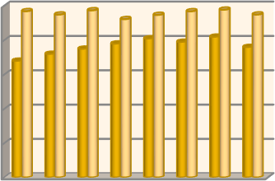

100

80

60

40

20

0

96.8944.97.3942.2944.6996.7987.7934.9

68 72 75

78 81 79 82 76

Folding

Endurance

Drug Content

F1 F2 F3 F4 F5 F6 F7 F8

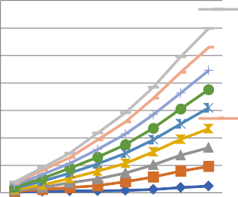

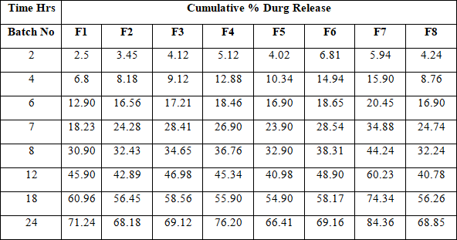**Fig.12:** Cumulative % Durg Release of Formulations F1-F8

700

600

500

400

300

200

100

0

Cumulativ

e % Durg Release F8

Cumulativ e % Durg Release F7

1 2 3 4 5 6 7 8

**Axis Title**



**Fig.10:** A Diagrammatically Representation of Folding Endurance & Drug Content

**Fig.11:** A Diagrammatically Representation of % moisture abs. & % moisture loss

## In-Vitro Drug Release Study:

**Table.10:** Cumulative % Durg Release of Formulations F1-F8

## Conclusion:

A medication used to treat hypertension is called Carvedilol. Due to first pass metabolism, it has an oral bioavailability of 25% and a half-life of 6 hours. Since Carvedilol has a 50mg daily maximum dose, frequent dosing was necessary. Carvedilol transdermal patches were created to increase the drug's bioavailability and patient compliance. By adjusting the proportions of HPMC, Methyl Cellulose, and PVP, different formulations were created using the solvent casting method. The produced formulations were assessed for a number of factors, including weight variation; patch thickness, folding durability, drug content, moisture absorption and loss rates, and in-vitro drug release. Using a 32 complete factorial design, it was possible to determine how changing the amounts of HPMC (X1) and PVC (X2) would affect the answers, i.e. The dependent variables are the tensile strength and the percentage of medication released in 20 hours (Q20). For dependent variables, regression analysis and analysis of variance were done. It is reasonable to believe that carvedilol can be made into transdermal patches to extend the features of its release. Therefore, it was determined that the formulation HPMC, Methyl Cellulose, and PVP (3:1) F7 was the best for controlled release, releasing 84.36% of the medicine in 24 hours. The goal was to administer the medication over intact skin at a controlled rate to increase bioavailability and extend the duration

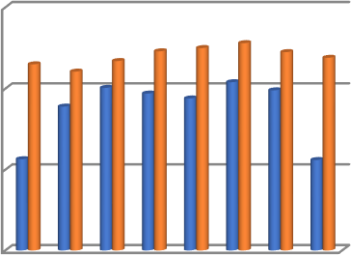

3

2.3

2.212.34

2.462.52.562.452.38

2

2.011.941.8 2.081.98

1.7

8

8

1.13

1.12

1

% Moisture

Absorption

% Moisture Loss

0

F1 F2 F3 F4 F5 F6 F7 F8

of hypertension treatment via transdermal patches. The ability to avoid problems with gastric irritation, gastric emptying rate, avoid hepatic first-pass metabolism thereby increasing the bioavailability of drug, and reduce the risk of systemic side effects are just a few of the advantages the skin has over many other routes of drug administration.

## References:

1. Tripathi K. D., 2003. Essentials of Medical Pharmacology. 5th edition. Jaypee Brothers Medical Publishers (P) Ltd, New Delhi. 1 – 10.
2. Mrs. Aishwarya P Pimple, Miss. Varsha S Kudal, Dr. Gajanan S Sanap, Miss Pooja S Murkute, A Review: Routes of Drug Administration with Their Recent Advances, IJCRT 10(2) ,2022, 421-430.
3. [Jean Kim](https://pubmed.ncbi.nlm.nih.gov/?term=Kim%2BJ&cauthor_id=33760436) , [Orlando De Jesus](https://pubmed.ncbi.nlm.nih.gov/?term=De%2BJesus%2BO&cauthor_id=33760436) , Medication Routes of Administration, StatPearls [Internet]. Treasure Island (FL): StatPearls Publishing; 2023.
4. Gaurav Tiwari, Ruchi Tiwari, Birendra Sriwastawa, 2012, Drug Delivery System: An Updated review, IJPI, volume -2, issue -1.
5. Chien Y.W., 2005. Novel Drug Delivery Systems. Marcel Dekker, New York. 2 nd edition. volume 1. 1 – 2.
6. Mukesh R Patel, Sustained Released Drug Delivery System: A Patent Overview. volume 1. issue 1, 104. 1-3
7. Jain N. K., 2004. Controlled and Novel Drug Delivery. CBS Publisher and Distributors, New Delhi. 1st edition. 1 – 2 and 100 – 129.
8. Ahlam Zaid Alkilani, Rayn F Donnelly, Maeliosa. T C McCrudden, Transdermal Drug Delivery: Innovating Pharmaceutical Developments of The Barrier Properties of The Stratum Corneum, 2015; 7(4): 239-240.
9. Kamal Saroha, Bhavna Yadav, Benika Sharma, 2011, Transdermal Patch: A Discrete Dosage Form, Int J Curr Pharm Res, Vol 3, Issue 3, 98.
10. Bharat Lal, Manoj Gadewar, 2022, Transdermal Drug Delivery System: A Novel Alternative For Drug Delivery, JPRI, 34(7A), 11.
11. D Prabhakar, J Sreekanth, K N Jayaveera, Transdermal Drug Delivery Patches: A Review, JDDT 2013, 3(4), 213
12. Shingade GM, Aamer Quazi, Sabale PM, Review on: Recent Trend on Transdermal Drug Delivery System, JDDT-2012, 2(1), 67.
13. K.M Siddu; Factors Affecting Transdernal drug Delivery System, 2018, 2-7.
14. Jalwal P., Jangra1 A., Dahiya L., Sangwan Y., Saroha R., 2010. A Review on Transdermal Patches. The Pharma Res. 3. 139‐149.
15. Latheeshjlal.L, P. Phanitejaswini, Y.Soujanya, Transdermal Drug Delivery Systems: An Overview, Int.J. PharmTech Res.2011,3(4), 2143- 2144.
16. Dipen Patel, Sunita A. Chaudhary, Bhavesh Parmar, Nikunj Bhura, Transdermal Drug Delivery System: A Review, The Pharma Innovation Journal: Vol. 1 No. 4 2012, 69-71
17. Nidhi Sharma, A Brief Review on Transdermal Patches, OMCIJ 2018; 7(2), 1-3.
18. Keith AD., 1983. Polymer matrix considerations for transdermal devices. Drug. Dev. Ind. Pharm. 9. 605.
19. Adrin C. Williams, Brian W. Barry, Penetration Enhancers, Advanced Drug Delivery Reviews 56 (2004), 603-618.
20. Karande P., Jain A., Ergun K., Kispersky V., Mitragotri S., 2005. Design principles of chemical penetration enhancers for transdermal drug delivery, Proceedings of the national academy of sciences of the United States of America. 102. 4688-93.