

**International Journal of Research Development and Technology**

**Vol.2, Issue.2, Year 2024 ISSN: 2584-0290**

**Web:** [**www.ijrdt.com**](http://www.ijrdt.com/)

Formulation and Optimization of Posaconazole Nano-suspension

# 1Neha (Research Scholar), 2Mohammad Khalid, 3Ankit Kumar, 4Dashrath Singh Krishna Pharmacy College Bijnor

**Email id:** [**nehakashmir6@gmail.com**](mailto:nehakashmir6@gmail.com)

**\*\*\*\*\*\*\*\*\*\*\*\*\*\*\*\*\*\*\*\*\*\*\*\*\*\*\*\*\*\*\*\*\*\*\*\*\*\*\*\*\*\*\*\*\*\*\*\*\*\*\*\*\*\*\*\*\*\*\*\*\*\*\*\*\*\*\*\*\*\*\*\*\*\*\*\*\*\*\*\*\*\***

***Abstract:***

*A nano-suspension prepared with posaconazole was optimised via CCD. The morphological studies produced evidence of the drug's amorphous state (SEM and PXRD). In vitro, there was a higher release of medicines from the nano-suspension than from the pure drugs. When the medication is prepared as a nano-suspension, its oral bioavailability is enhanced compared to the commercial version. Stability tests indicated that the formulation stayed stable for up to six months. The QbD technique was employed to examine the effects of CPPs and CMAs on CQAs, thereby augmenting the formulation's safety and quality. The quantity of Tween-20, soy lecithin, and carbopol-934, as well as process variables such method PB, are critical material features. RSM's CCD was used to improve the nano-suspension. Posaconazole was chosen since it is prescribed to treat oral candidiasis that is resistant to other triazole derivatives. Furthermore, the optimised nano-suspension was assessed. The lower PDI values, increased drug concentration, smooth and spherical particles with increased entrapment efficiency, and improved bioavailability all corroborate the anticipated characteristics of the nano-suspension. The results show that QbD is an effective tool for novel drug delivery systems, which is significant since it aids in the USFDA's and the Indian market's efforts to lower manufacturing costs, enhance safety and quality, and lessen production variability.*

*Keywords: Posaconazole, oral Candidiasis, nano-suspension, oral bioavailability, enhance safety*

**\*\*\*\*\*\*\*\*\*\*\*\*\*\*\*\*\*\*\*\*\*\*\*\*\*\*\*\*\*\*\*\*\*\*\*\*\*\*\*\*\*\*\*\*\*\*\*\*\*\*\*\*\*\*\*\*\*\*\*\*\*\*\*\*\*\*\*\*\*\*\*\*\*\*\*\*\*\*\*\*\*\***

# Introduction:

Each year, fungal infections affect more than one billion people worldwide, with more than 1.6 million deaths [2].

Candidiasis accounts for 75 to 88% of these infections, and despite therapeutic advances, their incidence continues to increase with increasing mortality. The clinical spectrum of Candidiasis extends from superficial diseases such as cutaneous, nail, digestive, and genital Candidiasis, to systemic diseases such as candidemia [3].

Yeasts of the genus Candida cause these infections. Over 200 species of Candida have been listed, and only around 20 are responsible for human infections. These are generally commensally germs that develop in the skin, inside the body, in the mouth, throat, intestines, vagina, without causing problems [4].

They express their pathogenic power only in the presence of factors favoring the origin of the translation of endogenous commensally to the disease-causing parasite. These factors can be intrinsic or extrinsic to the host, and we distinguish the medical condition of the host for overweight, prolonged use of broad-spectrum antibiotic therapy and corticosteroids, etc. [5-6].

Immunosuppressant remains one of the most prevalent risk factors. The resurgence of diseases weakening the immune system, such as AIDS, and immunosuppressive treatments, such as heavy

chemotherapy, has led to a drastic increase in Candida infections, which have become a major cause of mortality and morbidity in hospitals. The disseminated forms of the Candidiasis can be life- threatening with mortality rates of 35-60% among immune compromised cancer patients, and those exposed to multiple treatments, such as broad- spectrum antibiotics, chemotherapy, immunosuppressive therapy, and antiretroviral therapy [7].

On the other hand, inappropriate medical practices such as misdiagnosis and inadequate medication are responsible for the worsening, spread, and persistence of the infection.

# Materials and Methods: Materials:

**Table.1** Materials used in Preparation

|  |  |  |
| --- | --- | --- |
| **S.**  **No.** | **Chemicals** | **Brand** |
| 1 | Posaconazole | Preegus Healthcare Private Limited, Sector  12, Dwarka Delhi |
| 2 | Soya Lecithin | Process Agrochem Industries Pvt Ltd New  Delhi. |
| 3 | Carbopol 934P | Krishna  Institute of Pharmacy, Noorpur Road, Bijnor |
| 4 | Propylene  Glycol | Krishna  Institute of Pharmacy, |

# Instruments:

**Table.2:** List of Instruments

# Preformulation Study: Characterization of the Drug: Organoleptic Properties:

The sample of Posaconazole was studied for organoleptic properties such as colour, odour and appearance.

# Melting Point:

The melting points of Posaconazole were determined by melting point apparatus. Observed value was compared with the reported value.

# Solubility:

Saturation solubility was done with the addition of a surplus amount of pure drug and optimized nano- suspension in 10ml of distilled water. Then, samples were agitated using an orbital shaker (Remi instruments limited, Mumbai) for 48 h at 25°C, then centrifuged to remove the solid content as a residue and the amount of drug present in the supernatant layer was analyzed spectrophotometrically using a UV-visible spectrophotometer at 260nm.

# UV Spectroscopy:

**Preparation of 6.8 pH phosphate buffer:** Dissolve 13.872g of potassium di-hydrogen phosphate and 35.084g of disodium hydrogen phosphate in sufficient water to produce 1000ml [8-10].

# Standard Graph of Posaconazole in 6.8 pH:

The drug was analyzed by using LAB INDIA UV- 1800 spectrophotometer having double beam detector configuration. Posaconazole dissolved in 50ml of phosphate buffer to produce primary stock solution having a concentration of 1mg/ml. 10ml of primary stock further diluted to 100ml to produce secondary stock solution having concentration of 100μg/ml. 0.5-3ml aliquots of the secondary stock were further diluted to 10ml to produce standard solutions having concentrations of 5-30μg/ml. The absorbance of the solutions was measured at 264nm using double beam UV-Visible spectrophotometer. The plot of absorbance vs. concentration (μg/ml) was plotted and data was subjected to linear regression analysis [Gupta KR, Wadodkar AR 2010].

|  |  |  |
| --- | --- | --- |
|  |  | Noorpur Road, Bijnor |
| 5 | Tween--20 | Krishna Institute of Pharmacy,  Noorpur Road, Bijnor |
| 6 | Purified Water | Krishna Institute of Pharmacy,  Noorpur Road, Bijnor |

|  |  |
| --- | --- |
| **S. No.** | **Equipment** |
| 1 | UV-visible spectrophotometer  (Shimadzu-1700, Japan) |
| 2 | FTIR Spectrophotometer |
| 3 | Zetasizer Nano S90 Particle Size Analyzer |
| 4 | SEM (JEOL JSM-6360, Japan) |
| 5 | X-ray diffract meter  (Philips analytical XRD, PW 3710) |
| 6 | Electronic Balance |
| 7 | Hot Air Oven |
| 8 | DSC |
| 9 | Stability Chamber |
| 10 | dissolution apparatus (Electro lab TDT-  08 L, India |

# Determination of Absorption maxima by UV spectrophotometer:

Solution of drug were prepared in 7.4pH buffer and scanned in the range of 200 to 400 nm by using UV-visible spectrophotometer, in order to determine the absorption maxima for analysis of dissolution samples. Preparation of calibration curve of Posaconazole 10mg was dissolved in 10ml of methanol by slight shaking (1000mcg/ml). 1ml of this solution was taken and made up to 10ml with 7.4pH buffer , which gives 100mcg/ ml concentration (stock solution). From the stock solution, concentrations of 5, 10, 1 5, 20, 25 and 30µg/ml in 7.4pH buffer were prepared. The absorbance of diluted solutions was measured at 264nm and a standard plot was drawn using the data obtained. The correlation coefficient was calculated [11-12].

# Fourier Transformation Infra –Red Analysis:

Drug- Excipients compatibility studies the infra red absorption spectra of unmixed drug & with unalike ingredient were hold in the scale of four hundred thousand to four hundred cm-1 using KBr dise procedure, 1-2 milligram of material to be analyse was mixed with 300-400 mg, specified quantity of minute powder & dried KBr these sum are mainly enough to give a circle of 10-15 diameter and pellet of right strength by a hydraulic press [13].

# Differential Scanning Calorimetry (DSC):

DSC method can be used as a screening tool for the detection of co-crystal formation in binary physical mixtures of drugs and co-former. Thermal analysis of Posaconazole and prepared co-crystals were recorded on a DSC (Shimadzu DSC-60, Tokyo, Japan). The temperature axis and cell constant of DSC were previously calibrated with indium. A heating rate of 10ºC/min was employed with nitrogen purging. Powder sample (5-10 mg) was filled into an aluminium pan and was subjected to heating from 0-300ºC, using an empty aluminum

pan as a reference and analyzed (Rahman et al., 2011).

# Micrometries Study:

**Angle of Repose:**

Mostly funnel was used in this method, firstly weight of the powder and it taken in a funnel, the height (h) funnel was place in a stand, after the powder is place in the funnel to freely flow, then the angle of repose of the powder is find out. Range of repose can zero degree. The angle of repose of the powder is found out the following formula [14].

Tan θ = h/r

Therefore,

θ = tan h/ r

Here,

**θ** = angle of repose. h = height of the pile.

r = radius of the pile base.

# Bulk Density:

Bulk density was calculated by adding a known mass powder to a cylinder. The density was calculated as mass. Tapped density in this method firstly we have to weigh the known powder and then the known powder transfer in a 10ml mechanically tapping cylinder. The tapping was started until the little further volume changed was observed [15].

Calculated by following equation:

Loosen Bulk Density = Total Mass of Powder

/Volume of Powder

Tapped Bulk Density = Powder Wt. / Tapped Volume

# 2.4.3 Carr’s index:

Carr’s index help in measuring the power need to breakdown the friction into the particle & the hopper. Carr’s index > 25% is carefully to be a sign of low flow capability, and under 15, of good flow property It can be calculated by following equation [16-17].

Carr’s Index (%) = [(Total Bulk Density-Loosen Bulk Density) **×**100]/TBD

Where,

TBD = Tapped Bulk Density

# Hausner Ratio:

Hausner ratio is an indirect index of ease of powder flow.

It is calculated by the following formula. Hausner’s Ratio = Tapped density / Bulk Density **Formulation of nano-suspensions:**

Formulation of Posaconazole nano-suspension using quality by design (QbD) approach Quality by Design (QbD) was used to optimize the nano- suspension formulation. An appropriate design was selected based on the need for screening the excipients and optimizing the process. The number of factors and their respective levels also play an important role in the selection of an experimental design. An optimum design space was generated by the software wherein, if the experimental parameters are kept as per the domain generated, the results will fall in the desired range. Further validation was carried out by selecting a point in the design space and then carrying out that particular batch in triplicates. The response (i.e., particle size) was noted and checked whether it falls between the levels of the confidence intervals. The criteria of the response specified for the optimization purpose were 300 to 500 nm. As per QbD optimization, 50ml nano-suspension of Posaconazole was prepared by weighing the optimized amount of ingredients. A coarse suspension of Posaconazole in a solution of Tween- 20, Soya Lecithin and Carbopol-940P was prepared with the help of an overhead stirrer. Propylene Glycol was added to this coarse suspension. After uniform dispersion of Posaconazole in the surfactant solution, the coarse suspension was passed through a micro-fluidizer and was sterilized by autoclaving at 121°C for 20 min under a pressure of 15 psi.

# Evaluation of Posaconazole Nano-suspension: Thermodynamic stability:

The selected formulation is subjected to different thermodynamic stability tests.

# Heating Cooling Cycle:

The temperature of refrigerators between 4°-45° of six cycles with storage at each temperature of not less than 48hr is studied. Those formulations, which are stable at these temperatures, are subjected to centrifugation [18].

# Centrifugation:

The prepared formulations that are passed for centrifugation are centrifuged at 5000rpm for 30min by using centrifuge. The formulations that did not show any phase separated were taken to further tests [19].

# Viscosity Determination:

Viscosity of nano-emulsion is determined by using Brookfield viscometer. 20ml of nano-emulsion is filled in a 25ml beaker and the viscosity is measured using spindle number 6 at 10rpm [20-23]. **Scanning electron microscope (SEM):**

The thermal behavior of pure drug, physical mixture (PM) with excipients, and optimized nano- suspension were studied using a Perkin Elmer 4000e module controlled by PYRIS Version-

11.1.0.0488 (Perkin Elmer, Inc., USA.). For each analysis, before heating under nitrogen purging (20ml/min), the samples of 1 mg were kept in sealed aluminium pans and scanned at a scanning rate of 10°C/min for a temperature range of 3°C– 350°C.

# Powder X-ray difractometry (XRD):

The XRPD spectra of pure drug, PM, and optimized nano-suspension were obtained using an X-ray diffractometer (Philips analytical XRD, PW 3710) with Cu-Kα radiation (1.54Å), at 40 kV, 40mA by passing through a nickel filter. The samples were analyzed in the 2θ angle range of 5- 80°. The range and the chart speed were 5 × 103CPS and 10mm/°2θ, respectively [24-25].

# Measurement of pH:

The pH of the nano-suspension was analyzed using a calibrated pH meter (Eutech instruments, pH meter) at day 0, day 30, and day 60.

# In vitro drug release studies:

Dissolution studies on pure drug and their optimized nano-suspension were performed using USP type-II apparatus. Weighed quantities of samples were transferred into the dissolution apparatus (Electro lab TDT-08 L, India) containing 900ml of SGF with pH 1.2, simulated intestinal fluid with pH 6.8 and pH 7.4, respectively, as a medium. The shaft speed was set to 50 rpm at a medium temperature of 37 ± 0.5°C. Samples (5ml each) were withdrawn at 10, 20, 30, 40, 50, and 60 min of time points and the fresh buffer was added for sink condition maintenance. The samples were collected and filtered using the Whatman filter paper (0.25μm, Whatman Inc., USA) and inspected using a UV spectrophotometer at 260nm. The release profile of nano-suspension was correlated with the pure drug [26-27].

# Stability:

The stability studies were performed as per ICH Q1A (R2) guidelines for the optimized nano- suspension. The formulations were placed in HDPE bottles and stored at three temperature conditions 4°C (refrigerator), room temperature and 40°±2°C/75±5% RH (stability Chamber) for 6 months and further evaluated for particle size, to study the physicochemical stability of product [28- 30].

# Results and Discussion: Preformulation Study: Organoleptic Properties:

**Table.3:** Identification tests of Posaconazole

|  |  |  |
| --- | --- | --- |
| **Parameter** | **Reported value** | **Observed value** |
| Appearance | Crystalline | Crystalline |
| Colour | White | White |
| Odour | Odour-less | Unpleasant |

# Melting Point:

The melting point was determined by melting point apparatus and the melting point was found to be.

**Table.4:** Melting point of Posaconazole

|  |  |  |
| --- | --- | --- |
| **Parameter** | **Standard** | **Observed** |
| **Melting Point** | 170℃-172℃ | 169-171℃ |

# Solubility:

Solubility of Posaconazole was checked in various solvents.

**Table.5:** Determination of drug solubility in various solvents

|  |  |  |
| --- | --- | --- |
| **S. No.** | **Solvent** | **Descriptive Term** |
| 1 | Methanol | Soluble |
| 2 | Water | Slightly Soluble |
| 3 | Dimethyl  Formamide | Soluble |
| 4 | Dichloromethane | Soluble |
| 5 | Benzyl *alcohol* | Poorly Soluble |
| 6 | *Phenolic* | Poorly Soluble |

# UV Spectroscopy:

The absorbance for various concentrations measured at 264nm is as follows:

**Table.6:** Standard Graph of Posaconazole in 6.8 pH Phosphate Buffer Solution



1 y = 0.1113x

0.8

0.6

0.4

0.2

0

R² = 0.8908

0 5 10 15 20 25 30

|  |  |  |
| --- | --- | --- |
| **S.No.** | **Conc. (µg/ml)** | **Abs. at 264nm** |
| 1 | 0 | 0 |
| 2 | 5 | 0.308 |
| 3 | 10 | 0.382 |
| 4 | 15 | 0.454 |
| 5 | 20 | 0.564 |
| 6 | 25 | 0.622 |
| 7 | 30 | 0.748 |



**Table.1:** Standard Graph of Posaconazole in 6.8 pH Phosphate Buffer Solution

# Determination of Absorption Maximum (λmax) of Posaconazole:

Determination of Posaconazole λ-max was done for accurate quantitative assessment of drug dissolution rate.

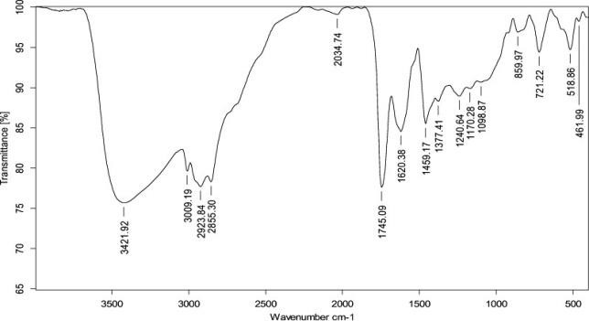

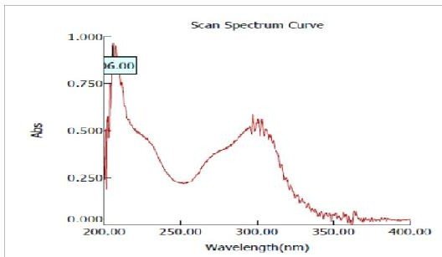**Fig.2:** Absorption Maximum (λmax) of Posaconazole

**Fig.5:** FTIR spectrum of pure drug + Soya Lecithin **Table.9:** Interpretation Spectra of Pure Drug + Soya Lecithin

# FTIR Study:

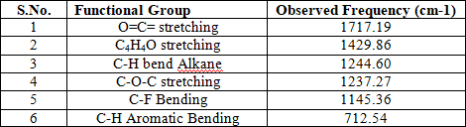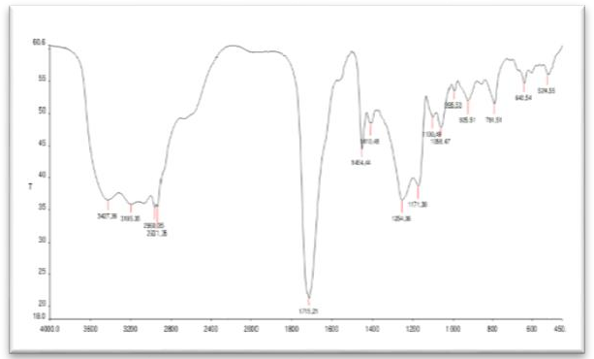

**IR Spectra of Pure Drug:**

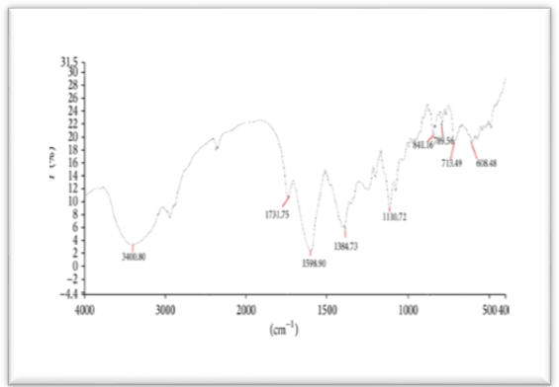The FTIR spectrums of Pure Drug with different polymers were used in formulation was showed in Figures.

**Fig.3:** FTIR spectrum of Posaconazole

**Table.7:** Interpretation of IR spectra of pure drug

**Fig.4:** FTIR spectrum of pure drug + Tween-20

**Table.8:** Interpretation of IR Spectra of Pure Drug

+ Tween-20

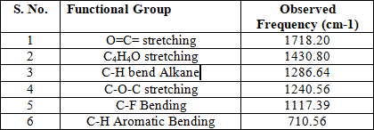

**Fig.6:** FTIR spectrum of Carbopol 934P **Table.10:** Interpretation Spectra of Pure Drug + Carbopol 934P

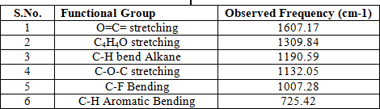

# Discussion of FTIR Spectrum:

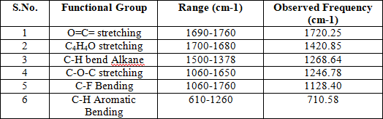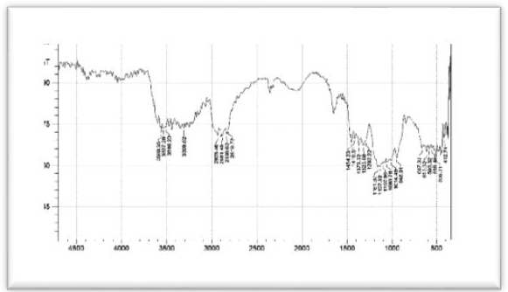

The IR spectrum of the formulation showed that there was no significant evidence for interaction between drug and the polymer. Peaks of both drugs as well as formulation were observed are same. So this clearly suggest that the drug has not undergone any interaction with the polymer in the formulation, as there was no any shift in the positions of the characteristic absorption bands of drug in the formulation.

# Differential Scanning Calorimetry (DSC):

The results of the DSC analysis are displayed in Fig.7. Coarse Posaconazole powder showed a distinct endothermic peak at 183.41°C, which was the marked intrinsic melting point peak of PC, while DSC of the PM showed two distinct melting endotherms at 165.85 °C & 178.63°C, In addition, Mannitol showed a sharp endothermic peak at 167.74°C, which indicates its high crystalline. The mixture of drug & excipients demonstrated an exothermic peak at 163.34°C; thus, it was inferred

that the final combination mixture

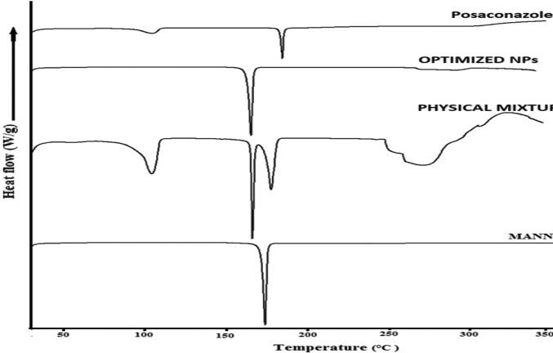

**Fig.7:** DSC thermo grams of Posaconazole & Mannitol

**Table.12:** Evaluation of Powders for Posaconazole

|  |  |  |  |
| --- | --- | --- | --- |
| **Formulatio n**  **Code** | **Bulk density (gm/ml)** | **Tapped density (gm/cc)** | **Hausner’ s ratio** |
| F1 | 0.64±0.6  8 | 0.78±0.5  4 | 1.25±0.14 |
| F2 | 0.62±0.5  1 | 0.77±1.0  6 | 1.19±0.18 |
| F3 | 0.58±0.4  4 | 0.75±0.9  9 | 1.26±0.23 |
| F4 | 0.63±1.2  2 | 0.70±1.0  5 | 1.40±0.20 |
| F5 | 0.59±0.7  8 | 0.69±0.0  2 | 1.29±0.18 |
| F6 | 0.61±0.5  6 | 0.74±0.8  9 | 1.34±0.13 |
| F7 | 0.60±0.5  2 | 0.72±0.7  9 | 1.30±0.13 |

# Micrometry Study:

**Table.11:** Evaluation of Powders for Posaconazole

|  |  |  |
| --- | --- | --- |
| **Formulation Code** | **Carr’s index (%)** | **Angle of Repose** |
| F1 | 24.15±1.9 | 28.20±0.52 |
| F2 | 21.36±0.6 | 26.36±1.06 |
| F3 | 20.50±1.2 | 30.86±0.48 |
| F4 | 28.68±0.8 | 28.25±1.10 |
| F5 | 26.09±0.7 | 27.54±0.12 |
| F6 | 19.50±0.8 | 29.74±0.64 |
| F7 | 24.16±0.6 | 31.46±0.60 |

Values are expressed as mean ±SD (n=3)

# Discussion:

The physical mixtures for Posaconazole Powder are evaluated with respect to Carr’s index values are found 19.50±0.8 to 28.68±0.8% and Angle of repose was found b/w 27.54±0.12 to 31.46±0.60 the powder of all batches excellent to poor flow ability and compressibility.

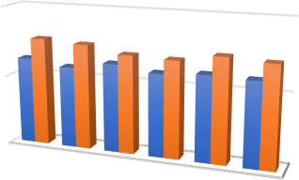

1

0.5

0

F2

F3

F4

F5

F6

F7

Bulk density (gm/ml)

**Fig.8:** Powder Evaluated with respect to Angle of repose & Carr’s index

Values are expressed as mean ±SD (n=3)

# Discussion:

Bulk density ratio 0.58±0.44 to 0.64±0.68 and Tapped density ratio 0.69±0.02 to 0.78±0.54 & Hausner ratio is found to be 1.19±0.18 to 1.40±0.20 for all the batches indicating that possible and poor flow properties.

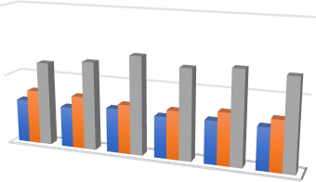

2

1

0

F2

F3

F4

F5

F6

F7

Bulk density (gm/ml) Tapped density (gm/cc)

**Fig.9:** Powder Evaluated with respect to Bulk, Tapped Density & Hausner’s Ratio

# Preparation:

**Table.13:** Preparation of Nano-suspension

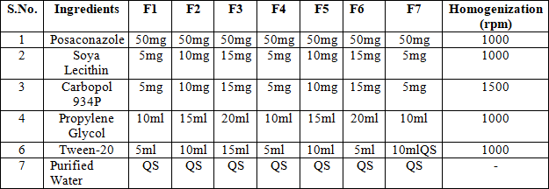

# Evaluation Parameters: Thermodynamic stability:

**Table.14:** Thermodynamic Stability Study

|  |  |  |
| --- | --- | --- |
| **Formulation Code** | **Heating Cooling**  **Cycle** | **Centrifugation** |
| **F1** | Stable | No phase  separation |

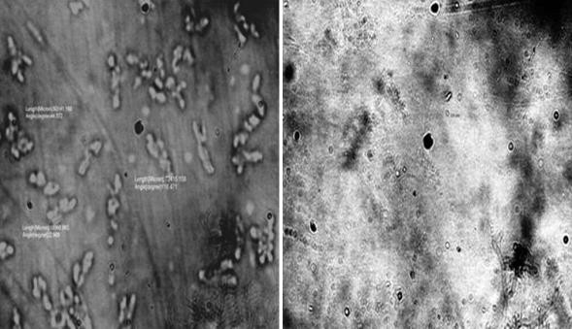

**Table.15:** Characterization of Nano-emulsion

|  |  |
| --- | --- |
| **Formula Code** | **Viscosity (cp)** |
| F1 | 5229 |
| F2 | 4332 |
| F3 | 4320 |
| F4 | 4850 |
| F5 | 5920 |
| F6 | 6030 |
| F7 | 5437 |

The mean average viscosity was found to be 4000 to 6000cp; F6 batch shows highest viscosity in table.11.

**Viscosity (cp)**

8000

6000

4000

2000

0

Viscosity (cp)

F1 F2 F3 F4 F5 F6 F7

**Fig.10:** A Diagrammatically Representation of Viscosity (cp)

**Scanning electron microscope (SEM):** Posaconazole is a coarse micronized powder with a fine white texture and has poor aqueous solubility. The coarse PC particles bear an average size of particle 5-7μm with broad size distribution observed in SEM. The SEM of optimized lyophilized nanosuspensions showed that particles were discrete with an absence of agglomeration due to the presence of a stabilizer. They had porous surfaces and were slightly elongated and needle in shape but not completely spherical in shape. SEM images of nanosuspensions showed quasi-spherical spheres [Fig.11].

**Fig.11:** SEM images of Posaconazole nano- suspension

# Powder X-ray difractometry (XRD):

|  |  |  |
| --- | --- | --- |
| **F2** | Stable | No phase  separation |
| **F3** | Stable | No phase  separation |
| **F4** | Stable | No phase  separation |
| **F5** | Stable | No phase  separation |
| **F6** | Stable | No phase  separation |
| **F7** | Stable | No phase separation |

The XRPD patterns of powder drug, PM, and optimized nano-suspension are displayed in Figure

1. Five sharp characteristic diffraction peaks were exhibited by the drug at 2θ of 13.54°, 15.36°, 16.5°, 18.0°, and 19.42° & several short peaks were between 2θ of 10.66° and 32.36°, indicating its high crystalline nature. The PM demonstrated two reflections at 2θ of 20.52° and 21.66° with the lowest intensities compared to drug and nanosuspensions. Nanosuspensions showed six diffraction lines but at lesser intensities as compared to a drug at 2θ of 9.5°, 10.76°, 13.52°, 17.14°, 19.86°, 20.28°, 21.2°, 27.4°, 30.28°, and 31.42° with the additional peaks of mannitol [Fig.12].

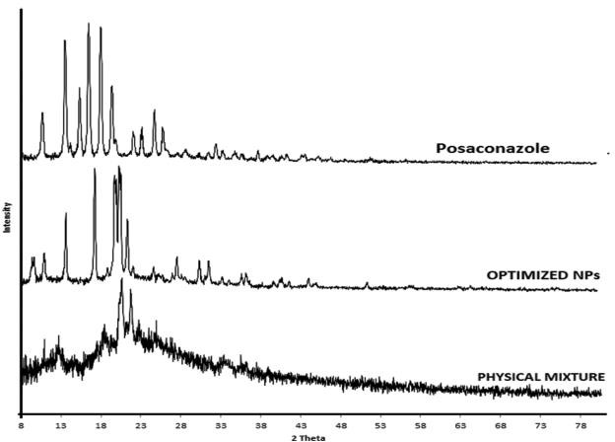

**Fig.12:** DSC analysis of Posaconazole, optimized nano-suspension, and physical mixture

# Measurement of pH:

**Table.16:** Evaluation Parameters of pH

|  |  |
| --- | --- |
| **Formulation Code** | **Surface pH Study** |
| F1 | 7.01 |
| F2 | 6.90 |
| F3 | 6.70 |
| F4 | 7.16 |
| F5 | 7.30 |

Values are intimate as design ± SD (n = 3)

|  |  |
| --- | --- |
| F6 | 7.04 |
| F7 | 6.56 |

# Discussion:

The pH was found 7.01 to 6.56 for all the batches indicating that possible evaluation properties.

**Fig.13:** A Diagrammatically Representation of pH Study

2 3 4 5

**In-Vitro Drug Release Studies: Table.17:** Release studies F1-F7

Point are communicate as mean ±standard deviation (n = 3)

# Discussion:

Formulations F1 to F7 of the in vitro drug release investigation were successfully finished. When compared to another formulation, Formulation F6's medication release time of 8 hours for 98.96% of patients was shown to be the most effective.

10

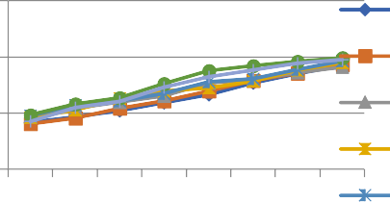

150

0

50

0

F1

F2

F3

F4

0.5 1 2 3 4 5 6

8

F5

**Fig.14:** A Diagrammatically Representation of % Release Drug

# Stability Studies:

The 6-month stability data for optimized nanosuspensions stored at refrigerated temperature showed insignificant increase in particle size from 210.0±1.4nm to 4.25±0.17nm, while storage under room temperature conditions showed a slight increase from 217.3±3.2nm to 228.1±4.0nm, respectively. The nano-suspension stored at 40°±2°C showed an increase in the size of particles from 221.3±2.8nm and 245.8±5.4nm, respectively. Nano-suspension at the refrigerator conditions shows better stability as compared to room temperature and 40°C (ACC) conditions which may be attributed to the aggregation of nanoparticles with a rise in temperature [Table.18].



7.5

7

6.5

Surface

pH Study

6

1

6 7

|  |  |  |  |  |  |  |  |
| --- | --- | --- | --- | --- | --- | --- | --- |
| **Time/Hrs** | **% Release Drug** | | | | | |  |
| **Formulati on** | **F1** | **F2** | **F3** | **F4** | **F5** | **F6** | **F7** |
| 0.5 | 41.75±2.4 | 40.30±0.28 | 46.65±0.24 | 46.04±0.96 | 47.40±0.72 | 48.42±1.30 | 42.42±1.30 |
| 1 | 46.56±2.2 | 45.55±0.99 | 54.46±0.48 | 52.52±1.33 | 56.85±0.88 | 57.78±1.25 | 54.78±1.25 |
| 2 | 51.78±2.3 | 54.04±0.90 | 59.52±0.76 | 63.13±1.28 | 60.58±1.24 | 63.47±1.20 | 60.47±1.20 |
| 3 | 59.25±0.2 | 60.56±0.36 | 65.32±0.82 | 69.49±1.22 | 67.44±1.45 | 75.89±1.18 | 72.89±1.18 |
| 4 | 66.52±0.5 | 69.78±1.25 | 76.70±0.91 | 72.21±0.98 | 77.98±1.20 | 87.45±0.78 | 82.45±0.94 |
| 5 | 76.48±0.8 | 78.65±1.09 | 79.46±0.52 | 78.16±0.88 | 80.43±1.40 | 92.25±1.77 | 88.45±0.76 |
| 6 | 84.89±0.3 | 85.44±1.17 | 86.24±0.78 | 88.29±0.68 | 88.78±1.48 | 95.67±1.57 | 94.45±1.24 |
| 8 | 92.34±0.9 | 93.13±1.18 | 90.76±0.34 | 94.90±0.48 | 96.38±1.26 | 98.96±0.82 | 97.45±1.82 |

**Table.18:** Physical stability data of optimized nano-suspension for the 6‑month stability study

|  |  |  |  |  |  |
| --- | --- | --- | --- | --- | --- |
| **S. N**  **o.** | **Storag e Temp.**  **Condit ion** | **Initial Particl e Size** | **Particle Size nm** | | |
| **2mont hs** | **4month s** | **6month s** |
| 2 | 4℃ | 210.0± | 211.2± | 215±3.0 | 4.25±0. |
|  |  | 1.4 | 2.3 |  | 17 |
| 3 | Room |  | 217.3± | 220.4±3 | 228.1±4 |
|  | temp. | 3.2 | .6 | .0 |
| 4 | 40℃ |  | 221.3± | 232.9± | 245.8± |
|  |  | 2.8 | 2.9 | 5.4 |

# Conclusion:

Using CCD, a posaconazole-formulated nano- suspension was optimised. The drug's amorphous condition was demonstrated by the morphological investigations (SEM and PXRD). The release of

pharmaceuticals from the nano-suspension in vitro was greater than that of the pure medications. In comparison to the commercial formulation, the drug's oral bioavailability is improved when it is formulated as a nano-suspension. According to stability experiments, the formulation remained stable for a maximum of six months. The impact of CPPs and CMAs on CQAs was investigated using the QbD technique, which contributes to the formulation's increased safety and quality. Critical material characteristics include the content of Tween-20, soy lecithin, and carbopol-934, as well as process factors like technique PB. To optimize the nano-suspension, RSM's CCD was employed. Because of its prescription for treating oral Candidiasis that is resistant to other triazole derivatives, Posaconazole was selected. Additionally, the optimized nano-suspension was evaluated. The reduced PDI values, higher drug content, smooth and spherical particles with higher entrapment effectiveness, and enhanced bioavailability all support the expected properties of the nano-suspension. According to the findings, QbD is a useful tool for innovative drug delivery systems, which is important since it helps the USFDA and the Indian market reduce manufacturing costs, improve safety and quality, and reduce production variability.

# References:

* 1. Seager, H., Drug delivery products and Zydis fast dissolving dosage form, 1998, 50, 375-382.
  2. Bongomin F, Gago S, Oladele R, Denning D. Global and Multi-National Prevalence of Fungal Diseases-Estimate Precision. J Fungi (Basel) 2017; 3: 57.
  3. Gupta P, Gautam P, Rai N, Kumar N. An emerging hope to combat Candida albicans: plantbased therapeutics. Biotechnol Int 2012; 5: 85-114.
  4. Calderone RA, Clancy CJ, editors. Candida and Candidiasis. Washington: American Society of Microbiology Press. 2012.
  5. Hani U, Hosakote G, Vaghela R, Osmani RA, Shrivastava A. Candidiasis: a fungal infection-current challenges and progress in prevention and treatment. Infect Disord Drug Targets 2015; 15: 42-52.
  6. Berkow EL, Lockhart SR. Fluconazole resistance in Candida species: a current perspective. Infect Drug Resist 2017; 10: 237-45.
  7. Han Y, Ulrich M, Cutler J. Candida albicans mannan extract-protein conjugates induce a protective immune response against experimental candidiasis. J Infect Dis 1999; 179: 1477- 84.
  8. Cateau E, Rodier MH, Imbert C.

Candidoses associées aux cathéters: Quelle place pour les verrous antifongiques [Could antifungal lock be useful in the management of candiasis linked with catheters] Med Sci (Paris) 2012; 28: 740-5.

* 1. Madhu P. Oral candidiasis. Int J Pharm Sci Invent 2013; 2: 3-6.
  2. Guessous-Idrissi N, Essari A, Abdallaoui S, Youssouf M. Première identification de Candida dubliniensis au centre hospitalier universitaire Ibn Rochd de Casablanca, Maroc. J Mycol Med 2007; 17: 77-81.
  3. Eggimann P, Que YA, Revelly J P, Pagani JL. Preventing invasive Candida infections. Where could we do better? J Hosp Infect 2015; 89: 302-8.
  4. Seleem D, Pardi V, Mendonça Murata R. Review of flavonoids: a diverse group of natural compounds with anti-Candida albicans activity in vitro. Arch Oral Biol 2017; 76: 76-83.
  5. Barnes PD, Marr KA. [Aspergillosis:](https://www.ncbi.nlm.nih.gov/pubmed/16984868) [spectrum of disease, diagnosis &](https://www.ncbi.nlm.nih.gov/pubmed/16984868) [treatment external icon.](https://www.ncbi.nlm.nih.gov/pubmed/16984868) Infect Dis Clin North Am. 2006 Sep; 20 (3):545-61.
  6. Yang M, Dong Z, Zhang Y, Zhang F, Wang Y, Zhao Z. Preparation and evaluation of posaconazole-loaded enteric microparticles in rats. Drug Dev Ind Pharm 2017;43:618-27. 4.
  7. Patel R, Shah D. Nanoparticles loaded sublingual film as an effective treatment of chemotherapy-induced nausea and vomiting. Int J PharmTech Res 2015;8:77-87.
  8. Singh N, Bhalodiya NH. [Allergic fungal](https://www.ncbi.nlm.nih.gov/pubmed/16354339) [sinusitis (AFS)–earlier diagnosis and](https://www.ncbi.nlm.nih.gov/pubmed/16354339) [management external icon.](https://www.ncbi.nlm.nih.gov/pubmed/16354339) J Laryngol Otol. 2005 Nov; 119 (11):875-81.
  9. Mario Jug and Mira Becirevic-Lacan. Influence of hydroxypropyl cyclodextrin complexation on piroxicamrelease from buccoadhesive tablets. Er. J. Pharm. Sci. 2004;21: 251–260.
  10. Priyanka R, Murthy RS. Formulation and evaluation of mucoadhesive buccal films impregnated with carvedilol nanosuspension: a potential approach for delivery of drugs having high first-pass metabolism. Drug Delivery 2013;20:224- 35.
  11. Ranganathan T, Sudhakar Y, Chetty M. Buccal drug delivery from carvedilol polymeric mucoadhesive film. J Pharm Res 201;4:3897-901.
  12. Concetta G, Ayensu II, John JT. Development and characterization of chitosan films impregnated with insulin loaded PEG-b-PLA nanoparticles (NPs):

a potential approach for buccal delivery of macromolecules. Int J Pharm 2012;428:143–51.

* 1. Shirsand S, Suresh S, Keshavshetti G, Swamy P, Reddy PVP. Formulation and optimization of mucoadhesive bilayer buccal tablets of atenolol using the simplex design method. Int J Pharma Investig 2012;2:34-41.
  2. Vamshi VY, Ramesh G, Chandrasekhar K, Bhanoji Rao ME, Madhusudan Rao Yamsani. Development and *in vitro* evaluation of buccoadhesive carvedilol tablets. Acta Pharm 2007;57:185–97.
  3. Vamshi VY, Chandrasekar K, Ramesh G. Development of mucoadhesive patches for buccal administration of carvedilol. Curr Drug Delivery 2007;4:27-39.
  4. Shojaei HA. Buccal mucosa as a route for systemic drug delivery: A Review. J Pharm Sci 1998;1(1):15-30.
  5. Gandhi PA, Patel MR, Patel KR, Patel NM. A review article on mucoadhesive buccal drug delivery system. Int J Pharm Res Dev 2011 july;3(5):159-73.
  6. Tor-Tora G. Principles of anatomy and physiology. 7 th ed. Harpet Collins College Publishers;1992:770-4.
  7. 9. Gupta SK, Singhvi IJ, Shirsat M, Karwani G, Agarwal A, Aditi A. Buccal adhesive drug delivery system: a review. Asi J Biochem Pharm Res 2011 april;2(1):105-14.
  8. Chen YS, Squier CA. The structure and function of oral mucosa. Pergamon Press, Oxford 1984:7-30.
  9. Ross & Wilson. Anatomy & physiology

in health and illness. 9th ed. Edinburgh Publishers;2001:289-93.

* 1. Jain NK. Controlled and novel drug delivery. 1st ed. New Delhi: CBS Publishers & Distributors; 1997:52-81.
  2. Prakash1*, FORMULATION AND EVALUATION OF HERBAL ANTI- ACNE GEL Journal of Pharmaceutical Negative Results ¦ Volume 13 ¦ Special Issue 6 2022.
  3. *Satya Prakash1, To Study the Antiulcer Activity of Hydro Alcoholic Extract of Euphorbia Thymifolia on Absolute Ethanol Induced Ulcer in Rats. European Journal of Molecular & Clinical Medicine ISSN 2515-8260 Volume 10, Issue 1 2023.
  4. Satya Prakash, et. al., 2022 Guidelines for Approval of Clinical Trials and Study Reports of SARS Covid-19 Vaccines. IJPRA, ISSN: 2456-4494. 64. et al., S. P. (2019). FORMULATION AND EVALUATION OF FLOATING TABLET OF ZOLMITRIPTAN TABLET. International Journal of Advanced Science and Technology, 28(17), 82
  5. Satya Prakash, et. al., 2023 Gold Nanoparticles for Targeted and Selective Delivery of Cancer Chemotherapeutics: A Review of the Literature (Eur. Chem. Bull. 2023, 12 (Special Issue 1), 2896- 2901).
  6. Satya Prakash et al., 2019 Formulation and Evaluation of Floating Tablet Zolmitriptan. (International Journal of Advanced Science and Technology Vol. 28 No. 17 (2019): Vol 28 No 17 (2019))