

**International Journal of Research Development and Technology**

**Vol.2, Issue.2, Year 2024 ISSN: 2584-0290**

**Web:** [**www.ijrdt.com**](http://www.ijrdt.com/)

Formulation and Evaluation of Baclofen Nano-emulsion for the Treatment of Multiple Sclerosis

**Pragati Rani (Research Scholar), Seema Tyagi Krishna Pharmacy College Bijnor**

**Email id:** [**Pragatichaudhary9898@gmail.com**](mailto:Pragatichaudhary9898@gmail.com)

**\*\*\*\*\*\*\*\*\*\*\*\*\*\*\*\*\*\*\*\*\*\*\*\*\*\*\*\*\*\*\*\*\*\*\*\*\*\*\*\*\*\*\*\*\*\*\*\*\*\*\*\*\*\*\*\*\*\*\*\*\*\*\*\*\*\*\*\*\*\*\*\*\*\*\*\*\*\*\*\*\*\***

***Abstract:***

*In conclusion, the development and assessment of Baclofen nano-emulsion present a promising therapeutic avenue for addressing multiple sclerosis. This research aimed to fabricate and appraise the Nano-emulsion of Baclofen using the high-shear homogenization method. Various parameters such as Physical Appearance, pH, viscosity, % drug content, centrifugation, UV spectroscopy, and Fourier transform spectroscopy were evaluated to gauge the formulations' quality. Moreover, in vitro drug release studies and stability assessments were conducted. Formulation F5 exhibited a viscosity of 5920cp, and formulation F5 demonstrated the optimal drug release rate of 98.12% within 6 hours. Stability assessments revealed minor alterations in formulations after two months at 4°C ± 2 and 75% ± 5% humidity. These findings underscore the potential of nanoemulsions as a viable vehicle for orally administering Baclofen to treat sclerosis. Leveraging nanotechnology's advantages, this innovative formulation offers prospects for enhanced drug delivery, improved therapeutic efficacy, and mitigated adverse effects compared to conventional treatment modalities.*

***Keywords:*** *Nano-emulsion****,*** *Baclofen, Improved efficacy, FTIR, % drug content.*

**\*\*\*\*\*\*\*\*\*\*\*\*\*\*\*\*\*\*\*\*\*\*\*\*\*\*\*\*\*\*\*\*\*\*\*\*\*\*\*\*\*\*\*\*\*\*\*\*\*\*\*\*\*\*\*\*\*\*\*\*\*\*\*\*\*\*\*\*\*\*\*\*\*\*\*\*\*\*\*\*\*\***

# Introduction:

Drug delivery methods using nanoemulsions hold great potential for increasing the bioavailability of hydrophobic medications. Since most medications are hydrophobic (Lipophillic) by nature, there are issues with limited solubility and bioavailability [1- 2].

Low oral bioavailability, erratic absorption patterns, dosage fluctuations, significant intra- and inter-subject variability, and a higher likelihood of food influence are all characteristics of hydrophobic drugs. Thus, these drugs express poor therapeutic efficacy [3-4].

U.S. food and drug administration (FDA) in its biopharmaceutical classification system (BCS) for drug substances has categorized the drugs into four classes such as:

Class I - High Solubility & High Permeability. Class II - Low Solubility & High Permeability. Class III - High Solubility & Low Permeability.

Class IV - Low Solubility & Low Permeability

Class II medications have low solubility and high permeability over the gastrointestinal membrane, while class IV drugs have poor solubility and poor permeability across the gastrointestinal membrane, according to the biopharmaceutical classification system (BCS). As a result, medications in classes II and IV exhibit erratic absorption patterns and reduced oral bioavailability [5-7].

Currently, lipid-based formulations are good choice for delivering drug compounds, which have low oral bioavailability and other formulation problems [8].

Solutions, suspensions, emulsions, nanoemulsions, solid-lipid nano-particles (SLN), liposomes, lipoplexes, and other lipid-based dosage forms are examples of lipid formulations. The most effective strategy among them has been the use of nano- emulsion drug delivery systems to increase the solubility, absorption, and bioavailability of hydrophobic medicines with low oral bioavailability and other formulation issues [9-11].

Using a nano-emulsion drug delivery technology is another effective way to deliver bioactive ingredients in food. Food bioactive substances known as flavonoids (flavanols, flavones, flavanones, and isoflavones), non-flavonoids (hydroxyl-benzoic acids, stilbenes & curcuminoids), Carotenoid (carotenes and xanthophylls) have all been successfully encapsulated in nano-emulsion formulations [12].

The nano-emulsion systems have high interfacial area and stability, protect compounds from adverse environmental conditions and improve their stability Nanoemulsions systems can be used for delivering drugs via transmucosal and transdermal routes [13].

Nano-emulsion is defined as a colloidal dispersion of two immiscible liquids that is thermodynamically unstable. In nano-emulsion, one of the liquids forms the dispersed phase and other liquid forms the dispersing medium. Nano- emulsion comprises of droplets with diameters ranging from 10~200 nm and each droplet has a protective coating of emulsifier molecules [14].

Formulation that self-emulsifies the two most common types of self-emulsifying formulations is self-nano-emulsifying drug delivery systems (SNEDDS) and self-emulsifying drug delivery systems (SEDDS). While SNEDDS produces emulsion at the nanoscale, SEDDS produces coarse emulsion. These systems consist of oil, a co- surfactant, and an isotropic mixture of surfactant. Following in vivo dilution by the aqueous phase, these systems undergo mild agitation caused by (GIT) motility to create emulsions (in the case of SEDDS) or fine and optical transparent nanoemulsions (in the case of SNEDDS). Since the emulsion or nano-emulsion is created in vivo by dilution with aqueous media, SEDDS and SNEDDS are typically referred to as emulsion or nano-emulsion pre-concentrates [15-20].

# Materials and Methods:

**Materials:**

Baclofen is received as gift sample from Fresenius Kabi Oncology Echelon, Gurgaon, Pvt. Ltd. Haryana, oleic acid, Isopropyl Myristate, SLS & Carbopol-934 are purchased from S.D. Lobachem, Mumbai, India, All chemicals and solvents are of analytical grade.

# Preformulation Study: Determination of Melting Point:

Melting point of drug is determined by using capillary method. Drug is filled into capillary tube upto the height of 3mm by sealing its one end. The capillary is introduced into the digital melting point

apparatus and the point at which the drug starts melting note that point until the entire sample get melted [21-22].

# Solubility Study:

For the purpose of solubility, beyond saturation additional amount of drug is added in the solvent (either aqueous or non-aqueous) at room temperature and kept for 24 hrs with rare shaking. The supernatant was taken and evaluated by using Shimadzu UV 1800 double beam spectrophotometer [23].

# Identification of drug by FTIR:

The pure drug is mixed with IR grade solvent in a proper ratio and applying pressure on IR plate. The sample of drug is then scan over the range of 4000-

400 cm-1 in Perkin Elmer FTIR spectrometer. FTIR spectrum of Baclofen shows the presence of the peaks which complies with the reference spectra [24].

# Identification of drug by UV-Spectroscopy:

2mg of drug (Baclofen) is accurately weighed on digital balance and is taken into 100ml volumetric flask. Sufficient quantity of methanol is added to dissolve the drug. The volume is made up to 100ml using methanol to prepare stock solution of 100μg/ml [25-26].

# Preparation of Standard Calibration Curve of Alemtuzumab in Methanol:

From the stock solution 0.2, 0.4, 0.6, 0.8, 1.0, and

1.2 ml of solution is pipette out into 10ml volumetric flasks and volume is made up to 10 ml to form concentrations of 2, 4, 6, 8, 10, 12μg/ml with methanol. The absorbance was measured with the help of UV spectrophotometer at 274nm by taking methanol as reference solution. All study done in triplicate (n=3) with the same instrument [27-28].

# Preparation method of Nano-emulsion:

The formulations were prepared by incorporation of Baclofen & Carbopol-934 in an oil solution. Isopropyl Myristate, Stearic acid and Oleic acid were added to the distilled water respectively and a water solution was prepared. Oil solution was added to water solution at 1000 rpm at 400 -500 C temperature. The final mixture was mixed by vortexing until a transparent solution was obtained. The formulation was homogenized using a high- speed homogenizer and finally Baclofen nano- emulsion was characterized [29-30].

**Table.1:** Preparation of Baclofen nano-emulsion

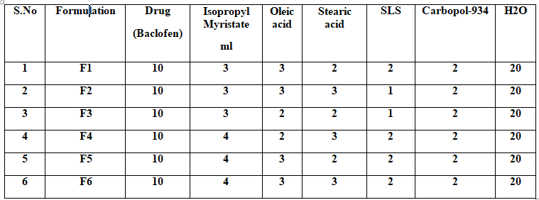

# Evaluation of Nano-emulsion: Thermodynamic stability:

The selected formulation is subjected to different thermodynamic stability tests.

# Heating Cooling Cycle:

The temperature of refrigerators between 4°-45° of six cycles with storage at each temperature of not less than 48hr is studied. Those formulations, which are stable at these temperatures, are subjected to centrifugation [31].

# Centrifugation:

The prepared formulations that are passed for centrifugation are centrifuged at 5000rpm for 30min by using centrifuge. The formulations that did not show any phase separated were taken to further tests [32].

# Measurement of pH:

pH of various nanoemulsions formulations are determining by using digital pH meter. 1ml of nano-emulsion is dissolved in 100ml of distilled water & pH was measured. The measurement of formulation is done in triplicate to avoid error [33]. **Percentage Drug Content:**

1ml of nano-emulsion is mixed with 10ml of suitable solvent. Aliquots of different concentration are prepared and by using suitable dilutions after filtering the stock solution; absorbance is measured by UV spectroscopy. Drug content is calculated by using the equation obtains from linear regression analysis of calibration curve [34].

# Determination of % Transparency & Drug Precipitation:

Formulations of different ratio are selected on the basis of ternary phase diagram. Transparency study is made to find out the maximum % transparency and drug precipitation between oil, surfactants mixture (surfactant and co-surfactant) and water containing 1% drug. (Nano-emulsion system is a clear transparent system when diluted with distilled water) [35].

# Viscosity Determination:

Viscosity of nano-emulsion is determined by using Brookfield viscometer. 20ml of nano-emulsion is filled in a 25ml beaker and the viscosity is measured using spindle number 6 at 10rpm [36].

# Dissolution studies of Nano-emulsions:

Dissolution studies for Baclofen Nano emulsions were performed in pH 6 phosphate buffer using USP dissolution test apparatus with a paddle stirrer. The paddles were allowed to rotate at a speed of 75rpm. The dissolution medium was maintained at a temperature of 37±0.5℃ and the samples were withdrawn for every 1hr. The volume of withdrawal samples was replaced by fresh dissolution medium in order to keep the volume of dissolution medium constant. Then the withdrawal samples were checked for absorbance at 272nm using UV-Visible spectrophotometer [37-38].

# Stability Study:

The optimized Alemtuzumab nanoemulsions F5 kept under accelerated conditions (temperature 40°C±2°C and RH 75±5%) according to ICH guidelines using stability chamber for the period of one month. The samples were withdrawn at 15days predetermined intervals and evaluated for their physical appearance, pH, Viscosity & *%* drug release study [39-40].

# Results and Discussion: Preformulation Study:

**Physical appearance:**

**Table.2:** Physical appearance of Baclofen

|  |  |  |
| --- | --- | --- |
| Test | Specification | Observation |
| Nature | Amorphous | Amorphous |
| Color | White | White |
| Physical  state | Solid powder | Solid powder |

# Melting point analysis:

Melting range of Baclofen was found to be 179- 180℃.

# Solubility Study:

**Table.3:** Solubility of drug

|  |  |
| --- | --- |
| **Oil & surfactants** | **Conc. of drug dissolved in (μg/ml)** |
| Water | 18.4 |
| Isopropyl Myristate | 756.24 |
| Oleic acid | 842.90 |
| Stearic acid | 956.78 |
| SLS | 564.98 |
| Carbopol-934 | 789.90 |

**Identification of drug by UV- spectroscopy: Table.4:** Calibration Curve of Baclofen



14

12

10

8

6

4

2

0

y = 2x

R² = 1

Concentrati

on (µg/ml)

1 2 3 4 5 6

|  |  |  |
| --- | --- | --- |
| **S.No** | **Conc. (μg/ml)** | **Abs.** |
| 1 | 2 | 0.136 |
| 2 | 4 | 0.248 |
| 3 | 6 | 0.356 |
| 4 | 8 | 0.428 |
| 5 | 10 | 0.596 |
| 6 | 12 | 0.688 |



**Fig.1:** Calibration Curve of Baclofen

# Identification of drug by FTIR:

Identification of Baclofen was carried out using Fourier Transform Infra-red Spectroscopy (FTIR), Infra-red spectra of Baclofen were determined using FTIR (S PECTRUM Rx1: shimadzu) using potassium bromide method. The baseline correction was done by scanning potassium bromide pellets over a range of 400-4000cm-1. Then the pellets containing potassium bromide and Baclofen mixture and excipients were scanned and data were interpreted.

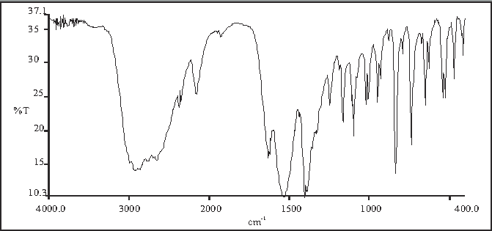

**Fig.2:** FTIR Study of Baclofen

**Table.5**: FT-IR spectrum interpretation of Baclofen

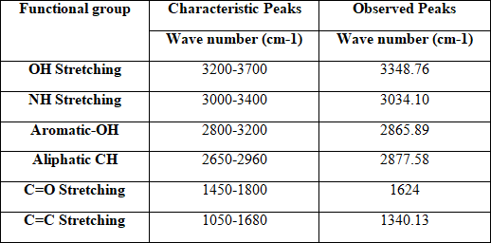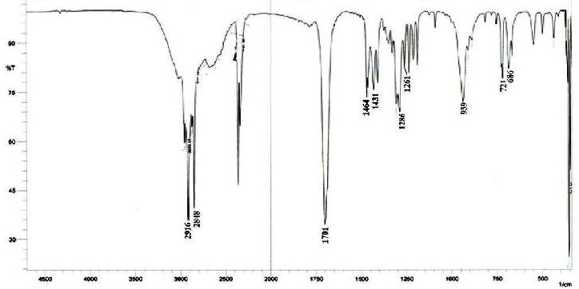

**Fig.3:** FTIR Study of Baclofen & Isopropyl Myristate

**Table.6:** FT-IR spectrum interpretation of Baclofen & Isopropyl Myristate

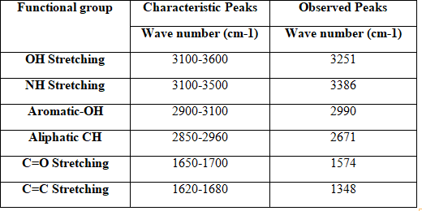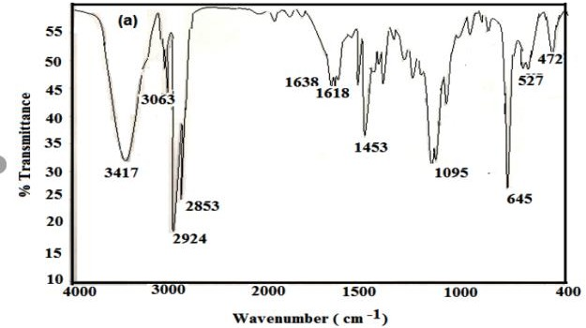

**Fig.4:** FTIR Study of Baclofen & Oleic acid

**Table.7:** FT-IR spectrum interpretation of Baclofen & Oleic acid

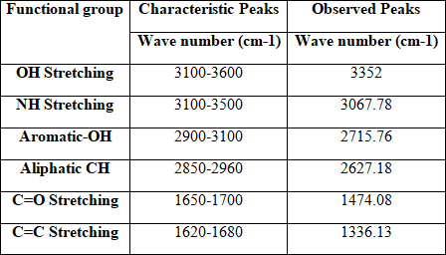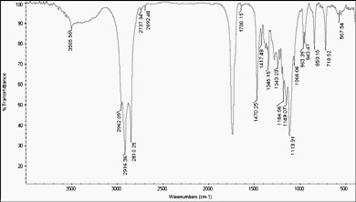

**Fig.5:** FTIR Study of Baclofen & Stearic acid

**Table.8:** FT-IR spectrum interpretation of Baclofen & Stearic acid

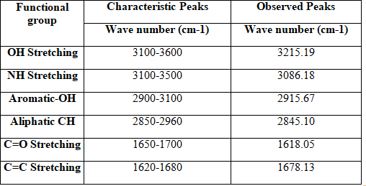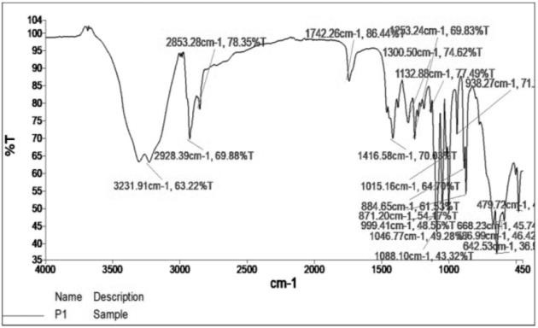

**Fig.6:** FTIR Study of Baclofen, Carbopol-934 & SLS

**Table.9:** FT-IR spectrum interpretation of Baclofen, Carbopol-934 & SLS

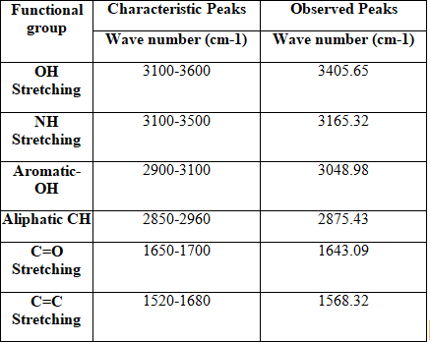

***Inference:*** There is no disappearance of characteristic peaks of drug in FT-IR Spectra. Hence there is no interaction.

# Evaluation of Nano-emulsion: Thermodynamic stability:

**Table.10:** Thermodynamic Stability Study

|  |  |  |
| --- | --- | --- |
| **Formulation Code** | **Heating**  **Cooling Cycle** | **Centrifugation** |
| **F1** | Stable | No phase  separation |
| **F2** | Stable | No phase  separation |
| **F3** | Stable | No phase  separation |
| **F4** | Stable | No phase  separation |
| **F5** | Stable | No phase  separation |
| **F6** | Stable | No phase  separation |

# pH, Viscosity and % Drug content:

**Table.11:** Characterization of Nano-emulsion

|  |  |  |  |
| --- | --- | --- | --- |
| **Formula Code** | **pH** | **Viscosity (cp)** | **Drug Content (%)** |
| F1 | 5.6 | 5229 | 97.98 |
| F2 | 5.7 | 4332 | 96.30 |
| F3 | 5.3 | 4320 | 98.42 |
| F4 | 5.4 | 4850 | 96.16 |
| F5 | 6.4 | 5920 | 98.58 |
| F6 | 5.8 | 4530 | 94.62 |

pH of prepared nano-emulsion formulations was found in the range of 5.6-5.8 and tabulated. The percentage drug content of prepared nano-emulsion formulation was found to be 94.62 to 98.58%. The mean average viscosity was found to be 4000 to 6000cp; F5 batch shows highest viscosity in table.11.

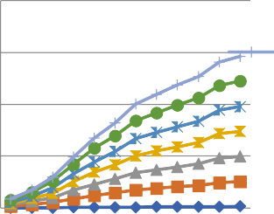

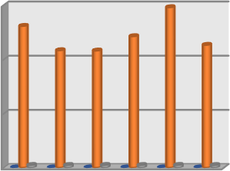

5920

6000

5229

43324320

4850

4530pH

4000

Viscosity (cp)

2000

5.6 5.7 5.3 5.4 6.4 5.8

0

Drug content

(%)

F1 F2 F3 F4 F5 F6

**Fig.8:** A Diagrammatically Representation of pH, Viscosity (cp) & Drug content (%)

**Axis Title**



800

600

400

200

Cumulati

ve % Durg Release F6

0

1 3 5 7 9 11

**Dissolution Studies of Nano-emulsions: Table.12:** In-vitro drug release of Nano-emulsion

**Fig.9:** A Diagrammatically Representation of % drug release study

# Stability Studies:

**Table.13:** Stability data for Optimized Formulation F5

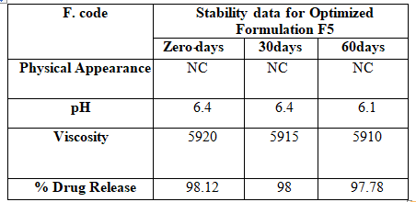

*NC-No change

|  |  |  |  |  |  |  |
| --- | --- | --- | --- | --- | --- | --- |
| **Tim**  **e in hrs** | **F1** | **F2** | **F3** | **F4** | **F5** | **F6** |
| 0.5 | 6.66 | 5.96 | 4.54 | 3.98 | 8.22 | 5.79 |
| 1 | 12.4  7 | 12.8  6 | 10.9  1 | 9.59 | 14.1  3 | 7.97 |
| 1.5 | 20.8  5 | 16.9  5 | 17.6  9 | 20.4  5 | 25.4  9 | 16.0  9 |
| 2 | 34.0  8 | 34.2  2 | 32.3  4 | 28.6  8 | 38.2  2 | 27.1  6 |
| 2.5 | 44.4  3 | 45.1  3 | 45.6  2 | 40.0  4 | 52.7  6 | 40.3  6 |
| 3 | 56.3  2 | 54.0  4 | 53.8  2 | 51.5  8 | 59.5  8 | 50.6 |
| 3.5 | 66.3  2 | 67.5  3 | 63.1  2 | 67.2  0 | 69.1  0 | 64.2  3 |
| 4 | 72.2  1 | 71.2  9 | 73.5  6 | 71.2  1 | 75.2  5 | 71.1  5 |
| 4.5 | 77.2  6 | 76.2  7 | 78.3  8 | 76.3  5 | 85.2  5 | 76.4  5 |
| 5 | 82.4  2 | 82.7  8 | 83.2  5 | 82.1  0 | 90.2  4 | 81.6  5 |
| 5.5 | 92.2  6 | 95.5  2 | 94.2  8 | 90.7  8 | 94.7  0 | 90 |
| 6 | 96.2  8 | 96.2  8 | 96.7  5 | 96.1  2 | 98.1  2 | 95.2  5 |

# Inference:

**Dissolution profile of Nano Emulsions:**

In-vitro drug release of all the prepared Nano emulsions were carried out in phosphate buffer of pH 6.0. The percent drug release was calculated for all the prepared formulations and the values ranged from 3.98% to 98.12%. Among all F1-F6 gave maximum drug release of 96.28% to 95.25in 6 hours, hence this was selected as the optimized formulation and further analysis was done. The drug release studies showed that among all the prepared formulations F5 has shown better results. So this formulation was taken for further instrumental analysis.

The optimized nanoemulsions formulations (F5) subjected to stability studies and shown in table.13, No significant changes in appearance, Color but small changes in drug release, pH & Viscosity were observed after the end of 98.12 to 97.78, 6.4 to 6.1 and 5920 to 5910 for 60 days and found identical in stability studies.

# Conclusion:

In conclusion, the formulation and assessment of Baclofen nano-emulsion offer a promising therapeutic avenue for treating multiple sclerosis. This study aimed to develop and evaluate a nano- emulsion of Baclofen, which was achieved using the high-shear homogenization method. Various parameters such as Physical Appearance, pH, viscosity, % drug content, centrifugation, UV spectroscopy, and Fourier transform spectroscopy were assessed to characterize the formulations. Additionally, in vitro drug release studies and stability assessments were conducted. Among the formulations, F5 demonstrated a viscosity of 5920cp and exhibited the most favorable drug release profile, with formulation F5 achieving a release of 98.12% within 6 hours. Furthermore, stability studies indicated minimal changes in the formulations after 2 months at 40°C±2°C and 75±5% relative humidity. These findings suggest that nano-emulsions could serve as an effective vehicle for the oral delivery of Baclofen in the treatment of multiple sclerosis. By leveraging the benefits of nanotechnology, this innovative

formulation holds promise for enhancing drug delivery, improving therapeutic efficacy, and reducing adverse effects compared to conventional treatment modalities.

# References:

1. Mu H, Holm R, Mullertz A. Lipid-based formulations for oral administration of poorly water-soluble drugs. Int J Pharm. 2013;453 1(1):215-224.
2. Qian C, McClements DJ. Formation of nanoemulsions stabilized by model food- grade emulsifiers using high-pressure homogenization: Factors affecting particle size. Food Hydrocoll. 2011;25 (5):1000-

1008.

1. Chatterjee B, Hamed Almurisi S, Ahmed Mahdi Dukhan A, Mandal UK, Sengupta

P. Controversies with self-emulsifying drug delivery system from pharmacokinetic point of view. Drug Deliv. 2016;23 (9):3639-3652.

1. Dokania S, Joshi AK. Self-micro- emulsifying drug delivery system (SMEDDS) – challenges and road ahead. Drug Deliv. 2015;22 (6):675-690.
2. Lindenberg M, Kopp S, Dressman JB. Classification of orally administered drugs on the World Health Organization model list of essential medicines according to the biopharmaceutics classification system. Eur J Pharm Biopharm. 2004;58 (2):265-

278.

1. Rehman FU, Shah KU, Shah SU, Khan IU, Khan GM, Khan A. From nanoemulsions to self-nanoemulsions, with recent advances in self- nanoemulsifying drug delivery systems (SNEDDS). Expert Opin Drug Deliv. 2016;5247 (August):1-16.
2. Kalepu S, Manthina M, Padavala V. Oral lipid-based drug delivery systems – an overview. Acta Pharm Sin B. 2013;3 (6):361-372.
3. Feeney OM, Crum MF, McEvoy CL, et al. 50 years of oral lipid-based formulations: Provenance, progress and future perspectives. Adv Drug Deliv Rev. 2016;101:167-194.
4. Mohsin K, Alamri R, Ahmad A, Raish M, Alanazi FK, Hussain MD. Development of self-nanoemulsifying drug delivery systems for the enhancement of solubility and oral bioavailability of fenofibrate, A poorly water-soluble drug. Int J Nanomedicine. 2016;11:2829-2838.
5. Nidhi K, Indrajeet S, Khushboo M, Gauri K, Sen DJ. Hydrotropy: A promising tool for solubility enhancement: A review. Int J Drug Dev Res. 2011;3 (2):26-33.
6. Gursoy RN, Benita S. Self-emulsifying drug delivery systems (SEDDS) for improved oral delivery of lipophilic drugs. Biomed Pharmacother. 2004;58 (3):173-

182.

1. Donsi F. Applications of nanoemulsions in foods. In: Jafari SM, McClements DJ, eds. Nanoemulsions: Formulation, Applications, and Characterization. Academic Press; 2018:349-376.
2. Madene A, Jacquot M, Scher J, Desobry

S. Flavour encapsulation and controlled release - A review. Int J Food Sci Technol. 2006;41:1-21.

1. Gibaud S, Attivi D. Microemulsions for oral administration and their therapeutic applications. Expert Opin Drug Deliv. 2012;9 (8):937-951.
2. Pouton CW. Lipid formulations for oral administration of drugs: Non-emulsifying, self-emulsifying and “self-micro- emulsifying” drug delivery systems. Eur J Pharm Sci. 2000;11 (SUPPL. 2):93-98.
3. Pouton CW, Porter CJH. Formulation of lipid-based delivery systems for oral administration: Materials, methods and strategies. Adv Drug Deliv Rev. 2008;60 (6):625-637.
4. Pouton CW. Formulation of poorly water- soluble drugs for oral administration: Physicochemical and physiological issues and the lipid formulation classification system. Eur J Pharm Sci. 2006;29 (3-4 SPEC. ISS.):278-287.
5. Agrawal S, Giri TK, Tripathi DK, Ajazuddin, Alexander A. A review on novel therapeutic strategies for the enhancement of solubility for hydrophobic drugs through lipid and surfactant based self micro emulsifying drug delivery system: A novel approach. Am J Drug Discov Dev. 2012;2(4):143-183.
6. Goncalves A, Nikmaram N, Roohinejad S, et al. Production, properties, and applications of solid self-emulsifying delivery systems (S-SEDS) in the food and pharmaceutical industries. Colloids Surfaces A Physicochem Eng Asp. 2018;538:108-126.
7. Qadir A, Faiyazuddin MD, Talib Hussain MD, Alshammari TM, Shakeel F. Critical steps and energetics involved in a successful development of a stable nanoemulsion. J Mol Liq. 2016;214:7-18.
8. Komaiko JS, Mcclements DJ. Formation of food-grade nanoemulsions using low- energy preparation methods: A review of available methods. Compr Rev Food Sci Food Saf. 2016;15(2):331-352.
9. Singh Y, Gopal J, Raval K, et al. Nano- emulsion: Concepts, development and applications in drug delivery. J Control Release. 2017;252:28-49.
10. Khan AW, Kotta S, Ansari SH, Sharma RK, Ali J. Potentials and challenges in self-nanoemulsifying drug delivery systems. Expert Opin Drug Deliv. 2012;9 (10):1305-1317.
11. Gurram A, Deshpande P, Kar P, Nayak U, Udupa N, Reddy M. Role of components in the formation of self-microemulsifying drug delivery systems. Indian J Pharm Sci. 2015;77 (3):249-257.
12. Mahdi Jafari S, He Y, Bhandari B. Nano- emulsion production by sonication and microfluidization - A comparison. Int J Food Prop. 2006;9 (3):475-485.
13. Graves S, Meleson K, Wilking J, Lin MY, Mason TG. Structure of concentrated nanoemulsions. J Chem Phys. 2005;122 (13):1-6.
14. Gharibzahedi SMT, Hernandez-Ortega C, Welti-Chanes J, et al. High pressure processing of food-grade emulsion systems: Antimicrobial activity, and effect on the physicochemical properties. Food Hydrocoll. 2019;87:307-320.
15. Rai VK, Mishra N, Yadav KS, Yadav NP. Nanoemulsion as pharmaceutical carrier for dermal and transdermal drug delivery: Formulation development, stability issues, basic considerations and applications. J Control Release. 2018;270:203-225.
16. Floury J, Desrumaux A, Lardieres J. Effect of high-pressure homogenization on droplet size distributions and rheological properties of model oil-in-water emulsions. Innov Food Sci Emerg Technol. 2000;1 (2):127-134.
17. Schultz S, Wagner G, Urban K, Ulrich J. High-pressure homogenization as a process for emulsion formation. Chem Eng Technol. 2004;27 (4):361-368.
18. Azeem A, Rizwan M, Ahmad FJ, et al. Nanoemulsion components screening and selection: a technical note. AAPS PharmSciTech. 2009;10 (1):69-76.
19. Jafari SM, He Y, Bhandari B. Production of sub-micron emulsions by ultrasound and microfluidization techniques. J Food Eng. 2007;82 (4):478-488.
20. Hsieh CW, Li PH, Lu IC, Wang TH. Preparing glabridin-in-water nanoemulsions by high pressure homogenization with response surface methodology. J Oleo Sci. 2012;61 (9):483-

489.

1. Whitesides GM. The origins and the future of microfluidics. Nature. 2006;442 (7101):368-373.
2. Lovelyn C, Attama AA. Current state of nanoemulsions in drug delivery. J Biomater Nanobiotechnol. 2011;02

(05):626-639.

1. Maa YF, Hsu CC. Performance of sonication and microfluidization for liquid-liquid emulsification. Pharm Dev Technol. 1999;4 (2):233-240.
2. Villalobos-Castillejos F, Granillo- Guerrero VG, Leyva-Daniel DE, et al. Fabrication of nanoemulsions by microfluidization. In: Jafari SM, McClements DJ, eds. Nanoemulsions: Formulation, Applications, and Characterization. Academic Press; 2018:207-232.
3. Perrier-Cornet JM, Marie P, Gervais P. Comparison of emulsification efficiency of protein-stabilized oil-in-water emulsions using jet, high pressure and colloid mill homogenization. J Food Eng. 2005;66(2):211-217.
4. Wooster TJ, Golding M, Sanguansri P. Impact of oil type on nano-emulsion formation and ostwald ripening stability. Langmuir. 2008;24(22):12758-12765.
5. Pinnamaneni S, Das NG, Das SK. Comparison of oil-in-water emulsions manufactured by microfluidization and homogenization. Pharmazie. 2003;58(8):554-558.
6. Prakash1*, FORMULATION AND EVALUATION OF HERBAL ANTI-

ACNE GEL Journal of Pharmaceutical Negative Results ¦ Volume 13 ¦ Special Issue 6 2022.

1. *Satya Prakash1, To Study the Antiulcer Activity of Hydro Alcoholic Extract of Euphorbia Thymifolia on Absolute Ethanol Induced Ulcer in Rats. European Journal of Molecular & Clinical Medicine ISSN 2515-8260 Volume 10, Issue 1

2023.

1. Satya Prakash, et. al., 2022 Guidelines for Approval of Clinical Trials and Study Reports of SARS Covid-19 Vaccines. IJPRA, ISSN: 2456-4494. 64. et al., S. P. (2019). FORMULATION AND EVALUATION OF FLOATING TABLET OF ZOLMITRIPTAN

TABLET. International Journal of Advanced Science and Technology, 28(17), 82.

1. Satya Prakash, et. al., 2023 Gold Nanoparticles for Targeted and Selective Delivery of Cancer Chemotherapeutics: A

Review of the Literature (Eur. Chem. Bull. 2023, 12 (Special Issue 1), 2896-2901).

1. Formulation and Evaluation of Floating Tablet Zolmitriptan. (International Journal of Advanced Science and Technology Vol. 28 No. 17 (2019): Vol 28 No 17

(2019))