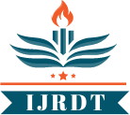

**International Journal of Research Development and Technology**

**Vol.2, Issue.2, Year 2024 ISSN: 2584-0290**

**Web:** [**www.ijrdt.com**](http://www.ijrdt.com/)

Studies on Hepatoprotective Properties of leaf Extracts of Azadirachta indica in 2-nitropropane Induced Hepatotoxicity

1Atar Singh (Research Scholar), 2Dr. Shamim Ahmad, 3Dr. Nasiruddin Ahmad Farooqui

Translam Institute of Pharmaceutical Education & Research Meerut U.P Email Id: [atar25635@gmail.com](mailto:atar25635@gmail.com)

**\*\*\*\*\*\*\*\*\*\*\*\*\*\*\*\*\*\*\*\*\*\*\*\*\*\*\*\*\*\*\*\*\*\*\*\*\*\*\*\*\*\*\*\*\*\*\*\*\*\*\*\*\*\*\*\*\*\*\*\*\*\*\*\*\*\*\*\*\*\*\*\*\*\*\*\*\*\*\*\*\*\***

***Abstract:***

*These days, there are very few hepatoprotective medications accessible to treat liver diseases. Jaundice has historically been treated using herbal remedies like Phyllanthus niruri. To determine which phytoconstituents are responsible for the hepatoprotective action, studies have been carried out on a variety of herbal plants. The goals of this study are to examine the effectiveness of ethanolic extract of Azadirachta indica and assess its hepatoprotective impact in rats that have been induced hepatotoxicity by 2-nitropropane.*

***Keywords:*** *Hepatoprotective impact, Azadirachta indica, Jaundice*

**\*\*\*\*\*\*\*\*\*\*\*\*\*\*\*\*\*\*\*\*\*\*\*\*\*\*\*\*\*\*\*\*\*\*\*\*\*\*\*\*\*\*\*\*\*\*\*\*\*\*\*\*\*\*\*\*\*\*\*\*\*\*\*\*\*\*\*\*\*\*\*\*\*\*\*\*\*\*\*\*\*\***

## Introduction:

The liver, being the central organ for metabolism and detoxification, is particularly vulnerable to damage from hepatotoxic agents. 2-nitropropane, a potent hepatotoxin, induces oxidative stress and disrupts cellular integrity, mimicking conditions observed in human liver diseases. Given neem's rich phytochemical composition, which includes flavonoids, terpenoids, and phenolic compounds, there is growing interest in its ability to mitigate hepatotoxicity and promote liver regeneration [1, 2].

Studies exploring the hepatoprotective properties of Azadirachta indica leaf extracts have shown promising results in ameliorating 2-nitropropane- induced liver damage by attenuating oxidative stress, enhancing antioxidant 1aemoglo, and modulating inflammatory responses. These findings underscore the potential of neem as a natural remedy for liver disorders, prompting further investigation into its mechanisms of action and clinical applications [3, 4, 5, 6].

## Materials and Method

The research was carried out on thirty mature male Wistar albino rats, weighing between 150 and 200 grams, which were obtained from the Small Animal

Breeding Station at the Mannuthy College of Veterinary and Animal Sciences. The creatures were kept in suitable enclosures within a well- ventilated space that had a 12-hour light-dark cycle. The animals were given a conventional food and unlimited access to water. They were cared for in the lab using the same diet and supervision techniques. The experiment was authorized to start after a seven-day acclimatization period. Ten days were dedicated to the conduct of the experiment.

## Plant Materials:

The leaves of the plants Azadirachta indica was collected from the Pradeep nursery Meerut (up)

## 4.2 Preparation of alcoholic extract of Azadirachta indica:

We used an electrical pulverizer to coarsely crush the leaves of Azadirachta indica after they were air- dried in the shade. Utilizing a Soxhlet device with 95% ethanol, the powder was extracted. Following a decrease in pressure and temperature to 55°C, the ethanolic extracts were concentrated in a rotating vacuum evaporator and refrigerated until the solvent had completely evaporated [7].

## Experimental Animals:

**Gathering and Identifying Plant Material**:

In April, fresh leaves of Azadirachta indica were gathered from the plains in Meerut, Uttar Pradesh, India. The plant material was verified at Chaudhary Charan Singh University’s Botany Department in Meerut.

## Making plant extract:

The leaves were washed with water and shade dried in open air, then pulverized to dry powder using electric grinder. About 500 gm of the powder was extracted with 4 litres of ethyl alcohol (70%) by cold maceration for 7 days. The extract was filtered, evaporated using vacuum rotary evaporator (Buchi) and heated on water bath at 45 ± 5°C to obtain *A. indica* extract (12.17% yield w/w). Carboxy methyl cellulose (0.5%) was used as solvent to prepare different doses of *A.* indica extract.

## Wistar albino rats:

The animal house of TIPER, Meerut, Uttar Pradesh, provided the wistar albino rats of both sexes (weighing 150–200 grams) that were employed in this exploration. Standard temperature (25±2°C) and light/dark cycle (12:12 h) were maintained in the animals’ housing. Standard pellet food and unlimited water were provided to the rats. The institutional animal ethics committee of TIPER College in Meerut gave its approval before any experimental research could begin.

## An initial examination of photochemistry:

Standard protocols were used to carry out a preliminary phytochemical screening of the A. indica extract.10–13] The presence of flavonoids was confirmed by the golden yellow precipitate that formed when 1 milliliter of the extract was combined with diluted NaOH. Ten 2aemoglobin of warm distilled water were combined with one 2aemoglobi of the extract to test for saponins; the creation of persistent glycosides. When 1 ml of extract and 1 ml of 10% lead acetate solution are combined, the presence of tannins is confirmed by the formation of a white precipitate [8, 9, 10].

## Acute dosage toxicity investigation:

The investigation on acute toxicity was carried out in accordance with OECD standards 425. A. indica extract was first administered orally to one female rat at a dose of 2000 mg/ kg. Following continual observation throughout the first four hours of the rat’s existence, it was evaluated for signs of toxicity and mortality every few hours. Within 24 hours, the identical dosage was administered to four additional female rats [11, 12, 13, 14, 15].

## Experimental design:

**Analyzing extracts from A. indica for hepatoprotective effect:**

We randomly split thirty adult male Wistar albino rats into five groups, each with six animals. 10 days passed during the course of the experiment.

**Group I:** Vehicle distilled water was given orally to the healthy control group for ten days at a rate of 5ml/kg/day.

**Group II:** For 10 days, there were given 2ml/kg of 2-nitropropane orally in distilled water. **Group III:** For ten days, the rats received an oral dose of 100mg/kg of silymarine in distilled water. **Group IV:** Azadirachta indica leaf ethanolic extract was given 200mg/kg orally with 0.5% cmc.

**Group V:** Azadirachta indica leaf ethanolic extract was given 400mg/kg orally with 0.5% cmc.

## Drawing blood and separating serum:

Under light ether anesthesia, blood was drawn from the retro orbital plexus using 2aemoglobin capillary tubes and placed into sterile centrifuge tubes without the use of an anticoagulant. After being refrigerated for 30 minutes, it was removed and allowed to come to room temperature for an additional 30 minutes. After centrifuging it for 10 minutes at 3200 rpm, the clear serum was 2aemogl out [16, 17, 18, 19].

## Liver

The liver was taken out of the animals and cleaned under running water to get rid of the blood clots before the animals were put to sleep and examined. In order to undertake histological examinations, the liver was kept in 10% formalin [20].

## Serum Parameter Exact Mapping:

Analytical kits from Agappe Diagnostics Pvt. Ltd., Ernakulum, Kerala, India, were used to estimate the serum parameters colorimetrically in a semiautomatic blood analyzer (Microloan 200, MERCK).

## Alanine amino transferase (ALT) Inhibition:

Reitman and Frankel (1957) described the UV Kinetic test.

## Principle

With the creation of pyruvate and L-glutamate, serum ALT catalyzes the transfer of amino groups from L-alanine to L-oxoglutarate. When NADH and the pyruvate that is so created combine, L- lactate is the result. An indicator keeps track of the speed of this response.

**Estimation of serum total protein** Biuret method (Gornall el al., 1949) **Principle**

In an alkaline solution containing cupric ions, protein in plasma or serum samples forms a blue- colored complex. Protein concentration is directly correlated with the blue color’s intensity, which is measured at 540 nm.

## Procedure

Sample, standard and blank were prepared as follows

|  |  |  |  |
| --- | --- | --- | --- |
|  | **Sample** | **Standard** | **Blank** |
| Serum | 20 µl | 20µl |  |
| Standard |  | 20µl |  |
| Reagent | 1000µl | 1000µl | 1000µl |

Mixed the solutions and incubated for ten minutes at 37°C. Read the absorbance of standard and sample against blank at 546 nm

Serum total protein (𝑔/𝑑1)

Absorbance of sample

= × 6

Absorbance of standard

## Estimation of serum albumin

(Bromocresol Green Dye Method, Doumas, 1971)

## Principle

An acidic blue-green complex, whose pH is proportional to the albumin content, is created when serum or plasma albumin reacts with the dye bromocresol-green. Using photometry, this is measured.

Sample, standard and blank were prepared as follows

|  |  |  |  |
| --- | --- | --- | --- |
|  | Blank | Standard | Sample |
| Reagent | 1000µl | 1000µl | 1000µl |
| Sample |  | 100µl |  |
| Standard |  |  | 10µl |

Mixed the solutions and incubated for one minute at 37ċ. Read the absorbance of standard and sample against blank at 630 nm.

Serum albumin (𝑔/𝑑1)

Absorbance of sample

= Absorbance of standard × 3

# HAEMATOLOGICAL PARAMETERS:

## Concentration of haemoglobin:

The acid 3aemoglobin technique was used to estimate 3aemoglobin levels (Benjamin, 1985). **Leukocyte total count**:

Thomas fluid was used in a routine dilution procedure to count leukocytes. Leukocyte counts were performed in the leukocyte zone within the hemocytometer using a low power microscope (Benjamin, 1985).

## Variations in leukocyte counts:

Using the slide technique, blood smears were made from recently collected blood without the use of an anticoagulant. Following Wrights stain staining, counting was carried out in an oil-immersed environment (Benjamin, 1985).

# GROSS AND HISTOPATHOLOGICAL EXAMINATION OF LIVER:

By obtaining representative liver samples from the dissected animals on the tenth day, the gross and histological lesions in the liver were examined [21, 22].

## Visible lesions:

Comparisons were made between the treated and control groups' gross liver lesions. **Examination of the histology**:

In order to determine the Hepatotoxicity, the animals were euthanized on the tenth day, and the liver was removed for histological analysis. Randomly selected liver pieces, measuring three millimetres in thickness, were preserved in 10% formalin after being taken from the experimental and control groups of rats. After that, they underwent the processing and paraffin embedding methods outlined by Sheehan and Hrapchak (1980). According to Bancroft and Cook's (1984) method, the sections were stained with eosin and haematoxylin. The sections were thoroughly scrutinized.

## Analyzing data statistically:

Utilizing the analysis of variance (ANOVA) technique for group comparison and paired testing, results are analyzed (Snedecor and Cochran, 1985). As mean standard error, the results are presented.

# RESULTS:

## Physiological Parameters:

**Weight of body** between days 0 and 10 of the experiment, the rats' individual and mean body weights (groups I, II, III, IV, and V) were measured and are shown in Table 2. Group I to V had body weights of 178.833±3.96, 187.167±3.78,

183.05±3.81, 184.833±3.62, and 179.333±3.72 gm

on day 0. Following the tenth day of treatment, the average body weights were 185.333±3.57, 182.00±4.63, 186.05±3.83, 180.00±4.83, and

185.833±3.51gm, in that order. Animals in group II displayed a decrease in body weight, but group IV

animals showed little change. Weight increased gradually in groups I, III, and V.

## Serum data:

**Alanine Amino Transferase (ALT):**

The outcomes are displayed in Tables 3, 4, and Fig.3. Prior to therapy, groups I to V had serum ALT levels of 54.05±3.40, 51.833±2.46,

53.05±4.08, 58.66±3.91, and 58.166±2.70 U/L, in

that order. With a value increase from 51.833±2.46 to 148.05±4.38 U/L, the group receiving 2- nitropropane treatment had the greatest level of ALT. ALT levels in normal animals were 57.166±3.29 after ten days of the trial; in animals treated with extract, the values increased to 97.05±2.83 and 63.166±3.29 U/L at 200 mg/kg and

400 mg/kg body weightfor Azadirachta indica, respectively. In the silymarin treated group the value was near to those of normal animals (78.66±3.55 U/L). Group I and V, or groups III and IV animals did not differ significantly (p<0.05).

## Aspartate amino transferase (AST):

The results obtained are presented in the Tables 5, 6 and Figure 4. The AST levels before treatment were 166.333±3.55, 161.667±3.15, 158.05±3.85,

142.05±2.56 and 143.00±4.35 U/L respectively in groups I, II, III, IV and V animals. After treatment, the' value was highest in the 2-nitropropane treated animals. Here the value increased from 161.667±3.15 to 283.167±3.39 U/L. After

treatment the values were 157.05±4.78, 181.167±2.62, 188.05±3.89, and 172.05±3.18 U/L

respectively in groups I, III, IV and V animals. Group I and V and Group III and IV animals did not differ significantly @<0.05).

## Total protein in serum:

Tables 7 and 8 as well as Figure 5 show the serum total protein values obtained both before and after treatment. For groups 1 to V, the averages on day 0 were 6.68±0.13, 6.71±0.15, 6.66±0.16, 6.75±0.15,

and 6.81±0.12 g/dl, respectively. Following administration of 200mg/kg and 400mg/kg of Azadirachta indica ethanolic extract, the level shifted to 6.68±0.13 and 6.68±0.13 g/dl, respectively. The animals in group I had nearly the same value both before and after the treatment. Group II animals' total protein content dropped from 6.71±0.15 to 6.55±0.19 g/dl. Groups I and V had values of 6.7±0.10 and 6.71±0.12 g/dl, in that order.

## Albumin in serum:

Tables 9, 10, and Figure 6 display the data collected both before and after the treatment. Day 0 mean serum albumin levels for Groups I to V were 2.04±0.08, 2.45±0.08, 2.41±0.09, 2.45±0.08, and

2.48±0.08 g/dl, in that order. The results in Groups IV and V of the animals increased to 2.71±0.12 and

2.73±0.09 g/dl, respectively, after treatment with Azadirachta indica ethanol extract at 200 mg/kg and 400mg/kg dosages. Groups I and III each had mean serum albumin levels of 2.51±0.07 and

2.76±0.11 g/dl, respectively. The group that received 2-nitropropane showed a decrease in value. The number was lowered to 2.25±0.13 g/dl in this instance. The groups III and V did not significantly differ from one another.

## Total bilirubin in the blood:

Figure 7, tables 11, and 12 display the results obtained both before and after the treatment. Prior to the start of the treatment, the serum total bilirubin readings for groups I to V were 0.35±0.05, 0.83±0.09, 0.35±0.04, 0.31±0.04, and 0.35±0.04

mg/dl. The animals in group II exhibited a high level of bilirubin (0.96±0.06 mg/dl). For groups I, III, IV, and V, respectively, the levels of total bilirubin were 0.35±0.05, 0.35±0.04, 0.31±0.04, and 0.35±0.04 mg/dl. There was little difference (P<0.05) between groups I, III, IV, and V.

## Aspects Relating to Hematology: Concentration of haemoglobin:

In Tables 13 and 14, the average values are displayed. Prior to receiving therapy, the haemoglobin concentrations in animals belonging to groups I, II, III, IV, and V were 10.12±0.11, 10.15±0.15, 10.14±0.12, 9.99±0.13, and

10.19±0.16 g/dl. The concentrations for groups I to

V were 10.54±0.13, 10.12±0.15, 10.02±0.15,

09.95±0.16, and 10.06±0.19 g/dl, respectively, following treatment. On both occasions, the readings were within the typical range for every group.

## 5.4.2 Leukocyte count total (TLC):

Tables 13 and 14 show the values both before and after the treatment. Both before and after the treatment, every value was within the usual range. For groups I to V, the values on day 0 of the trial were 11.44±0.27, 11.41±0.37, 11.58±0.25,

11.72±0.26, and 11.49±0.29×103/µl, respectively. Following the intervention, the values for groups I to V were 11.43±0.33, 11.52±0.42, 11.65±0.27,

11.70±0.31, and 10.98±0.35×103/µl, in that order.

## Leukocyte count differential (DLC) Lymphocytes:

The results obtained are presented in the tables 13 and 14. Before the treatment the values were 79.65±0.28, 78.98±0.25, 78.90±0.24, 79.56±0.26

and 79.51±0.27percent respectively for the groups I to V. After the treatment with the plant extracts the values were 77.92±0.19 and 78.53±0.13 per cent

respectively for groups I11 and IV. In the group II animals the mean value was 78.48±0.13 per cent. For the groups I and V the mean values noticed were 77.92±0.19 and 78.53±0.13 per cent.

## Eosinophils:

The results obtained are presented in the tables 13 and 14. Before the treatment the values were 0.52±0.03, 0.65±0.02, 0.59±0.06, 0.62±0.05 and

0.61±0.04 percent respectively for the groups I to

V. After treatment with the plant extracts the values were recorded as 0.64±0.07 and 0.65±0.03 per cent respectively for groups III and IV. In the group II animals the mean value was 0.66±0.04 percent. For group I and V animals the values noticed were 0.64±0.07 and 0.65±0.03 percent. No significant change was noticed in values before and after the treatment.

## Neutrophils:

The data is presented in the tables 13 and 14. On the day 0 of the experiment the values were 18.46±0.16, 17.90±0.18, 18.57±0.15, 18.55±0.11

and 17.93±0.19 per cent respectively for the groups I to V. After the experiment on the 10"' day the values obtained were 18.83±0.13, 17.91±0.15,

18.38±0.14, 18.47±0.16 and 18.79±0.14 per cent

respectively for the groups I to V.

## Monocytes:

The data is presented in the tables 13 and 14. Before treatment the values were 0.12±0.03, 0.14±0.04, 0.12±0.03, 0.15±0.03 and 0.13±0.04

and after the treatment the values were 0.13±0.06, 0.15±0.05, 0.12±0.03, 0.16±0.05 and 0.13±0.06 per

cent respectively for the groups I to V. No significant change was noticed in values before and after the treatment.

## Basophils:

Prior to and following the treatment, no basophils were seen.

## Analysis of the gross and Histopathological liver:

With the exception of the group that took 2- nitropropane, the livers of all groups appeared and were coloured normally. A normal liver is depicted in (Fig. 8). In addition to numerous petechiae, the 2-nitropropane -treated group showed observable areas of greyish white necrosis (Fig 9). After undergoing histological examination, the liver from the normal control group had normal hepatic architecture (Fig.10). Large sections of the group receiving 2-nitropropane had centrilobular coagulation necrosis. In addition to having deeply eosinophilic cytoplasm with synoptic nuclei, the hepatocytes showed a significant infiltration of

inflammatory cells (Fig.11). 200 mg/kg of Azadirachta indica was given to animals.

**Table.1** Results of Phytochemical screening of ethanolic extract of Azadirachta indica

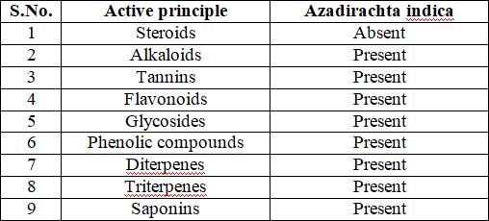

**Table.2. Effect of treatment on body weights (g) of rats (n=6)**

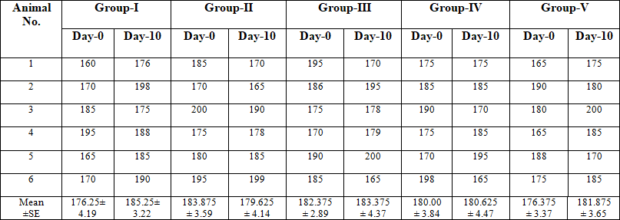

**Table.3. Serum ALT level (U/L) before treatment in rats (n=6) on day 0**

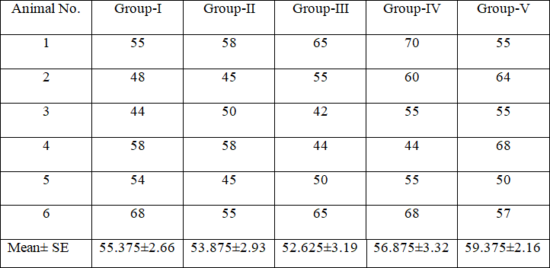

**Table.4. Effect of Azadirachta indica on ALT (U/L) in 2-nitropropane induced hepatotoxicity in rats (n=6) on day 10**

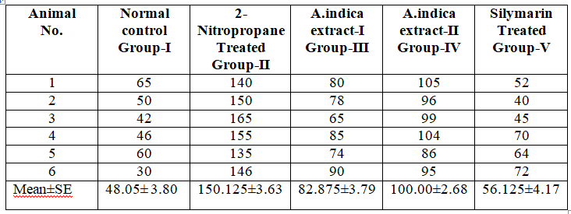

**Table.5 Serum AST level (U/L) before treatment in rats (n=6) on day 0**

**TabIe.6 Effect of Azadirachta indica on AST (U/L) in 2- nitropropane induced Hepatotoxicity in rats (n=6) on day 10**

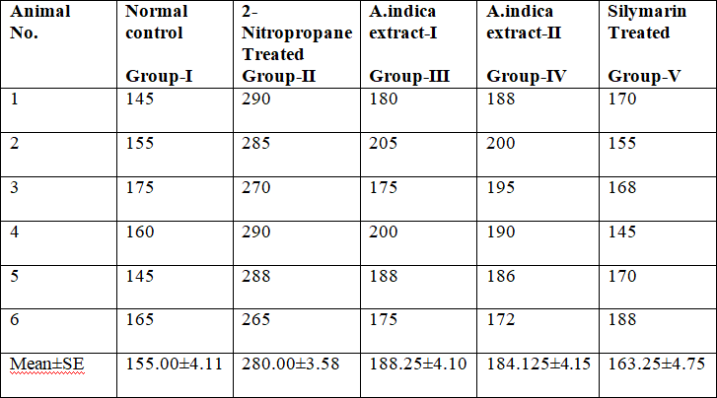

Means bearing the same superscripts do not differ significantly at P<0.05

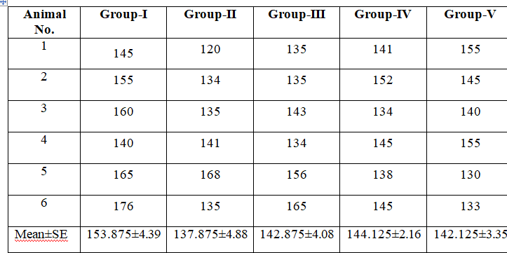**Table.7. Serum total Protein level (g/dl) before treatment in rats (n=6) on day 0**

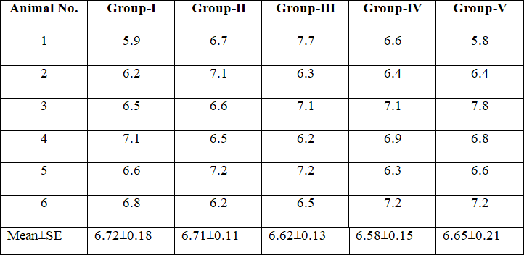

**Table.8. Effect of Azadirachta indica on total protein level in 2-nitropropane induced hepatotoxicity in rats (n=6) on day 1**

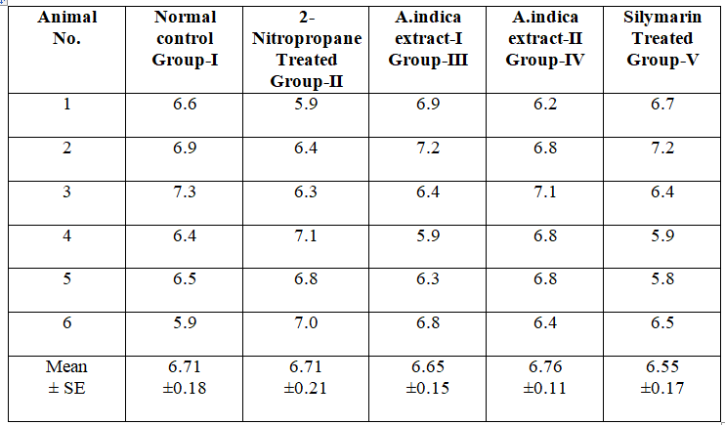

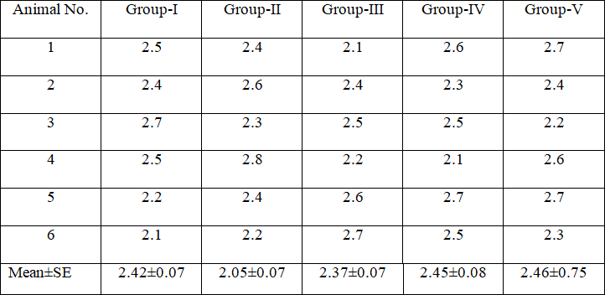**Table.9. Serum albumin level (g/dl) before treatment in rats (n=6) on day 0**

**Table 10. Effect of Azadirachta indica on serum albumin (g/dl) in 2-nitropropane induced hepatotoxicity in rats (n=6) on day 10**

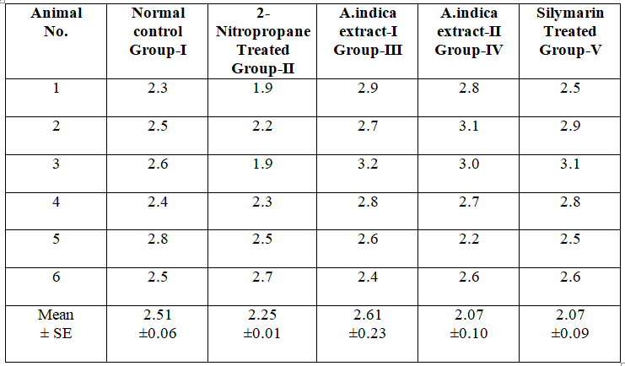

Means bearing the same superscripts do not differ significantly at P<0.05

## Table.11. Serum total bilirubin (mg/dl) before treatment in rats (n=6) on day

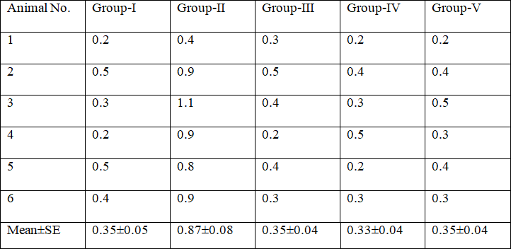

**Table 12.Serum total bilirubin (mg/dl) before treatment in rats (n=6) on day 0**

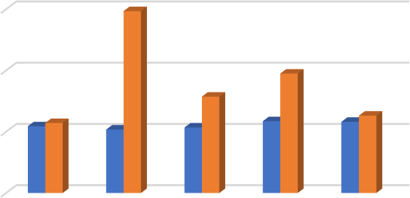

150

Fig.3. Effect of Treatment on

ALT level (U/L)

100

50

0

Dotted bar indicate level after treatment

U/L

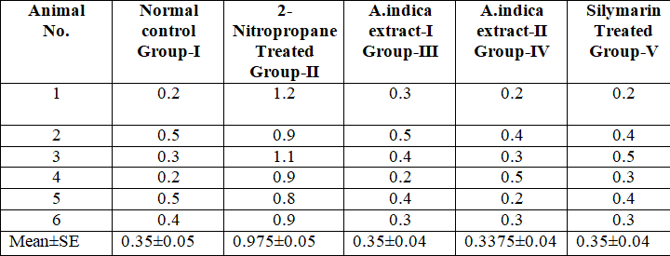

Means bearing the same superscripts do not differ significantly at P<0.05

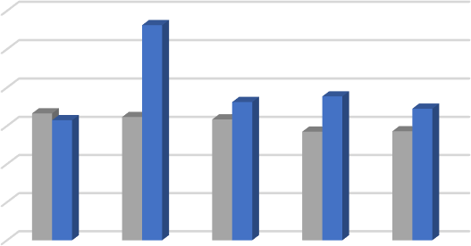

300

250

200

150

100

50

0

Fig.4. Effect of Treatment on

AST level (U/L)

Dotted bar indicate level after treatment

**Table.13. Haematological values before treatment in rats on day 0**

U/L

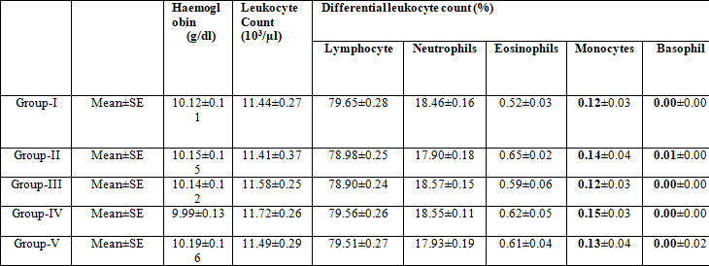

**Table.14. Effect of Azadirachta indica on haematological parameters in 2-nitropropane induced Hepatotoxicity in rats (n=6) on day 10**

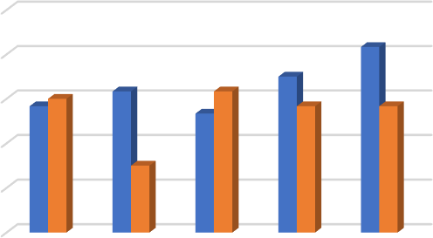

6.9

Fig.5. Effect of Treatment on total Protein level (g/dl)

6.8

6.7

6.6

6.5

6.4

Dotted bar indicate level after treatment

g/dl

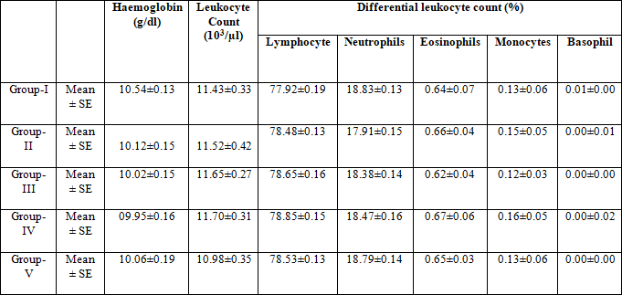

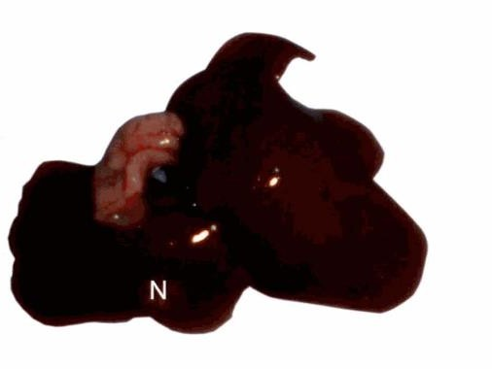

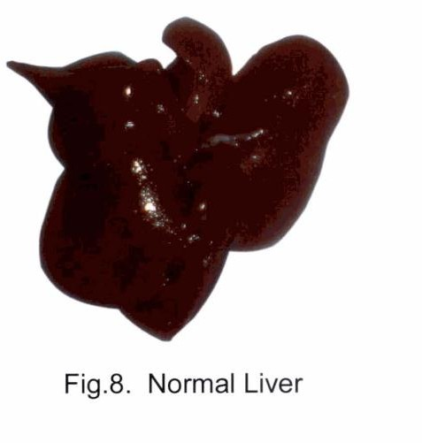**Fig. 9 Liver 2-nitropropane treated group**

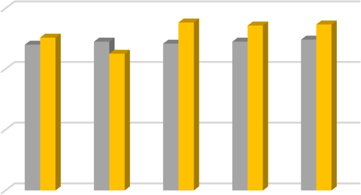

3

Fig.6. Effect of Treatment on

albumin level (g/dl)

2

1

0

Dotted bar indicate level after treatment

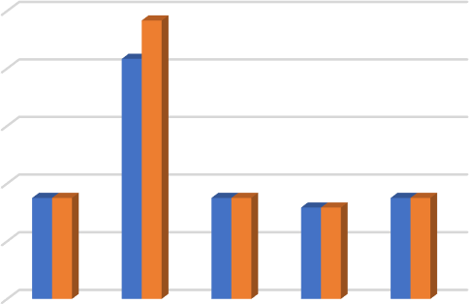

Fig.7. Effect of Treatment on

1 total bilirubin level (mg/dl)

0.8

0.6

0.4

0.2

0

Dotted bar indicate level after treatment

mg/dl

g/dl

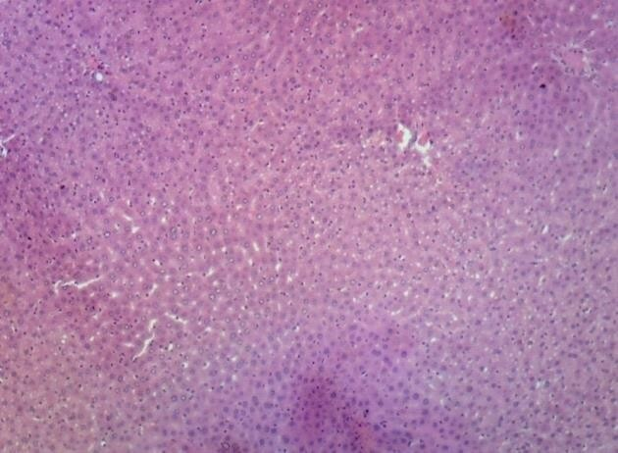

**Fig.10. Liver - healthy control Normal arrangement of hepatocytes (H & E X 100)**

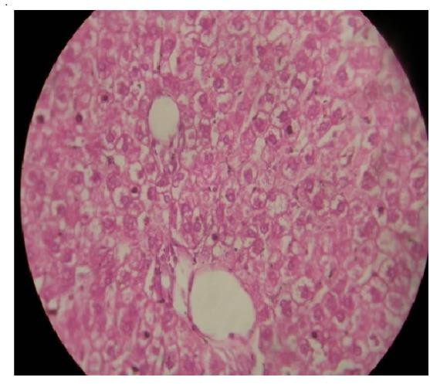

**Fig.12. Liver - Azadirachta indica 200 mg/kg Abundance of binucleate cells indicating areas of regeneration (H & E x 1000)**

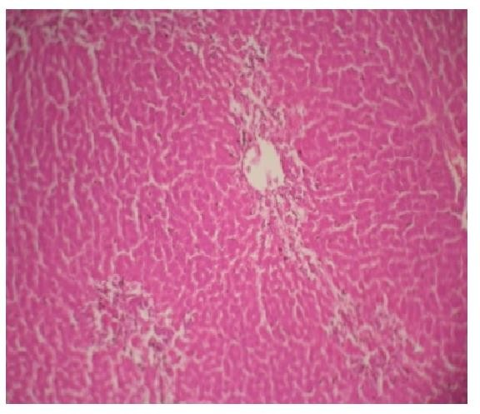

**Fig.13- Liver-Azadirachta indica 400mg/kg**

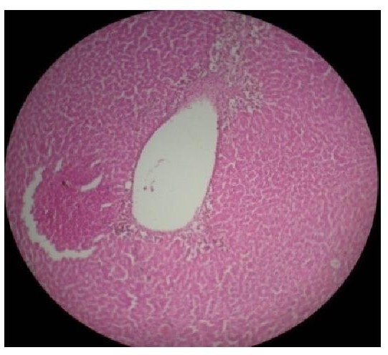

**Fig.14. Liver - silymarin 100 mg/kg on day 10 apparently normal hepatic architecture (H & E X 100)**

# DISCUSSION

These days, there are very few hepatoprotective medications accessible to treat liver diseases. Jaundice has historically been treated using herbal remedies like Phyllanthus niruri. To determine which phytoconstituents are responsible for the hepatoprotective action, studies have been carried out on a variety of herbal plants. The goals of this study are to examine the effectiveness of ethanolic extract of Azadirachta indica and assess its hepatoprotective impact in rats that have been induced hepatotoxicity by 2-nitropropane.

# PHYTOCHEMICAL SCREENING

Alkaloids, tannins, flavonoids, glycosides, phenolic compounds, diterpenes, triterpenes, and saponins were found in the ethanolic extract of Azadirachta indica used in this study's phytochemical screening. Neem leaf extract contains flavonoids, which have antioxidant properties, according to a related study by Bhanwra et al. (2000). Because flavonoids have antiperoxidant, free radical scavenger, and

antioxidant properties, they are hepatoprotective agents (Chakraborthy et al., 1989; Hewawasam et al., 2003). According to Vallachira (1998), bitter amorphous resin alkaloids margosine and margosic acid were found in the dried bark of Melia azadirachta. The results of this investigation also showed that the extract from neem leaves contains alkaloids.

# PHYSIOLOGICAL PARAMETERS

## Weight of body:

All of the groups in this study saw a progressive gain in weight, with the exception of the 2- nitropropane treated group. The hepatotoxic agent's stress and the reduced feed intake may be the causes of the weight loss seen in the 2-nitropropane treated group. Rats treated with 3-nitropropane at a dose of 2ml/kg orally for three days showed weight loss in a related study by Mathew (2005).

# SERUM PARAMETERS

In evaluating both clinical and experimental liver damage, the current investigation demonstrated the importance of blood indicators specific to the liver, including alanine amino transferase (ALT), aspartate amino transferase (AST), bilirubin, albumin, and total protein. Serum indicators such as ALT, AST, and bilirubin significantly increased as a result of 2-nitropropane induced hepatotoxicity, although serum albumin and total protein levels decreased. These findings are which showed that the 2-nitropropane-treated group significantly outperformed the normal control group in terms of serum albumin and total protein and significantly elevated hepatospecific serum markers such as ALT, AST, and bilirubin.

## Alanine amino transferase (ALT)

The current investigation revealed that the rats treated with 2-nitropropane had higher levels of ALT than the other groups, suggesting that the substance has the potential to cause hepatotoxicity. These results are consistent with the findings of the study by Bose et al. (2007), which showed that ALT is a more accurate measure of liver injury and that hepatic damage releases the enzyme into circulation. In a 1975 study, Dixon et al. measured the serum transaminase levels following 2- nitropropane-induced hepatic necrosis in rats and found that the serum enzyme levels are a good indicator of the degree of liver necrosis. These observations align with the findings of the current investigation.

The raised enzyme levels were decreased by the plant's ethanolic extract, and the silymarin-treated animals' enzyme levels did not differ significantly from those of the control group. In a related study, Bhanwra et al. (2000) found that administering 500

mg/kg of Azadirachta indica leaf extract significantly decreased the level of ALT and that the hepatic necrosis brought on by paracetamol at a dose rate of 2 g/kg Bwt increased the level of serum alanine amino transferase.

## Aspartate amino transferase (AST)

The administration of A. indica extract at doses of 300 mg/kg Bwt was found to considerably lower the high levels of AST produced by paracetamol intoxication in the current investigation. The enzyme levels of the normal animals and the animals treated with silymarin did not differ significantly. Always, a higher level of SGPT is accompanied by an elevated level of SGOT (Sallie et al., 1999). These findings align with the current investigation.

In a related study, Chattopadhyay et al. (1992) found that the group treated with A. indica leaf extract had much lower increased serum levels of ALT and AST than the group treated with paracetamol. The current study's findings are in

# HAEMATOLOGICAL PARAMETERS

Before and after the treatment, hematological parameters such as differential leucocyte count, total leucocyte counts (TLC), and hemoglobin concentration were examined. There was no difference observed between the pre- and post- treatment values for hemoglobin concentration, total leucocyte count, and differential leucocyte count.

# HISTOPATHOLOGICAL AND GROSS LIVER EXAMINATION

Following a ten-day treatment period, all animals were slaughtered, and the livers were examined closely. When the livers from all the groups were grossly examined, they appeared and were colored nearly normally, with the exception of the 2- nitropropane treated group. Necrosis regions in the liver of the 2-nitropropane-treated group were grayish white in color. In a related investigation, Bhanwra et al. (2000) found that the majority of the rats treated with 2-nitropropane had livers covered in white slough and numerous whitish. The control group displayed rows of hepatocytes, the portal triad, and a normal arrangement of hepatocytes upon histological analysis. There were patches of centrilobular coagulation necrosis in the 2- nitropropane treated group. Massive infiltration of inflammatory cells and profoundly eosinophilic cytoplasm with pyknotic nuclei were observed in the hepatocytes. These discoveries align with the findings of the Hewawasam et al. (2003) study, which demonstrated confluent necrosis with vacuolation and ballooning degeneration in the liver following 2-nitropropane treatment in the surviving hepatocytes. In a related investigation, Mathew (2005) found that 3-nitropropane

administered at a dose rate of 3 g/kg for three days caused liver centrilobular coagulative necrosis. The 2-nitropropane oxidation products' covalent bonding to the sulphydryl groups. The livers of the animals treated with 300 mg/kg of Azadirachta indica extract had an abundance of binucleate hepatocytes, which indicated areas of regeneration. around the 300 mg/kg range. Each and every blood vessel was clogged. Comparing this group to the preceding one, fewer regeneration areas were seen. Additionally, it was shown that the pre-treatment with the extracts decreased the harm caused by 2- nitropropane, demonstrating their hepatoprotective properties. It might be because the leaf extracts contain tannins, flavonoids, and phenolic components. The histological sections made it clear that pre-treatment with A. indica improved the hepatoprotective effect. According to a related study by Chattopadhyay (2003), A. indica leaf extract itself may function as a free radical scavenger by capturing the radicals implicated in As a result of the current study's findings, rats that were exposed to 2-nitropropane-induced hepatotoxicity were shown to respond better to treatments including ethanolic extracts of Azadirachta indica leaves. **References:**

1. Abrol, S., Trehan, A. and Katare, O.P. 2005. Comparative study of different silymarin formulations- Formulation, characterization and in-vitro/in-vivo evaluation. Current drug delivery. 2: 45-

51.

1. Abudulai, M., Shepard, B.M. and Mitchell, P.L. 2004. Effects of Neem (Azadirachfa indica) on predators of Nezara viridula. J. Agric. Urban Entomol. 21: 9-13.
2. Agrawal, S.S., Garg, A. and Agrawal, S. 1986. Screening of Phyllanthus niruri Linn, and Ricinus communis Linn. on alcohol induced liver cell damage in non- hepatectomized and partially hepatectomized rats. Indian J. Pharmacol. 14: 211-214.
3. Agrawal, S.S., Talele, G.S. and Surana,

S.J. 2009. Antioxidant activity of fractions from Tridmprocumbens. J. Pharm. Res. 2: 71-73.

1. Akare, S.C., Sahare, A.Y., Shende, M.A., Bondre, A.V. and Wanjari, A.D. 2009. Hepatoprotective activity of Acacia ferruginea DC. leaves against carbon tetrachloride induced liver damage in rats. Inf. J. Pharm Tech Res. 1: 962-965.
2. Al-Mustafa, Z.H., A1-Ali, A.K., Qaw,

F.S. and Cader, A.Z. 1997. Cimetidine enhances the hepatoprotective action of N- acetylcysteine in mice treated with toxic doses of paracetamol. Toxicology. 121:

223-228

1. Al-Sereiti, M.R., Abu-Amer, K.M. and Sen, P. 1999. Pharmacology of rosemary (Rosemarinus officinalis Linn.) and its therapeutic potentials. Indian J. Exp. Biol. 37: 124-130.
2. Ali, M.S. and Jahangir, M. 2002. A bis- bithiophene from Tridm procutnbens L. (Asteraceae). Nat Prod Lett. 16: 217-221.
3. Antony, B., Kumari, G.S., Merina, B., Sheeba, V. and Mukkadan, J. 2006. Hepatoprotective effect of Centella asiatica(L) in carbon tetrachloride induced liver injury in rats. Indian J. Pharm. Sci. 68: 772-776.
4. Asha, V.V. 2001. Preliminary studies on the hepatoprotective activity of Marmodica subangulata and Naragamia alata. Indian J. Pharmacol. 33: 276-279
5. Atawodi, S.E. and Atawodi, J.C. 2009. Azadirachta indica (neem): a plant of multiple biological and pharmacological activities. Phytochem Rev. 8: 601 -620.
6. Bai, X., Qui, A,, Guan, J. and Shi, Z. 2007.Antioxidant and protective effect of an oleanolic acid enriched extract of Actinidias deliciosa root on carbon tetrachloride induced rat liver injury. Asia. Pak Clin. Nutri. 16: 169-173.
7. Bancroft, J.D. and Cook, H.C. 1984. Manual ofHistological Techniques and their Diagnostic Applications. Second edition. Churchill Livingstone, Edinburgh, p.457.
8. Banerjee, A., Gupta, D.N. and De, B. 2005. In-vitro study of antioxidant activity of Sy~gium cumini fruit. Food Chem. 90: 727-733.
9. Benjamin, M.M. 1985. Outline of veterinary clinical pathology. Third edition. Kalyani publishers, New Delhi,

p.3 10.

1. Bhagwat, D.A., Suresh, G.K. and Rahul,

S.A. 2008. Anti- diabetic activity of leaf extract of Tridaxprocumbens. Intl. J. Green Pharm. 2: 126-128.

1. Bhanwra, S., Singh, J. and Khosla, P. 2000. Effect of Azadirachta indica (Neem) leaf aqueous extract on paracetamol - induced liver damage in rats. Indian J. Physiol. Pharmacol. 44: 64-68.
2. Prakash1*, FORMULATION AND EVALUATION OF HERBAL ANTI-

ACNE GEL Journal of Pharmaceutical Negative Results ¦ Volume 13 ¦ Special Issue 6 2022.

1. *Satya Prakash1, To Study the Antiulcer Activity of Hydro Alcoholic Extract of Euphorbia Thymifolia on Absolute Ethanol Induced Ulcer in Rats. European

Journal of Molecular & Clinical Medicine ISSN 2515-8260 Volume 10, Issue 1

2023.

1. Satya Prakash, et. al., 2022 Guidelines for Approval of Clinical Trials and Study Reports of SARS Covid-19 Vaccines. IJPRA, ISSN: 2456-4494. 64. et al., S. P. (2019). FORMULATION AND EVALUATION OF FLOATING TABLET OF ZOLMITRIPTAN

TABLET. International Journal of Advanced Science and Technology, 28(17), 82.

1. Satya Prakash, et. al., 2023 Gold Nanoparticles for Targeted and Selective Delivery of Cancer Chemotherapeutics: A Review of the Literature (Eur. Chem. Bull. 2023, 12 (Special Issue 1), 2896-2901).
2. Formulation and Evaluation of Floating Tablet Zolmitriptan. (International Journal of Advanced Science and Technology Vol. 28 No. 17 (2019): Vol 28 No 17

(2019))