
International Journal of Research Development and Technology Vol.2, Issue.2, Year 2024 ISSN: 2584-0290
Web: www.ijrdt.com

Design, Synthesis and Characterization of Benzothiazole Derivative as Anti- bacterial Agents
¹Rajesh (Research Scholar), ²Dr. Nasiruddin Ahmad Farooqui, ³Dr. Shamim Ahmad,
Translam Institute of Pharmaceutical Education & Research Meerut U.P Email Id: rajeshkumar9528320401@gmail.com
**********************************************************************************
Abstract
Benzothiazoles have played an important role in the field of biochemistry and medicinal chemistry due to their highly pharmaceutical and biological activity. The development of synthetic processes is undoubtedly one of the most significant problems facing researchers. In this review paper, we provided recent advances in the synthesis of benzothiazole compounds related to green chemistry from condensation of 2-aminobenzenethiol with aldehydes/ketones/acids/acyl chlorides and the cyclization of thioamide or carbon dioxide (CO2) as raw materials, and the future development trend and prospect of the synthesis of benzothiazoles were anticipated.
Keywords: Benzothiazoles, Thiamine, Aldehydes/ketenes/acids/acyl chlorides, 2-amino benzenethiol
**********************************************************************************

Introduction:
Benzothiazole is a representative class of sulfur- containing heterocycles and involves a benzene ring fused to a thiazole ring. The benzothiazole ring system was originally found in various marine and terrestrial natural compounds, which is widely used as vulcanization accelerators, antioxidants, plant growth regulators, anti-inflammatory agents, enzyme inhibitors, imaging reagents, fluorescence materials, and electroluminescent devices due to its highly pharmaceutical and biological activity [1,2]. Especially, benzothiazole plays an important role in the field of medicinal chemistry and renders an extensive range of biological activities including anti- cancer [5,6], anti-bacterial ,anti-tuberculosis anti- diabetic anthelmintic anti-tumor anti-viral anti- oxidant anti-inflammatory anti-glutamate and anti- parkinsonism anticonvulsant muscle relaxant activities neuroprotective inhibitors of several enzymes and so on Hence, the synthesis of benzothiazoles is of considerable interest due to their potent and significant biological activities and great pharmaceutical value. In addition, an alternative
method is the intramolecular cyclization of ortho- halogenated analogs Sahoo and colleagues indicated that benzothiazoles could be synthesized from ortho- halothioureas using both Cu (I) and Pd(II) [14-19]. transition metal as a catalyst. Unfortunately, these traditional processes have some disadvantages, such as low yield, poor selectivity, harsh reaction conditions, the use of toxic reagents or metal catalysts, etc. However, green chemistry advocates for the use of chemical technologies and methods to reduce or stop the use and production of raw materials, catalysts[11-13], solvents and reagents, products or by-products that are harmful to human health, community safety, and the ecological environment. Therefore, an exploration of environmentally friendly synthetic routes to prepare benzothiazoles is highly desirable [3-9].

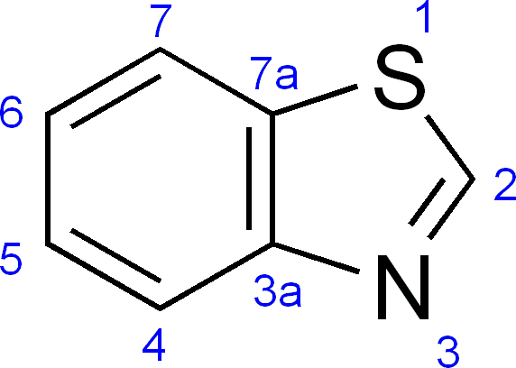

In recent years, with the continuous development of green chemistry concepts for the environmental protection the development of metal-free catalysts, the use of renewable reaction materials and reagents, and the realization of reactions under mild conditions have attracted researchers’ attention. Notably, various environmentally friendly pathways have been discovered for the synthesis of benzothiazoles in the past decades. Here, the present article is intended to briefly review recent research progress concerning the synthesis of benzothiazoles compounds, which mainly includes the condensation reaction of 2- aminobenzenethiol and aldehydes/ketones/acids/acyl chlorides. In addition, the cyclization of thioamides offered benzothiazole derivatives [10].
Moreover, a series of benzothiazole compounds were also synthesized by cyclization of CO2 as raw materials [20].
STEP-(II) SYNTHESIS OF 1-(CHLOROACETYL)- 2 AMINOBEZOTTHIAZOLE
The chloroacetylchloride react with prepared 2- aminobenzothiazole in the presence of potassium carbonate or iodoform and formation of 1- (chloroacetyl)-2-aminobenzothiazole as well as hydrochloric acid.
Scheme-II
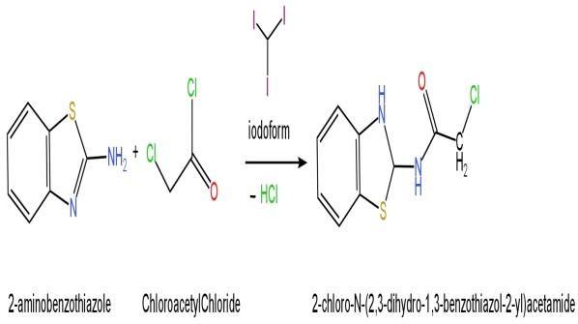
STEP-(III) SYNTHESIS OF N-(6-METHOXY-1, 3-BENZOTHIAZOL-2-YL) ACETAMIDE
In this step, the 1-(chloroacetyl)-2- aminobenzothiazole and methanol (methyl alcohol) is react to each other, its results the formation of N-(6- methoxy-1,3-benzothiazol-2-yl) acetamide and liberate the hydrochloric acid.

Scheme.III
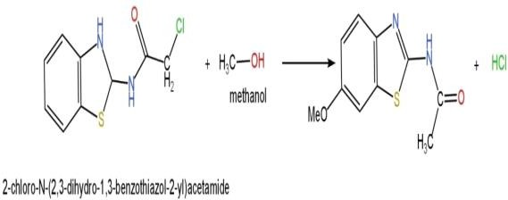

(1-Chloroacetyl)-2-aminobenzothiazole
N-(6-methoxy-1, 3-benzothiazol-2-yl) acetamide
(4A)
STEP-IV SYNTHESIS OF N-(6-ETHOXY-1,3- BENZOTHIAZOL-2-YL)ACETAMIDE
It is the last step to synthesize benzothiazole derivative in this study, the prepared N-(6-methoxy- 1, 3-benzothiazol-2-yl) acetamide react with sodium ethoxide and formation of N-(6-ethoxy-1,3- benzothiazol-2-yl) acetamide.

Scheme-IV
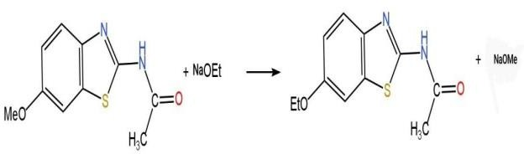

N-(6-methoxy-1, 3-benzothiazol-2-yl) acetamide N-(6-ethoxy-1, 3-benzothiazol-2-yl) acetamide (5A)
PROCEDURE:-
4.6g Aniline, 3.8g ammonuim thiocyanate dissolved in 10ml ethanol and add 4ml concentrated Hydrochloric acid, 6.7ml acetic acid, 5.7ml bromine solution in a round bottom flask and reaction reflux for one hour and then cooled in ice bath, formation the ppt of 2-Aminobenzothiazole, filtered and washed with cold water and dried the product. The crude product was recrystallized from ethanol. 8g 2- Aminobenzothiazole was rected with mono- chloroacetyl chloride in a round bottom flask with continuous strring under the temperature (0-25⁰C) and adding triethyamine as a catalyst ( Overnight ) on

the second day, we get the final product by mixing the reaction mixture with ice, allowed to melt, and the mixture was filtered to get the final product as powder.
- CHARACTERIZATION OF SYNTHESIZED COMPOUNDS:
The compounds were found to have sharp melting points. The synthesized molecules were subjected to TLC technique and found to be pure. Only a single spot was noticed for the synthesized compound. The synthesized molecules were characterised by IR Spectroscopy using FT-IR spectrophotometer. Proton NMR spectra were recorded using solvent deuterated methanol on BRUKER advance III 500 NMR spectrometer. Chemical shifts are reported in parts per million (ppm). The MASS spectra were recorded on JEOL GC Mate II Mass Spectrophotometer operating as direct probe using Electron Ionisation (EI) technique.
FT-IR SPECTRUM OF COMPOUND (1A)

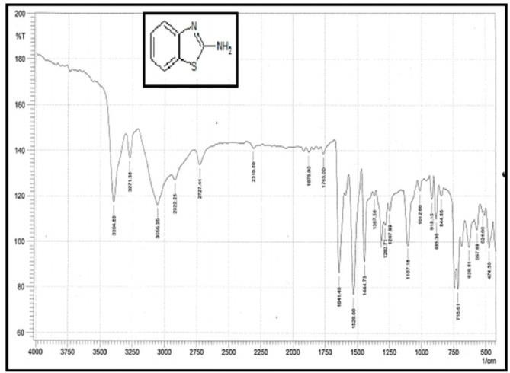
UV SPECTRUM OF COMPOUND (1A)
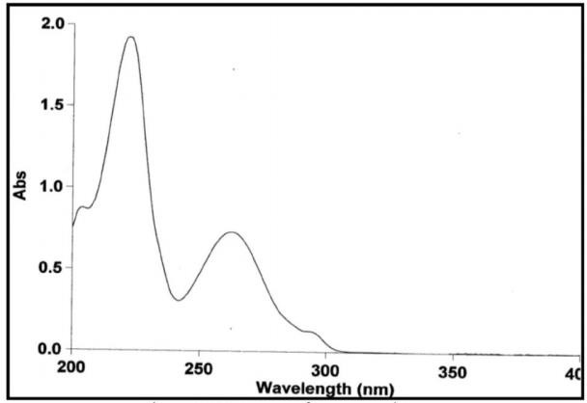
7.3 NMR SPECTRUM OF COMPOUND (1A)

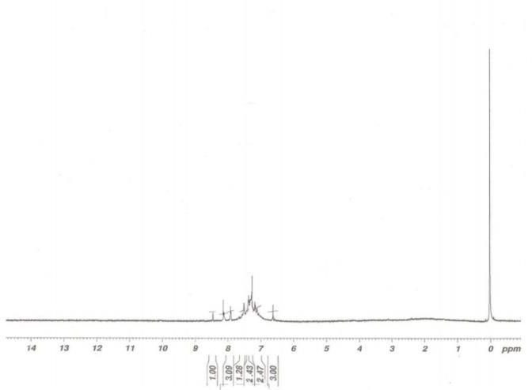
IR SPECTRUM OF COMPOUND (2A)
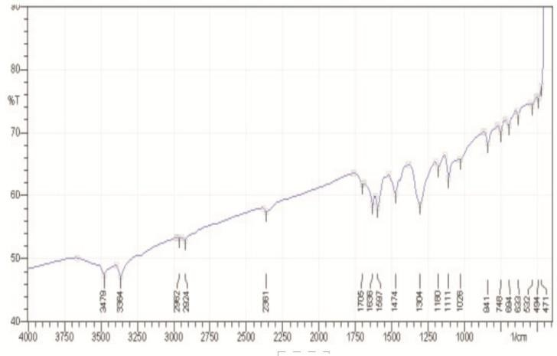
NMR SPECTRUM OF COMPOUND (2A)
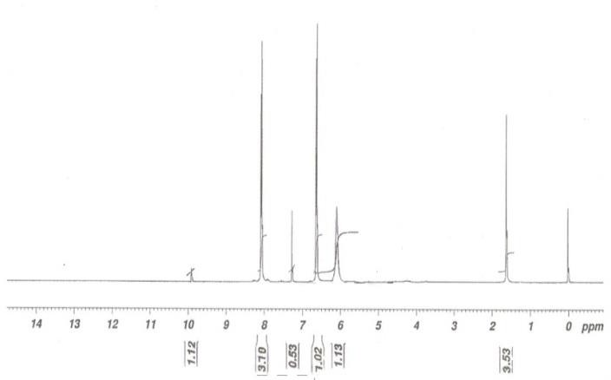
MASS SPECTRUM OF COMPOUND (2A)

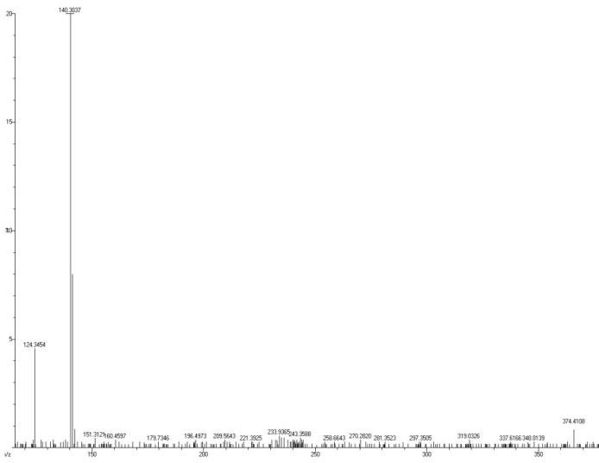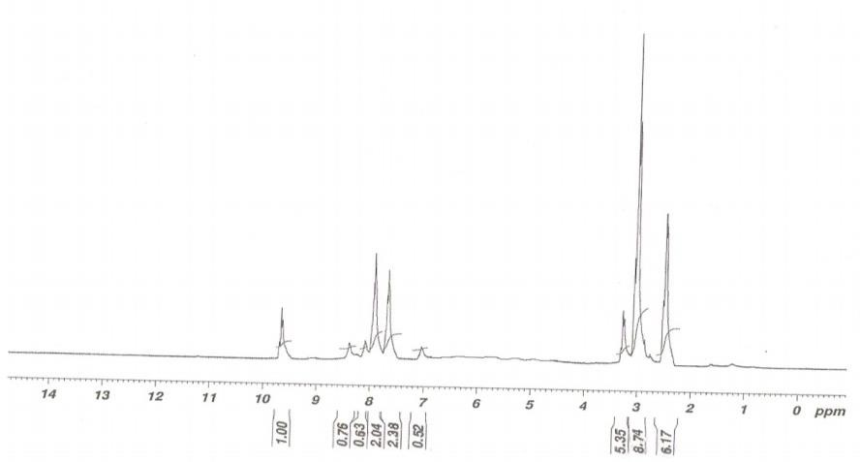

IR SPECTRUM OF COMPOUND (3A)


MASS SPECTRUM OF COMPOUND (3A)
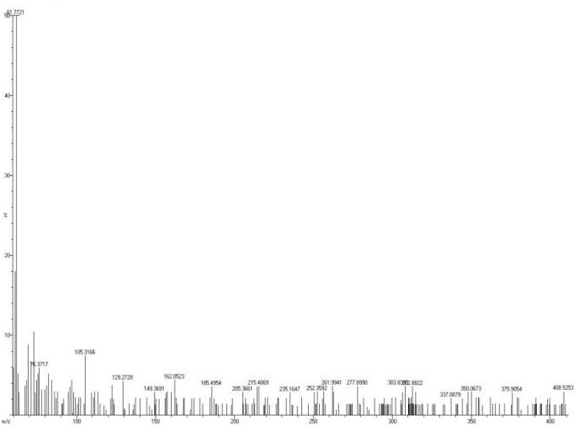
NMR SPECTRUM OF COMPOUND (3A)
IR SPECTRUM OF COMPOUND (4A)
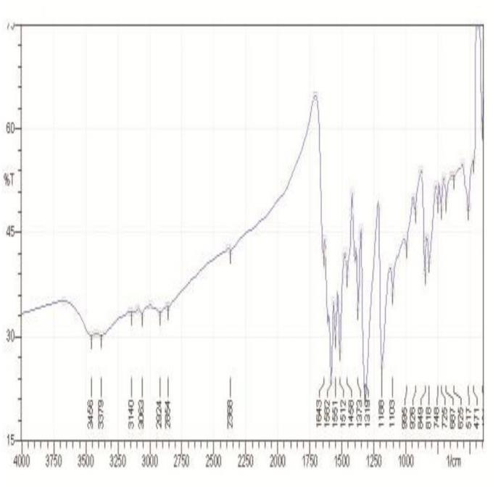
MASS SPECTRUM OF COMPOUND (4A)
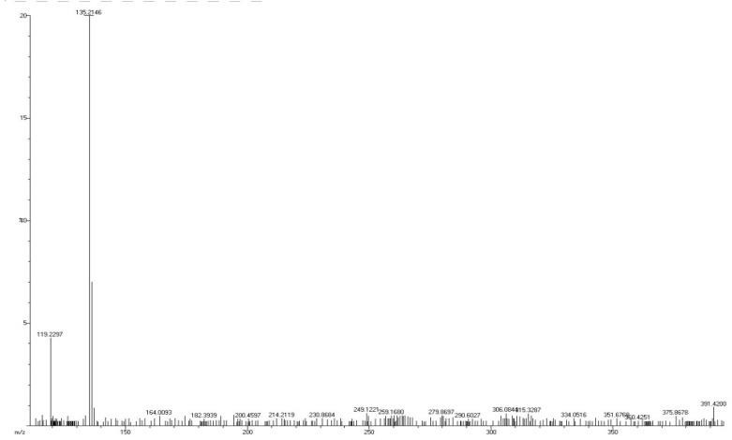
NMR SPECTRUM OF COMPOUND (4A)

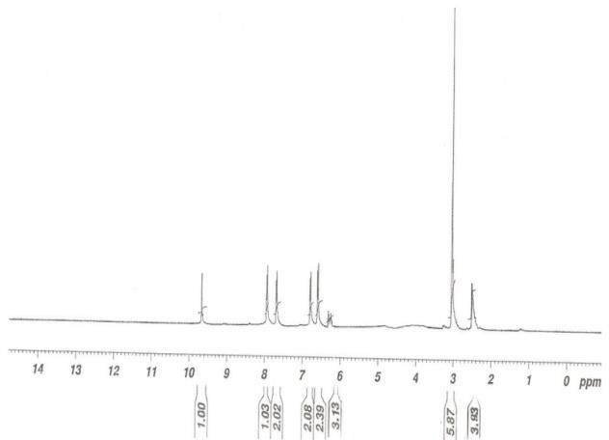
IR SPECTRUM OF COMPOUND (5A)


NMR SPECTRUM OF COMPOUND (5A)
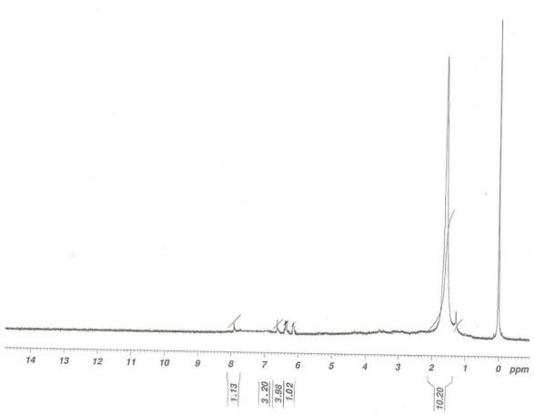

Table no. 8
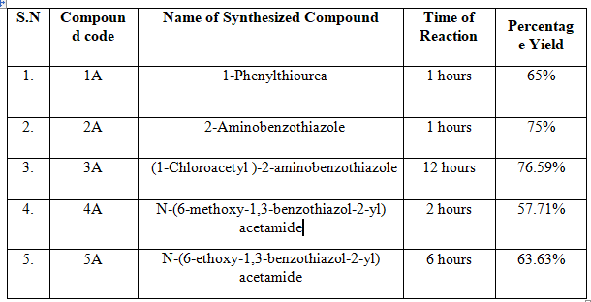
Physicochemical properties of synthesized benzothiazole derivatives Solubility of synthesized Benzothiazole derivatives
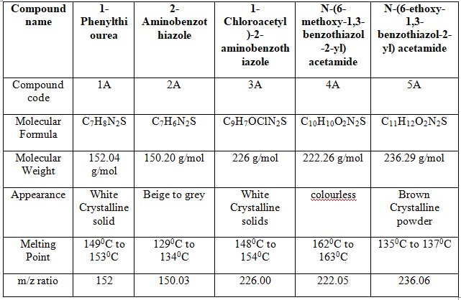
Freely soluble (From 1 to 10 part), +++ soluble (10 to 30 part), ++ sparingly soluble (30 to 100 part), - practically insoluble (more than 10,000)
RESULT AND DISCUSSION
Results and Discussion 2-aminobenzothiazole derivatives were prepared from the substituted aromatic amines which in the presence of ammonium thiocyanate forms substituted 1-phenylthiourea in acidic medium. This substituted 1- phenylthiourea cyclized into substituted 2- aminobenzothiazoles in the presence of oxidizing agent bromine water. All the compounds obtained were good yield ranging from 63-75%. The homogeneity of the compounds was monitored by performing TLC by which Rf and Rm values were calculated.

References
- Carroll A.R., Scheuer P.J. pentacyclic alkaloids from a tunicate and its prosobranch mollusk predator Chelynotus semperi. J. Org. Chem. 1990;55:4426– 4431. doi: 10.1021/jo00301a040.
- Gunawardana G.P., Kohmoto S., Gunasekera S.P., McConnel O.J., Koehn F.E. Dercitine, a new biologically active acridine alkaloid from a deep water marine sponge, Dercitus sp. J. Am. Chem. 1988;110:4856–4858.
doi: 10.1021/ja00222a071.
- Noel S., Cadet S., Gras E., Hureau C. The benzazole scaffold: A SWAT to combat Alzheimer’s disease. Chem. Soc. Rev. 2013;42:7747–7762. doi: 10.1039/c3cs60086f.
- Prajapati N.P., Vekariya R.H., Borad M.A., Patel
H.D. Recent advances in the synthesis of 2- substituted benzothiazoles: A review. RSC Adv. 2014;4:60176–60208.
- Kok S.H.L., Gambari R., Chui C.H., Yuen M.C.W., Lin E., Wong R.S.M., Lau F.Y., Cheng
G.Y.M., Lam W.S., Chan S.H., et al. Synthesis and anti-cancer activity of benzothiazole containing phthalimide on human carcinoma cell lines. Bioorg. Med. Chem. 2008;16:3626–3631.
- Moustafa T Gabr and Nadia S EI- Gohary 201 New series of benzothiazole derivatives were designed and synthesized. The newly synthesized compounds were screened for their antibacterial activity against Escherichia coli, Staphylococcus aureus and Bacillus cereus.
- Suresh Maddila, Sridevi Gorle and Nuthangi Seshadri 2016 synthesis , antibacterial and antifungal activity of novel benzothiazole pyrimidine derivatives . in this study involves a new series of 5- amino-6-(benzo[d]thiazol-2-yl)-2-(2- (substitutedbenzylidene)hydrazinyl)-7-(4- chlorophenyl)pyrido[2,3-d]pyrimidin-4(3H)-one derivatives (7a–k) were synthesized.
- Virendra R. Mishra, Chaitannya W Ghanavatkar and Suraj N Mali 2017 The novel azo linked substituted benzimidazole, benzoxazole,
and benzothiazole were synthesized by diazo coupling and characterized by 1H NMR, elemental analysis, FTIR and UV–vis spectroscopy.
- Virendra R mishra 2019 Design , synthesis , antimicrobial activity and computational studies of novel azo linked substituted benzimidazole
,benzoxazole and benzothiazole derivatives.
- Akhilesh Gupta (2019) Synthesis of Novel Methoxy Substituted Benzothiazole Derivatives and Antibacterial activity against Pseudomonas aeruginosa.
- Mohammed A. Morsy and Enas M. Ali 2020. Screening and Molecular Docking of Novel Benzothiazole Derivatives as Potential Antimicrobial Agents
- Alessia Catalano, Antonio Rosato 2021. This study focus on Benzothiazole-Containing Analogues of Triclocarban with Potent Antibacterial Activity.
- Ghulam Abbas Ashraf and Adeel Mubarak 2022. Computational Study of Benzothiazole Derivatives for Conformational, Thermodynami and Spectroscopic Features and Their Potential to Act as Antibacterials.
- R Egorov, Tatsiana V Shakola and Alexander G Tskhovrebov 2023. Benzothiazole Derivatives of Chitosan and Their Derived Nanoparticles: Synthesis and In Vitro and In Vivo Antibacterial Effects
- Ahmad HM Elwahy, Hadeel F Ahmad and Nada S Ibrahim 2024 The synthesis and antibacterial activities of novel hybrid molecules based on benzothiazole , benzimidazole and pyrimidine derivatives .
- . Liao, C.; Kannan, K. A survey of alkylphenols, bisphenols, and triclosan in personal care products from China and the United States. Arch. Environ. Contam. Toxicol. 2014, 67, 50–59.
- Iacopetta, D.; Catalano, A.; Ceramella, J.; Saturnino, C.; Salvagno, L.; Ielo, I.; Drommi, D.; Scali, E.; Plutino, M.R.; Rosace, G.; et al. The Different Facets of Triclocarban: A Review. Molecules 2021, 26, 2811. [CrossRef]
- Yun, H.; Liang, B.; Kong, D.; Li, X.; Wang, A. Fate, risk and removal of triclocarban: A critical review. J. Hazard. Mater. 2020, 387, 121944.
- Prakash1*, FORMULATION AND EVALUATION OF HERBAL ANTI-ACNE GEL
Journal of Pharmaceutical Negative Results ¦ Volume 13 ¦ Special Issue 6 2022.
- *Satya Prakash1, To Study the Antiulcer Activity of Hydro Alcoholic Extract of Euphorbia Thymifolia on Absolute Ethanol Induced Ulcer in Rats. European Journal of Molecular & Clinical Medicine ISSN 2515-8260 Volume 10, Issue 1 2023.
- Satya Prakash, et. al., 2022 Guidelines for Approval of Clinical Trials and Study Reports of SARS Covid-19 Vaccines. IJPRA, ISSN: 2456-4494.
64. et al., S. P. (2019). FORMULATION AND EVALUATION OF FLOATING TABLET OF

ZOLMITRIPTAN TABLET. International Journal of Advanced Science and Technology, 28(17), 82.
- Satya Prakash, et. al., 2023 Gold Nanoparticles for Targeted and Selective Delivery of Cancer Chemotherapeutics: A Review of the Literature (Eur. Chem. Bull. 2023, 12 (Special Issue 1), 2896-2901).
- Formulation and Evaluation of Floating Tablet Zolmitriptan. (International Journal of Advanced Science and Technology Vol. 28 No. 17 (2019): Vol
28 No 17 (2019))
- Catalano, A.; Iacopetta, D.; Sinicropi, M.S.; Franchini, C. Diarylureas as antitumor agents. Appl. Sci. 2021, 11, 374.
20. Catalano, A.; Iacopetta, D.; Pellegrino, M.; Aquaro, S.; Franchini, C.; Sinicropi, M.S. Diarylureas: Repositioning from antitumor to antimicrobials or multi-target agents against new pandemics. Antibiotics 2021, 10, 92.

