

**International Journal of Research Development and Technology Vol.2, Issue.2, Year 2024 ISSN: 2584-0290**

**Web:** [www.ijrdt.com](http://www.ijrdt.com/)

INVESTIGATING THE ESTROGENIC EFFECTS OF TEST ITEMS VIA ORAL ADMINISTRATION IN A FEMALE RAT OVARIECTOMY MODEL

1Vivek Jeet Singh (Research Scholar), 2Dr. Nasiruddin Ahmad Farooqui 3Dr. Shamim Ahmad,

Translam Institute of Pharmaceutical Education & Research Meerut U.P

**Email id:** [**vivekjeetsingh0987@gmail.com**](mailto:vivekjeetsingh0987@gmail.com)

**\*\*\*\*\*\*\*\*\*\*\*\*\*\*\*\*\*\*\*\*\*\*\*\*\*\*\*\*\*\*\*\*\*\*\*\*\*\*\*\*\*\*\*\*\*\*\*\*\*\*\*\*\*\*\*\*\*\*\*\*\*\*\*\*\*\*\*\*\*\*\*\*\*\*\*\*\*\*\*\*\*\***

***ABSTRACT***

*To evaluate the effects of estrogen and estrogenic compounds on cognition in ovariectomized rats. Female Albino wistar rats (3–5 months old) weighing 250–300g was randomly divided into seven groups: Sham, ovariectomized (OVX), OVX plus estradiol valerate, OVX plus ipriflavone, OVX plus raloxifene, OVX plus tibolone, OVX plus low-dose estradiol valerate and ipriflavone. All treatments were given orally for 3 months; whereas the drug groups received indicated drugs, the Sham and OVX control groups received saline. The escape latency of rats was tested by the Morris water maze test and the expression of amyloid precursor protein (APP) in hippocampus was determined by reverse transcription polymerase chain reaction. The level of serum estradiol and the diameter of the endometrial gland and the thickness of endometrium were also evaluated. The latency of the OVX group was noticeably longer than that of the Sham group, and the latency of all treatment groups was lower than that of OVX rats. The expression of APP mRNA in the hippocampii of OVX rats was significantly increased relative to that in Sham rats; interestingly, expression of APP in treatment groups was significantly reduced relative to OVX rats.*

***Keywords:*** *Estrogenic Effects, Estrogenic compounds, Hippocampii, Ovariectomized*

**\*\*\*\*\*\*\*\*\*\*\*\*\*\*\*\*\*\*\*\*\*\*\*\*\*\*\*\*\*\*\*\*\*\*\*\*\*\*\*\*\*\*\*\*\*\*\*\*\*\*\*\*\*\*\*\*\*\*\*\*\*\*\*\*\*\*\*\*\*\*\*\*\*\*\*\*\*\*\*\*\*\***

**Introduction:**

Estrogen is a steroid hormone associated with the female reproductive organs and is responsible for developing female sexual characteristics. Estrogen is often referred to as estrone, estradiol, and estriol. Of the previously mentioned forms of estrogen, estradiol is the most common form of estrogen hormone for hormone replacement therapy (HRT) in the treatment of symptoms of menopause. Estrogen for hormone replacement therapy has been heavily researched in medicine and remains a controversial topic. According to early studies, estrogen as hormone replacement therapy for postmenopausal women showed promising benefits of decreased risk of osteoporosis, coronary arterial disease, and mortality [1].

Later studies conducted by the Women's Health Initiative concluded that risk was greater than the benefit of hormone replacement therapy in

postmenopausal women. The Women's Health Initiative ended clinical studies prematurely because participants in the study developed an increased risk of breast cancer and coronary artery disease [2].

Newer studies contradict the finding of the Women's Health Initiative, with evidence of improved quality of life and reduced risk of coronary artery disease and osteoporosis in women when women start estrogen hormone replacement therapy at the onset of menopause [3].

The FDA has approved estrogen for hormone replacement therapy in the treatment of symptoms of menopause. Synthetic estrogen is also available for clinical use, designed to increase absorption and effectiveness by altering the estrogen chemical structure for topical or oral administration. Synthetic steroid estrogens include ethinyl estradiol, estradiol valerate, estropipate, conjugate esterified estrogen, and quinestrol. Ethinyl estradiol

is a commonly used synthetic estrogen to prevent pregnancy as a component of the oral contraceptive pill approved by the FDA [5, 4]. Some nonsteroidal synthetic estrogens include dienestrol, diethylstilbestrol, benzestrol, methestrol, and hexestrol.

# MATERIALS AND METHODS: ANIMALS

Albino Wistar rats that were 3- 4 weeks old and weighed 100-200 g were utilized in this investigation. The rats were exposed to the natural light cycle of darkness, normal laboratory diet, and unrestricted access to water. In the middle of 9:00

a.m. and 5:00 pm, a behavioral evaluation was conducted. The animals were accustomed to the lab setting five days before to the behavioral investigation and were kept there during the whole investigation. The Committee on Animal Control and Management (CPCSEA) (1147 / ab/ 07/CCPSEA) of the Department of Environment and Forestry authorized the study protocol, and the Institute of Animal Ethics and Committee (IAEC) oversaw the treatment of the animals.

# CHEMICALS AND DRUGS

Before usage, all of the medication solutions were newly prepared. sodium pentobarbital anesthesia, estradiol valerate (0.8mg/kg day), ipriflavone (100 mg/kg/day), raloxifene (5 mg/kg/day), tibolone (0.5mg/kg/day) and mix of estradiol valerate (0.4 mg/kg/day) and ipriflavone (50 mg/kg/ day), Glutathione, nitric oxide and lipid peroxidation (MDA) assay kits , thiobarbituric acid, Ellman’s reagent DTNB [5, 5`-dithiobis (2-nitrobenzoic acid), phosphate-buffered saline, Tris-HCl buffer, free thiol groups, trichloroacetic acid, thiocholine

,dithiobisnitrobenzoate, acetylthiocholine iodide

,Sorenson phosphate buffer, pH 8.0,sodium hydroxide, zinc sulphate solution, Greiss reagent.

# INDUCTION MODEL

Animals were administered with sodium pentobarbital anesthesia (50 mg/kg, i.p.) and then operated through flank incisions. The fur on both sides of the body was shaved from the hip to the lowest rib. Bilateral ovariectomies were performed using an incision 1.5 cm inferior to the palpated rib cage [6].

# PROTOCOL FOR EXPERIMENTS

There was a total of seven groups in this study, each with six male rats. Two weeks after the ovariectomy, total 7 groups were used and each group consisted of six male rats. The animals were housed to a cage, with free access to food and water, and were kept on a 12-hour light/dark cycle (lights on at 7:00 am).

**Group I –** Control group: Animals were exposed to Elevated plus maze (EPM) and Morris water maze (MWM) for acquisition trial from 1th to 2nd day and retrieval trial on 5th day in EPM and in MWM acquisition trial from 3rd to 6th day and retrieval trial on 7th day.

**Group 2-** Ovariectomized group (OVX):- Animals were administered with sodium pentobarbital anesthesia (50 mg/kg, i.p.) and then operated through flank incisions. The fur on both sides of the body was shaved from the hip to the lowest rib. Bilateral ovariectomies were performed using an incision 1.5 cm inferior to the palpated rib cage and the rest of the procedure was same as group III.

**Group 3-** Estradiol Valerate per-se group:- Animals were given 0.8mg/kg of Estadiol Valerate through i.p. route once a day for 90 days and rest of the procedure was same as group III.

**Group 4-** Ipriflavone treated group, Animals were given 100 mg/kg/day of Ipriflavone once daily for

14 days and rest of the procedure was same as group III.

**Group 5-** Estradiol Valerate treated group the Ovariectomized animals were given 0.8mg/kg i.p. once a day for 90 days and rest of the procedure was same as group III.

**Group 6-** Ipriflavone treated group, ovariectomized group treated with ipriflavone (100 mg/kg/day) once daily for 14 days and rest of the procedure was same as group III.

**Group 7-** EVP+ IP group, ovariectomized group treated with a mix of estradiol valerate (0.4 mg/kg/day) and ipriflavone (50 mg/kg/ day) for 90 days and rest of the procedure was same as group III.

## OVX surgery:

Rat in the control and OVX groups were anesthetized with 3.0% pentobarbital sodium (45 mg/kg, intraperitoneal), and some hair on the back was shaved off for surgery. A dorsolateral incision of the skin along the spine was made perpendicular to the line of the base of the thighs. The muscles

0.5 cm beneath the midline of the back beneath the skin were incised, and the fat beneath the muscles was grasped to exteriorize the ovary. The fallopian tube was ligated, and then the ovary was removed by cutting above the ligated area. In the Sham group, the mice underwent the same incisions, and the fallopian tubes and ovaries were exposed but not removed and then put back in the abdominal cavity. Finally, the incisions in the muscle and skin were closed [7]

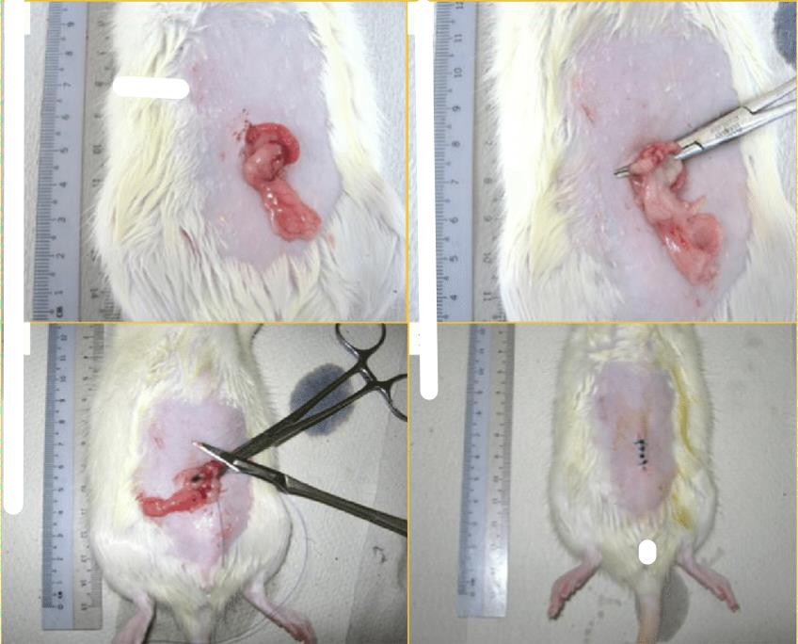

## Vaginal smear examination:

**Fig.1: Diagram of OVX Surgery**

characteristics, the relative proportion of leukocytes, cornified epithelial cells, and nucleated

The vaginal smear examination was performed

during the successive 7 days after surgery. Vaginal contents were collected with a blunted Pasteur pipette by placing a small drop of saline into the vagina; the vaginal cells obtained were immediately observed under a microscope Classified in terms of morphological

# PARAMETERS OF BEHAVIOUR:

## Elevated plus maze:

Cognitive impairment involves multiple domains including learning and memory so that retention and acquisition memory processes were identified by elevated plus maze (EPM) [9].

Transfer latency (TL) measurements on the raised plus maze on the first day (TL1) have been shown to serve as an index of learning and acquisition, whilst TL measurements on the second day (TL2) have been found to function as an index of memory and retrieval. therefore EPM was used for the memoryevaluation in rats. EPM are widelyused for the testing of nootropic substances.

The apparatus made up of Perspex plastic with the specific area which is 4 arms of 50 x 10 cm. The side walls of the two closed arms were 40 cm high. The equipment was given a plus sign appearance by connecting the open and closed arms to a centre square (5 x 5 cm). The maze was elevated to a height of 60cm from the ground. Mazes were left in the same location while the exam was being conducted in the lab, providing extra mazes for learning purposes. Each rat was placed in the middle ofthe EPM during a training session, given 30 seconds to explore it, and then taken back to its

160 cages. Initial transfer latency (ITL) is the amount of time it takes a rat to go from an open arm and into one of the closest closed arms. After

epithelial cells could be estimated. The phases of t h e estrus cycle could be estimated further according to the differences in cellular appearance. When the leukocytes occupied the majority of the field for at least 4 days, the mice were considered to have lost their estrus cycle, and the ovariectomy was successful [8].

receiving ITL, the animal was given 30 seconds to explore themaze before being returned to its home cage. The wistar rat was repositioned on the openarm 24 hours after ITL, and the retention latency was documented as "retention transfer latency" (RTL). The rat who stayed more than 5 minutes on the open arm or left the mazewas removed from the experiment [10].

## Locomotion:

Because rats with Cognition are expected to display anxiety-like behavior, which increases activity in mice, locomotion activity is evaluated in them. This is considered a symptom of cognitive [10].

The gadget Actophotometer was used to monitor locomotor activity. Throughout both the light and dark periods, the instrument actophotometer was utilized to observe locomotor activity. The equipment was turned on, and each group's rats were placed in the activity cage separately for 10 minutes while their basal activity scores were monitored and recorded. The following formula was used to compute the percent decrease in motor activity for each animal: -

% Reduction in motor activity = (Wa –Wb/Wa) × 100%.

The mean activity ratings before and after therapy are Wa and Wb, respectively (Marongiu et al., **Evaluation of catalepsy:**

Catalepsy refers to an animal's incapacity to alter an externally imposed position. It can be produced by the anaesthetic Overectomized, which was employed to induce Cognitive functionsin our investigation. The occurrence was seen while the mouse was lying on a 4 cm high bar in an enforced position with both forelimbs extended (0.4 cm diameter). For a maximum of 300 seconds, the total time the animal stayed on the bar with both forelimbs or even if it withdrew one limb was recorded.

## MWM (Morris Water Maze) Test:

MWM is one of the animal models for memory and learning that is most frequently used. It's a well- known test for assessing spatial memory in rats. The MWM approach involved submerging the animal in a pool of water. Because animals don’t like swimming, it was decided to build a run off platform to deter them from escaping the water. MWM constructed by a big circular pool filled with 28 °C water (circle was off 150cm, 45cm height, and 30 cm in depth). The water was dyed white to make it opaque. With the use of two threads positioned at right angles on the pool's rim, the pool was divided into fourequal halves. Platform's location was not changed throughout the training session. Each rat had 4 consecutive trials each day, separated by a 5-minute break. Every trial's drop point was different, and the rat was gently placed in the water between quads, facing the wall pool, with 120 seconds to locate the flooded platform. The tank was split into four equal quadrants using 2 threads that were positioned at right angles to one another on theside of the pool. Inside the target quadrants of this pool, a white-painted deluged platform (10 cm2) was positioned 1cm below the water's surface. Throughout the learning session,the location of platform was not changed. Each rat had 4 consecutive trials each day, separated by a 5- minute break. Each trial's drop point was different, and the rat was gentlyplaced in the water between quads, facing the pool wall, with 120 seconds to locate the flooded platform. It was then permitted to relax on the platform.

## Trial acquisition:

Every day, four trials were performed on each rat. A 5-minute rest period was permitted in between each trial. Over the course of four days, there were four trials. As illustrated below, the beginning position for four acquisition trials was altered each day, with Q4 serving as the target quadrant in each experiment. We assessed whether acquisition had taken place by measuring the mean escape latency time (ELT) for every day of the acquisition trials.

2012).

Day 1- q1: q2: q3:q4 Day 2- q1: q2: q3:q4 Day 3- q1: q2: q3:q4 Day 4- q1: q2: q3:q4

## Trial of retrieval:

The platform was taken apart on the sixth day. The rat has 120 seconds to make its way through a water maze. Each rat had four trials, each beginning in a different quad. The average time spent in each of the three quadrants (q1, q2, and q3) was recorded, and the time spent looking for the missing platform in the target quadrant (q4) served as a retrieval index. The experimenter always remained in the same location. The relative location of the water maze in relation to other things in the laboratory setting as well as overt visual cues were rigorously analyzed during the experiment. Every trial was taken place between the hours of 9:00 and 18:00 [9, 10].

# BIOCHEMICAL PARAMETERS:

## Samples collection:

For biochemical examination, blood samples were obtained by retro-orbital hemorrhage. The serum was obtained by centrifuging the blood for 15 minutes at 4000 rpm after 30 minutes at room temperature. The serum was then used for biochemical testing after that. Following the most recent retro-orbital hemorrhage, animals were killed by cervical dislocation, and the brain matter was painstakingly removed. The separated brains were homogenized in phosphate buffer (pH 7.4, 10% w/v) using a Teflon homogenizer. The mixture was then centrifuged for 15 minutes at 3000 rpm to extract the clear supernatant. The centrifuge tube's clear supernatant was carefully discarded and utilized. The centrifuge tube's clear supernatant was carefully removed and used in several biochemical studies.

## Assessment of brain nitrate/nitrate level

UV-1800 ENG 240V was used to spectrophotometrically measure the amount of nitrite in the brain at 545 nm [11, 12].

In a nutshell, 100 litres of brain or a standard sample was mixed with 400 litres of buffer carbonate (pH 9.0), then 0.15grammes of cadmium copper- alloy was added. The tubes were incubated at room temperature for an hour in order to convert nitrate to nitrite. If 100 l of sodium hydroxide at 0.35M are added, the process was halt. To deproteinize the samples, 400 l of a zinc sulphate solution were utilized next (120mM). Before being centrifuged for 10 minutes at 4000g, the samples were stand for 10 minutes. By spectrophotometrically measuring brain nitrite at 545nm using aliquots (500 l) of clear supernatant

combined with Greiss reagent (250 l of 1.0 % sulfanilamide in 3 N HCl & 250 l of 0.1% N- naphthylethylenediamine in water). The content of nitrite in the brain may be determined using the sodium nitrite standard curve (5 to 50 M).

## Assessment of Acetyl Cholinesterase (AChE) Activity in the Brain

A spectrophotometer was used to quantify the amount of AChE activity in the brain at 420 nm (UV-1800 ENG 240V). In a nutshell, the creation of a yellow color as a result of thiocholine's reaction with dithiobisnitrobenzoate ions was used to determine this. The rate of thiocholine synthesis from acetylthiocholine iodide inthe presence of brain cholinesterase was measured using a spectrophotometer. We were use newly made DTNB [5,5'-dithiobis-(2-nitro benzoic acid)] solution to elute 0.5 ml of the brain homogenate's clear liquid supernatant in a 25 ml volumetric flask (10 milligrammes of DTNB are dissolved in 100 ml of pH 8.0 Sorenson phosphate buffer). The volumetric flask was divided into two 4 ml parts, which were pipetted into two test tubes. One test tube received two drops of the eserine solution. Each test tube was received 1 mL of the substrate solution, which is 50 mL of distilled water and 75 mg of acetylcholine iodide. Using a spectrophotometer set at 420 nm, the test sample's change in absorbance per minute was calculated employing the eserine-containing test tube as a control.

## To calculate AChE activity, use the formula below:

R is equalto O.D. x assay volume x E x mg of protein.

Where R is the rate of enzyme activity in "n" moles of acetylcholine iodide hydrolyzed per minute and

O.D. is the change in absorbance per minute. 13600/M/cm is the extinction coefficient, or E.

## Assessment of compounds reacting to thiobarbituric acid (TBARS):

Oxidative stress has been connected to the pathophysiology of schizophrenia, and oxidative insults are well-known apoptotic triggers [13].

Thiobarbituric acid's reactive parts were computed. Thiobarbituric acid reactive substances (TBARS), a marker of lipid peroxidation in the brain discovered by Sharma and Singh, were quantified. The homogenate supernatant was pipetted out into a test tube and then mixed with 0.2 ml of 8.1 percent sodium dodecyl sulphate, 1.5 ml of 30 percent acetic acid (pH 3.5), 1.5 ml of 0.8 percent thiobarbituric acid, and 4 ml of distilled water. After the test tubes had been incubated at 95°C for an hour, 5 ml of the 15:1 v/v n-butanol- pyridine

mixture was added to them. After then, the test tubes were cooled. For 10 minutes, the sample was centrifuged at 4000 g. The produced pink hue's absorbance was measured spectrophotometrically at 532 nm. At doses ranging from 1 to 10 nM, 1, 1, 3, 3-tetra methoxy propane was used to create a standard calibration curve. The TBARS value was calculated using UV (UV-1800 ENG 240V) at 532nm and shown as nanomoles per mg of protein. [14].

## Brain glutathione (GSH) activity assessment

Cognitive functionspatients have been found to have dysregulated glutathione (GSH) at the gene, protein, and functional levels [15].

A spectrophotometer was used to measure the amount of reduced glutathione (GSH) in the brain using spectrophotometry at 412nm (UV-1800 ENG 240V). In a nutshell, the homogenate supernatant was combined 1:1 with trichloroacetic acid (10% w/v). The tubes underwent a 1000 g, 10-minute, 4oC centrifugation. The resulting supernatant was combined with 2 ml of disodium hydrogen phosphate in an amount of 0.5 ml (0.3 M). After adding 0.25ml of newly made DTNB [5, 5'- dithiobis (2-nitrobenzoic acid) combined with 1 percent w/v sodium citrate] at 0.001 M, spectrophotometric absorbance was then measured. [16].

## Histopathology assessment

**Staining with hematoxylin and eosin (H&E)**

The most used staining method in histopathology is hematoxylin and eosin (H&E). Hematoxylin and eosin, as the name indicates, are the two dyes used in the H&E stain. This mixture preferentially colors different tissue components and makes them simple to observe.

## Procedure:

Put the slide in the xylene while it is burning on the burner. To get rid of the wax, the procedure was repeated.

Hydrated the tissue segment by passed it through alcohol bathed with progressively lower alcohol concentrations and water.

Hematoxylin stained for three to five minutes. Washed in hot, running water for no more than five minutes, or until parts turn "blue."

After bluing, rinsed under running water. Dipped the parts in ammonia water until they become blue, then washed with tapped water.

Removed superfluous dye from the section with precision. For 10 minutes, stained in 1% Eosin Y. Washed for one to five minutes in the sink. Dehydrated as the alcohol content rised. For clearing, place the slides in two xylenes bathed. Use mounted material such as DPX. Examined with a compound microscope.

## Statistical analysis

In order to analyze the data, Graph Pad Prism 9.0 was used. The mean and standarddeviation were used to express each set of findings. Tukey's multiple range tests and one- way ANOVA were used to analyze the remaining data. Statistical significance was defined as a p value less than 0.05.

# RESULTS:

## Impact of various agents utilizing Elevated plus maze on transfer latency (EPM):

As learning and memory are both disturbed in cognition, rats' learning and memory were evaluated using the widely used Elevated Plus Maze (EPM) 168]. When Ovariectomized was delivered to the animals, it was seen that their RTL was lower than their ITL in the same group and when compared to control animals. The effects of Ovariectomized on RTL utilizing EPM were greatly mitigated by Ipriflavone and estradiol Valerate treatment (50 mg kg-1 and 100mg kg-1, p.o., 2 weeks). ITL and RTL were not significantly affected by the administration of Ipriflavone and estradiol Valerate (50mg kg-1 and 100mg kg-1, p.o., 2 weeks) (Fig.1).

## The impact on time spent in the target quadrant using the Morris water maze (TSTQ) and escape latency time (ELT) (MWM):

One of the most popular and well acknowledged models to assess rats' memory and learning is MWM [169]. The ELT of control rats exhibited a decreasing trend. When compared to these rats' day 1 ELT, there was a considerable decline on day 4, which is consistent with their typical capacity for learning.

A significant increase in TSTQ was also seen on day 5 in comparison to the time spent in the other quadrants, which again suggested normal retrieval. Treatment to rats showed no appreciable impact on TSTQ and ELT compared to control rats. ELT and TSTQ did not significantly change as a result of Ipriflavone and estradiol Valerate treatment (doses 1 and 2). OVX rats showed a significantly higher ELT on day 3 (the sixth day of Ovariectomized treatment) compared to day 3 of control animals, indicating impairment of acquisition. (Fig.2 & .3).

## Effect on locomotors activity and catalepsy:

Rats' catalepsy and locomotor activity both increased significantly after ovariectomized. Rats receiving Ipriflavone and estradiol Valerate (doses 1 and 2) saw a substantial reduction in catalepsy and locomotor activity (Fig.4).

## Impact on the activity of creatine kinase:

When ovariectomy of female performed, the rat's serum CK activity increased significantly compared to control rats, inhibiting the NMDA receptors. Rats treated with Ipriflavone and estradiol Valerate have considerably lower CK activity (Fig.5).

## Effects on the brain's nitrite/nitrate concentration:

On comparison to control rats, surgery of ovarian led to a significantly higher concentration of brain nitrite. Ovariectomized rat has lower level of estrogen which increases in brain nitrite concentration were greatly mitigated by treatment with Ipriflavone and estradiol Valerate (doses 1 and 2) (Fig.6).

## Effect of acetyl cholinesterase (AChE) activity in the brain:

In prior studies, acetyl cholinesterase activity was shown to increase in the brains of cognitive patients [170]. The treatment of ovariectomy caused a significant increase in brain AChE activity when compared to control rats. Treatment with Ipriflavone and estradiol Valerate greatly reduced the elevation in brain AChE activity brought on by Ovariectomized (Fig.7).

## Impact on the levels of TBARS and GSH:

Ovariectomy led to considerably decreased levels of brain reduced glutathione (GSH) and significantly higher levels of Thiobarbituric acid reactive species (TBARS) in comparison to control rats, indicating the onset of oxidative stress. Treatment with Ipriflavone and estradiol Valerate significantly decreased the oxidative harm caused by reduction of estrogen level. (Fig.8 &.9)

## Impact on the level of SOD:

OVX develops a significant increase in SOD compared to controls (Fig.10) SOD was not significantly impacted by any of them taken together. Estradiol Valerate and ipriflavone treatment (Fig.10 effectively reduced the SOD increase caused by OVX.

## Impact on the level of Serum Estradiol:

Low level of estrogen develops a significant increase in SOD compared to controls (Fig.11) SOD was not significantly impacted by any of them taken together. Estradiol Valerate and ipriflavone

treatment (Fig.11) effectively reduced the SOD increase caused by Estrogen.

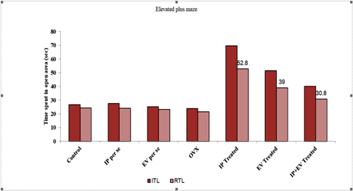

## Fig.1: Impact of various agents utilizing Elevated plus maze on transfer latency (EPM)

n=7, Results are presented as mean± standard deviation with Tukey's multiple range test coming after one-way ANOVA, F (7, 42) = 243.50 a p<0.05 Retention Transfer Latency by control animals; b. p<0.05 vs Retention Transfer Latency in ovariectomy animal. OVX= Ovariectomized; IP per se =Ipriflavone per se; EV per se= Estradiol Valerate; IP Treated = Ipriflavone Treated; EV Treated= Estradiol Valerate Treated; IP+EV Treated=Ipriflavone +Estradiol Valerate Treated.

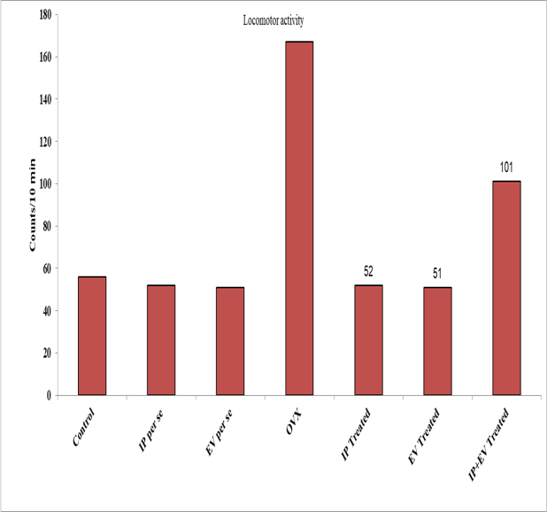

## Fig.2: Impacts of various substances on locomotor activity

n=7, Results are presented as mean± standard deviation with Tukey's multiple range test coming after one-way ANOVA, F (7, 42) = 376.9 a p<0.05 vs control group; b p<0.05 vs overectomized group.OVX= Overectomized; IP per se

=Ipriflavone per se; EV per se= Estradiol Valerate;

IP Treated = Ipriflavone Treated; EV Treated= Estradiol Valerate Treated; IP+EV Treated=Ipriflavone +Estradiol Valerate Treated.

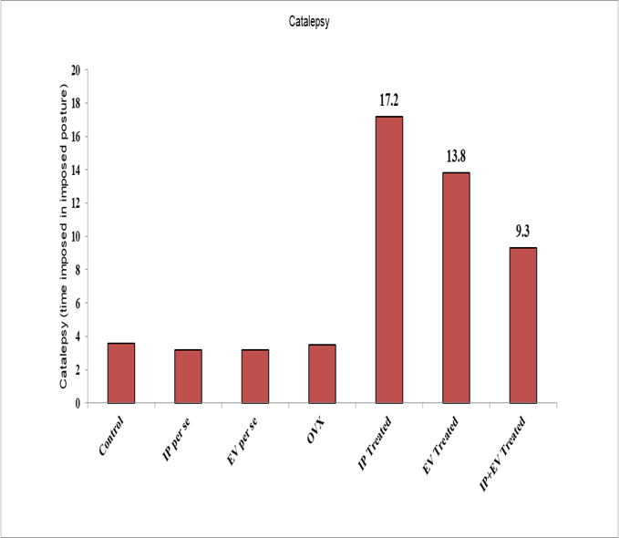

## Fig.3: The impact of different substances on catalepsy

n=7, Results are presented as mean± standard deviation with Tukey's multiple range test coming after one-way ANOVA, F (7,42) = 907.3; a p<0.05 vs control group; b p<0.05 vs ovariectomized group= Ovariectomized; IP per se =Ipriflavone per se; EV per se= Estradiol Valerate; IP Treated = Ipriflavone Treated; EV Treated= Estradiol Valerate Treated; IP+EV Treated=Ipriflavone

+Estradiol Valerate Treated.

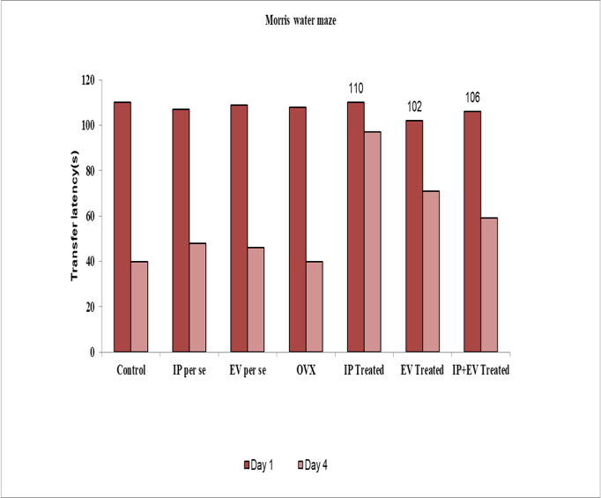

## Fig.4: Using the Morris water maze, the impacts of several agents on transfer latency (MWM)

n=7, Results are presented as mean± standard deviation with Tukey's multiple range test coming after one-way ANOVA, F (7, 42) = 97.3; a p<0.05 versus Retention Transfer latency by control animals; b p<0.05 vs ovariectomized group= Ovariectomized; IP per se =Ipriflavone per se; EV

per se= Estradiol Valerate; IP Treated = Ipriflavone Treated; EV Treated= Estradiol Valerate Treated; IP+EV Treated=Ipriflavone +Estradiol Valerate Treated.

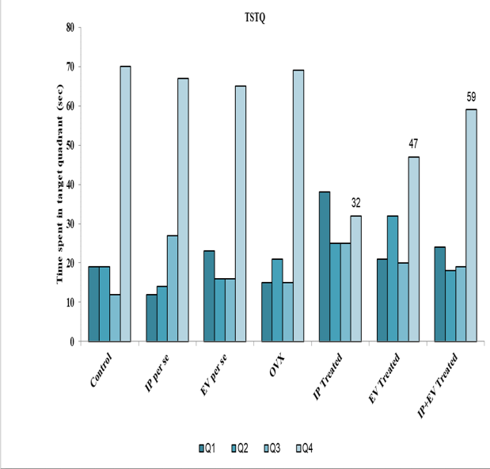

## Fig.5: Using the Morris water maze, the impacts of several agents on time spent in target quadrant (TSTQ) (MWM)

n=7, Results are presented as mean± standard deviation with Tukey's multiple range test coming after one-way ANOVA, F (7, 42) = 49.80, a p0.05 compared the average amount of time the control animals spent in the target quadrant (TSTQ), and b p 0.05 versus the average amount of time the ovariectomized group spent in the TSTQ.OVX= Ovariectomized; IP per se =Ipriflavone per se; EV per se= Estradiol Valerate; IP Treated = Ipriflavone Treated; EV Treated= Estradiol Valerate Treated; IP+EV Treated=Ipriflavone +Estradiol Valerate Treated.

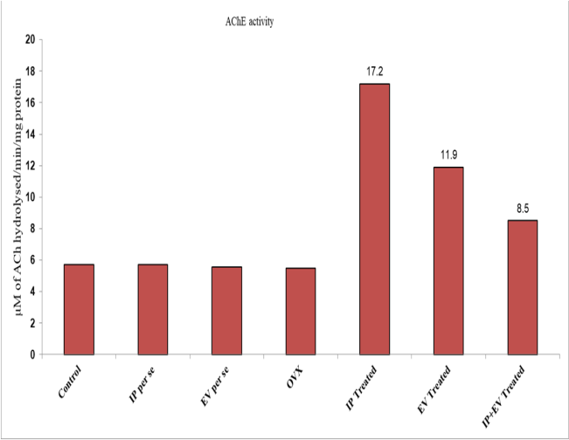

## Fig.6: Impacts of various substances on brains acetyl cholinesterase activity

n=7, Results are presented as mean± standard deviation with Tukey's multiple range test coming after one-way ANOVA, F (7, 42) = 2102; p<0.05 for the control group and group that received ovariectomized group. AChE stands for acetylcholinesterase, OVX= Ovariectomized; IP per se =Ipriflavone per se; EV per se= Estradiol Valerate; IP Treated = Ipriflavone Treated; EV Treated= Estradiol Valerate Treated; IP+EV Treated=Ipriflavone +Estradiol Valerate Treated.

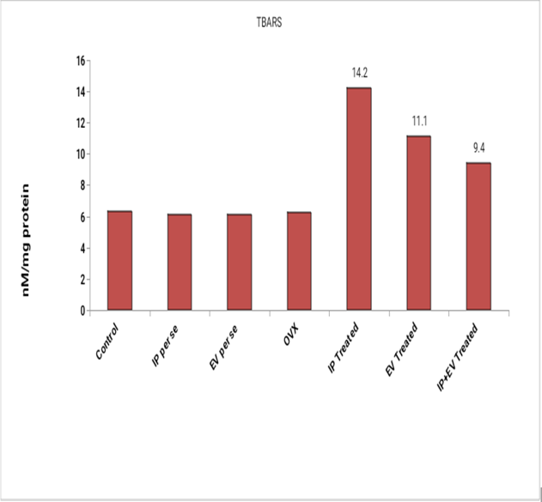

## Fig.7: Impact of different substances on brain TBARS levels

n=7, Results are presented as mean± standard deviation with Tukey's multiple range test coming after one-way ANOVA, F (7, 42) = 376.9, a p<0.05 for the control group and b p<0.05 for the group that ovariectomized. OVX= Ovariectomized; IP per se =Ipriflavone per se; EV per se= Estradiol Valerate; IP Treated = Ipriflavone Treated; EV Treated= Estradiol Valerate Treated; IP+EV Treated=Ipriflavone +Estradiol Valerate Treated.

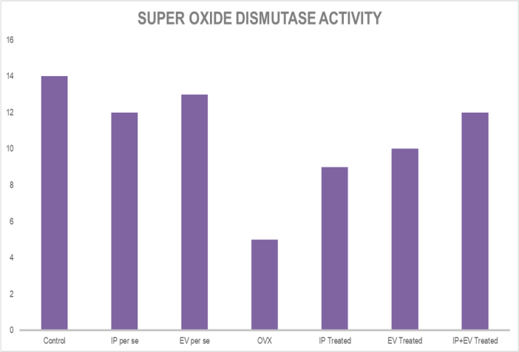

## Fig.8 Impact of different substances on serum oxide dismutase activity

n=7, Results are presented as mean± standard deviation with Tukey's multiple range test coming after one-way ANOVA, F (7, 42) = 32.896; p<0.05for comparison with the control group and the group that ovariectomized. OVX= Ovariectomized; IP per se =Ipriflavone per se; EV per se= Estradiol Valerate; IP Treated = Ipriflavone Treated; EV Treated= Estradiol Valerate Treated; IP+EV Treated=Ipriflavone +Estradiol Valerate Treated.

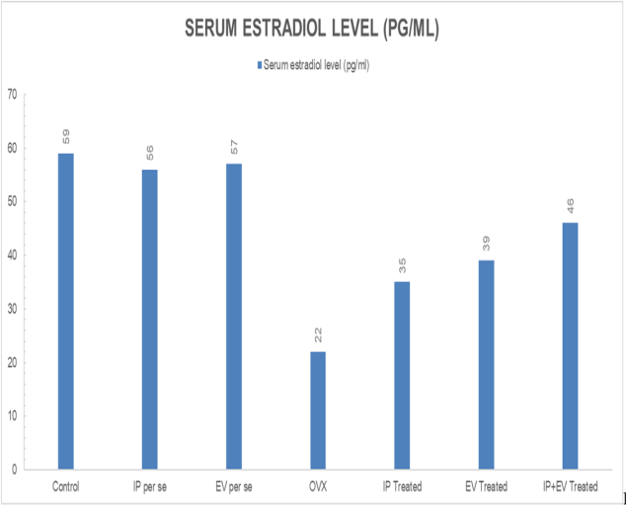

## Fig.7: Impact of different substances on serum estradiol levels

n=7, Results are presented as mean± standard deviation with Tukey's multiple range test coming after one-way ANOVA, F (7, 42) = 376.9, a p<0.05 for the control group and b p<0.05 for the group that ovariectomized. OVX= Ovariectomized; IP per

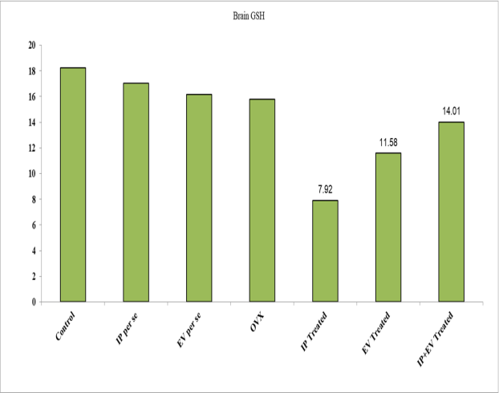

## Fig.8: Impact of different substances on Brain GSH level

n=7, Results are presented as mean± standard deviation with Tukey's multiple range test coming after one-way ANOVA, F (7, 42) = 31.32 a p<0.05 compared the control group b p<0.05 versus the group that ovariectomized. GSH = glutathione, OVX= Ovariectomized; IP per se =Ipriflavone per

se =Ipriflavone per se; EV per se= Estradiol Valerate; IP Treated = Ipriflavone Treated; EV Treated= Estradiol Valerate Treated; IP+EV Treated=Ipriflavone +Estradiol

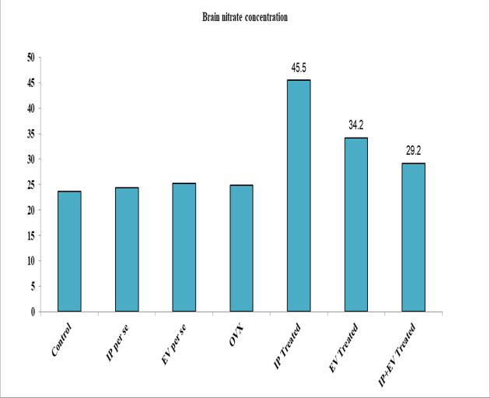

## Fig.9: Impact of different substances on Brain nitrate/nitrite concentration

n=7, Results are presented as mean± standard deviation with Tukey's multiple range test coming after one-way ANOVA, F (7, 42) = 42.32 a p<0.05compared the control group b p<0.05 versus the group that ovariectomized. OVX= Ovariectomized; IP per se =Ipriflavone per se; EV per se= Estradiol Valerate; IP Treated = Ipriflavone Treated; EV Treated= Estradiol Valerate Treated; IP+EV Treated=Ipriflavone +Estradiol Valerate Treated.

se; EV per se= Estradiol Valerate; IP Treated = Ipriflavone Treated; EV Treated= Estradiol Valerate Treated; IP+EV Treated=Ipriflavone

+Estradiol Valerate Treated.

## Histopathology:

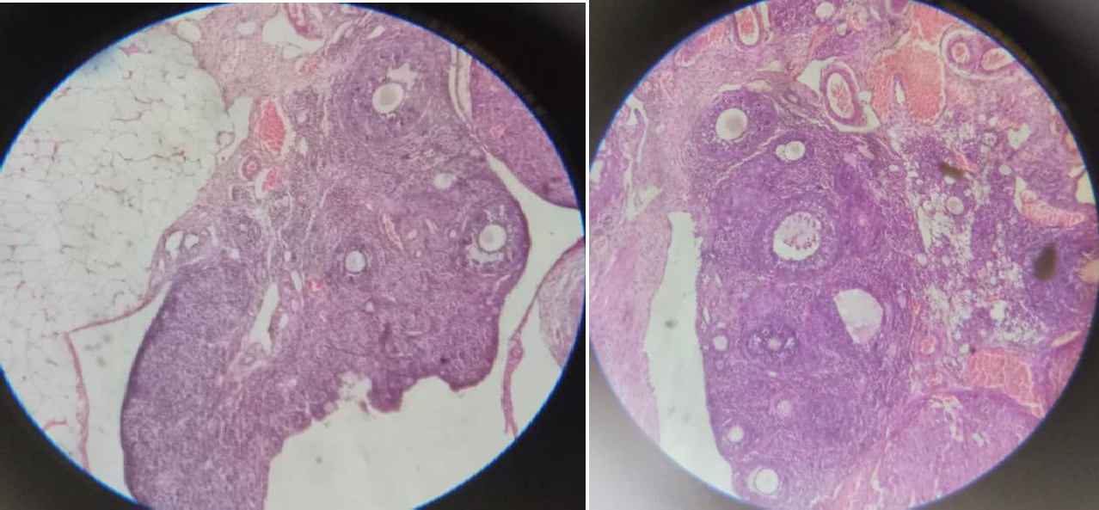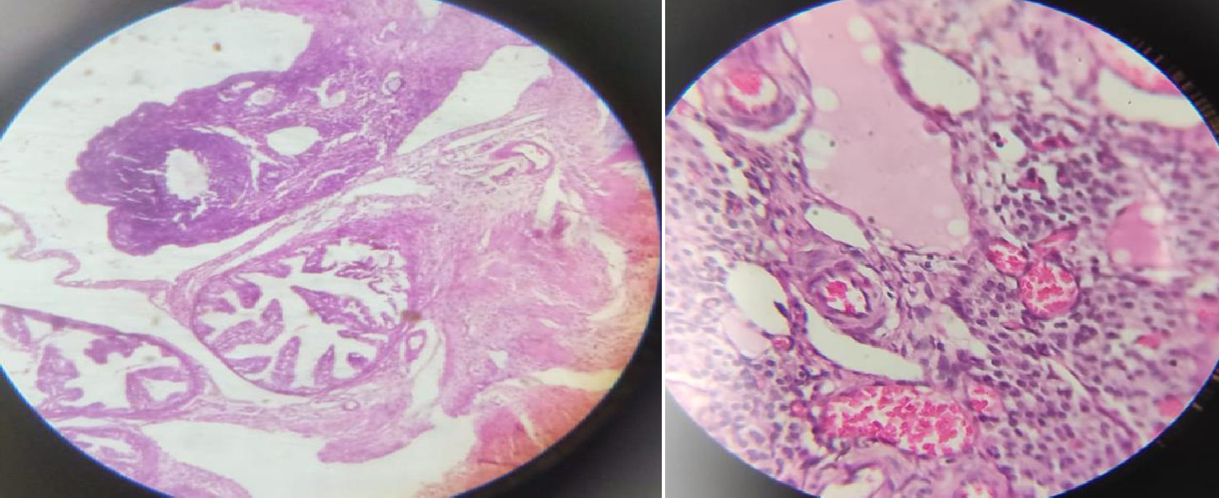

**Fig.11:** Ovary endometrial histopathology; x10 magnification, H&E staining ( C-Control group; OVX- Overectomized group; EV- Estradiol Valerate dose; IP- Ipriflavone dose; IP+EV- Estradiol Valerate+Ipriflavone)

## Discussion

In this study, researchers have explored the effects of changing E2 level on cognitive functioning with advancing age. We have identified that E2 may interact with three systems within the brain important to cognitive aging: the basal forebrain cholinergic system, the dopaminergic system, and the mitochondrial bioenergetic system. Declining E2 levels have been linked with decreased cognitive performance in clinical and preclinical studies, with E2 treatment attenuating these symptoms. In both clinical and preclinical studies, the timing of the treatment may be important, and this critical window may be linked to the declining cholinergic system. Some later life disorders appear to show a link to reduced E2 levels and the timing of menopause, particularly Alzheimer’s disease and depression.

Alzheimer’s disease shows a higher incidence in women, particularly in women who have

experienced an earlier menopause. In addition, schizophrenia displays a second peak of onset in midlife in women, around the time of menopause, and an early age of first menarche appears protective against developing schizophrenia. Given the cholinergic, dopaminergic, and mitochondrial systems are dysregulated in a number of neurodegenerative diseases associated with aging (e.g., Alzheimer’s disease) utilization of E2 therapy has been explored in with a number of clinical trials without success to date [21, 22, 23].

However, it may be that E2 treatment needs to be specifically tailored based on the patients risk profile. The preclinical studies assessing time of E2 delivery with reference to time of reduced E2, and method of E2 delivery, cyclic versus non-cyclic, with or without progesterone provide possible explanations of the disparate results that are seen in the clinical literature. It should also be noted that the nature of the menopause (natural or induced) may be important in dictating the efficacy of

potential treatment. Further, not only are the majority of the positive effects of treatment on cognitive end-points seen when the treatment is given around the time of the menopause transition, but this is also the time when the greatest structural and estrogen receptor changes are seen. One concept that will become increasingly important over the coming years is that of personalized or precision medicine. Specifically, identification of which individuals may benefit from E2 therapy and which individuals will not. To enable this, genomics approaches assessing the effects of genetic variables and different phenotypic presentations on response to different treatments should be utilized. This strategy will enable the maximal benefit to be obtained without treating individuals that do not require treatment and/or leading to increased risk without corresponding benefit. The presence of subjective cognitive decline (SCD), a known risk factor for the development of cognitive decline and dementia, that first occurs during or after menopause may indicate a higher risk population for which specific therapies may be helpful [24]. Additionally, it has been suggested that a neuroprotective effect of E2 may be dependent on apolipoprotein E genotype, although the specifics of this interaction are still not fully understood [25].

This does however provide evidence that based on age, phenotype, and genotype, it may be possible to identify patients that are at a higher risk of developing Alzheimer’s disease and may potentially benefit from E2 therapy.

With regard to depressive disorders, it is known that previous depressive episodes prior to the menopausal transition increases the risk of further depressive episodes following menopause in the absence of E2 therapy. Given the highly polymorphic nature of presence or absence of clinical signs following menopause, it is possible that specific phenotypes or genotypes predispose women to developing mood dysfunction following the menopause transition. Future studies that investigate whether specific phenotypes or genotypes predispose to cognitive or mood dysfunction following menopause, or whether specific genotypes predispose to responsiveness to specific therapies, would allow for greatly improved targeting of therapies by identifying only those individuals that will likely be responsive to treatment.

Since the publication of the Women’s Health Initiative studies beginning in the early 2000s, there has been a decline in the prescription of sex hormone treatment for postmenopausal symptomatology and presumed disease prevention. This decline was in part appropriate but the

subtleties of the WHI studies and their findings have not been as widely appreciated by clinicians and thus the risks of sex hormone prescription may be perceived as larger than the actual data would support. Future research will help clarify which hormone preparations may be potentially useful and at what stage of life. Rather than ubiquitous prescription for all postmenopausal women, selective use of sex hormone treatment will be aided by better differentiation of which women have higher or lower risk for late life cognitive or emotional impairment. In addition, novel hormone preparations or SERMs may be developed that allow for brain-specific effects without risks to peripheral tissues.

With the interaction of E2 and cholinergic, dopaminergic, and mitochondrial bioenergic systems, it should be considered that targeting of these systems may have E2 sparing effects, or potentiate E2 beneficial effects. Acetylcholinesterase inhibitors are the leading treatment for Alzheimer’s disease, which function through boosting cholinergic synaptic signaling. Gibbs and colleagues demonstrated acetylcholinesterase inhibitors can potentiate the effects of E2 in aged rats following prolonged estrogen deprivation. In clinical populations, it has been demonstrated that females who received the acetylcholinesterase inhibitors tacrine in conjunction with estradiol displayed a greater response on cognitive assessment that females who were not receiving concurrent estradiol therapy [26].

Thus combined hormonal and neurotransmitter based approaches may increase the beneficial effects of both individual therapeutic strategies. Direct targeting of the specific cholinergic receptors is also becoming an area of interest for boosting the failing cholinergic system in Alzheimer’sdisease [27, 28].

For example, selective M1 acetylcholine receptor positive allosteric modulators (PAMs) has been of particular interest in Alzheimer’s disease, with efficacy seen across cognitive and biomarker measures in preclinical species [29, 30].

Identification of at-risk individuals, for example individuals who are displaying SCD, asymptomatic, or early symptomatic increased β- amyloid plaque deposition could provide a population for combined treatment approaches. In future studies, it will be critical to understand the potential for M1 PAMs to act synergistically with E2 replacement (or similar hormonal approaches) to restore the cognitive and affective deficits associated with aging and pathologic decline such

as Alzheimer’s disease in preclinical species and clinical populations.

## Conclusions

Overectomized (25mg/kg intraperitoneally once daily for 7 days) administered animals exhibited increased locomotion, increased catalepsy behavior, impaired spatial learning memory, increased anxiety. These rats also shown biochemical changes like enhanced oxidative stress (enhanced lipid peroxide), increased creatinine kinase and disturbed cholinergic function (increased acetylcholinesterase activity). The Morris Maze Water was used to measure memory and learning impairment. To gauge anxiety, the Elevated Plus Maze was employed. The Actophotometer was used to measure locomotor activity.The metal bar was used to measure catalepsy. The glass box was used to measure climbing behavior. Rat brain homogenate and serum were used for the biochemical evaluation. Administration of Ipriflavone and estradiol Valerate (a phosphodiesterase-3- inhibitor) (50mg kg −1, oral and 100 mg kg−1, oral., 90 days) considerably restored locomotion, decreased catalepsy sbehavior, decreased anxiety and improved spatial learning memory. These rats also exhibited biochemical changes like decreased oxidative stress, decreased creatinine kinase and restored cholinergic function in Overectomized injected animals.

# REFERENCES

1. Panza F, D’Introno A, Colacicco A, et al. Cognitive frailty: Predementia syndrome and vascular risk factors.
2. Neurobiol Aging 2006;27: 933–40 2. Petersen RC, Doody R, Kurz A, et al. Current concepts in mild cognitive impairment. Arch Neurol 2001;58:1985–92
3. Selkoe DJ. Translating cell biology into therapeutic advances in Alzheimer’s disease. Nature 1999;399(Suppl):A23–31
4. Henderson VW. Menopause and disorders of the central nervous system. Minerva Ginecol 2005; 57:579–92
5. Cholerton B, Gleason CE, Baker LD, Asthana

S. Estrogen and Alzheimer’s disease: the story so far. Drugs Aging 2002;19:405–27

1. Bimonte-Nelson HA, Francis KR, Umphlet CD, Granholm AC. Progesterone reverses the spatial memory enhancements initiated by tonic and cyclic oestrogen therapy in middle-aged ovar iectomized femali rats. Eur J Neurosci 2006;24: 229–42
2. Daniel JM, Hulst JL, Berbling JL. Estradiol replacement enhances working memory in mid dle- aged rats when initiated immediately after

ovariectomy but not after a long-term period of ovarian hormone deprivation. Endocrinology 2006;147:607–14

1. Hogervorst E, Yaffe K, Richards M, Huppert

F. Hormone replacement therapy for cognitive function in postmenopausal women. Cochrane Database Syst Rev 2002;3:CD003122

1. Kurt M, Bekci B, Karakas S. Hormone replace ment therapy and cognition in postmenopausal women. Maturitas 2006;53:39–48
2. Low IF, Anstev KJ. Hormone replacement therapy and cognitive performance in postme nopausal women– a review by cognitive domain. Neurosci 2006;30:66–84.
3. Benedetti MD, Maraganore DM, Bower JH, et al. Hysterectomy, menopause, and estrogen use preceding Parkinson’s disease: An exploratory case-control study. Mov. Disord. 2001;16:830–837.
4. Lv M, Zhang Y, Chen G, et al. Reproductive factors and risk of Parkinson’s disease in women: A meta-analysis of observational studies. Behav. Brain Res. 2017;335:103–110.
5. Liu R, Baird D, Park Y, et al. Female reproductive factors, meno- pausal hormone use, and Parkinson’s disease. Mov. Disord. 2014;29:889–896.
6. Litim N, Morissette M, Di Paolo T. Neuroactive gonadal drugs for neuroprotection in male and female models of Parkinson’s disease. Neurosci. Biobehav. Rev. 2016;67:79–88.
7. Marder K, Tang MX, Alfaro B, et al. Postmenopausal estrogen use and Parkinson’s disease with and without dementia. Neurology. 1998;50:1141–1143.
8. Labandeira-Garcia JL, Rodriguez-Perez AI, Valenzuela R, et al. Menopause and Parkinson’s disease. Interaction between estro- gens and brain renin-angiotensin system in dopaminergic degen- eration. Front. Neuroendocrinol. 2016;43:44–59.
9. Re RN. Tissue renin angiotensin systems. Med. Clin. North Am. 2004;88:19–38.
10. Garrido AM, Griendling KK. NADPH oxidases and angiotensin II receptor signaling. Mol. Cell. Endocrinol. 2009;302:148–158.
11. Garrido-Gil P, Valenzuela R, Villar-Cheda B, et al. Expression of angiotensinogen and receptors for angiotensin and prorenin in the monkey and human substantia nigra: an intracellular renin- angiotensin system in the nigra. Brain Struct. Funct. 2013;218: 373–388.
12. Muñoz A, Rey P, Guerra MJ, et al. Reduction of dopaminergic degeneration and oxidative stress

by inhibition of angiotensin converting enzyme in a MPTP model of parkinsonism. Neuropharmacology. 2006;51:112–120.

1. Joglar B, Rodriguez-Pallares J, Rodriguez- Perez AI, et al. The inflammatory response in the MPTP model of Parkinson’s disease is mediated by brain angiotensin: relevance to progression of the disease. J. Neurochem. 2009;109:656–669.
2. Rodriguez-Perez AI, Borrajo A, Valenzuela R, et al. Critical period for dopaminergic neuroprotection by hormonal replacement in menopausal rats. Neurobiol. Aging. 2015;36:1194– 1208.
3. Harman D. Free radical theory of aging: Consequences of mito- chondrial aging. Age (Omaha). 1983;6:86–94.
4. Swerdlow RH, Khan SM. A “mitochondrial cascade hypothesis” for sporadic Alzheimer’s disease. Med. Hypotheses. 2004;63:8– 20.
5. Croteau E, Castellano CA, Fortier M, et al. A cross-sectional com- parison of brain glucose and ketone metabolism in cognitively healthy older adults, mild cognitive impairment and early Alzheimer’s disease. Exp. Gerontol. 2018;107:18– 26.
6. Mosconi L, Mistur R, Switalski R, et al. FDG- PET changes in brain glucose metabolism from normal cognition to pathologically verified Alzheimer’s disease. Eur. J. Nucl. Med. Mol. Imaging. 2009;36:811–822.
7. Yao J, Irwin RW, Zhao L, et al. Mitochondrial bioenergetic deficit precedes Alzheimer’s pathology in female mouse model of Alzheimer’s disease. Proc. Natl. Acad. Sci. U. S. A. 2009;106: 14670–14675.
8. Mosconi L, Berti V, Quinn C, et al. Perimenopause and emergence of an Alzheimer’s bioenergetic phenotype in brain and periphery. PLoS One. 2017;12:e0185926.
9. Yin F, Yao J, Sancheti H, et al. The perimenopausal aging transi- tion in the female rat brain: decline in bioenergetic systems and synaptic plasticity. Neurobiol. Aging. 2015;36:2282–2295.
10. Rasgon NL, Silverman D, Siddarth P, et al. Estrogen use and brain metabolic change in postmenopausal women. Neurobiol. Aging. 2005;26:229–235.
11. Prakash1*, FORMULATION AND EVALUATION OF HERBAL ANTI-ACNE GEL

Journal of Pharmaceutical Negative Results ¦ Volume 13 ¦ Special Issue 6 2022.

1. *Satya Prakash1, To Study the Antiulcer Activity of Hydro Alcoholic Extract of Euphorbia Thymifolia on Absolute Ethanol Induced Ulcer in Rats. European Journal of Molecular & Clinical Medicine ISSN 2515-8260 Volume 10, Issue 1

2023.

1. Satya Prakash, et. al., 2022 Guidelines for Approval of Clinical Trials and Study Reports of SARS Covid-19 Vaccines. IJPRA, ISSN: 2456- 4494. 64. et al., S. P. (2019). FORMULATION AND EVALUATION OF FLOATING TABLET

OF ZOLMITRIPTAN TABLET. International Journal of Advanced Science and Technology, 28(17), 82.

1. Satya Prakash, et. al., 2023 Gold Nanoparticles for Targeted and Selective Delivery of Cancer Chemotherapeutics: A Review of the Literature (Eur. Chem. Bull. 2023, 12 (Special Issue 1), 2896-2901).
2. Formulation and Evaluation of Floating Tablet Zolmitriptan. (International Journal of Advanced Science and Technology Vol. 28 No. 17 (2019):

Vol 28 No 17 (2019)

1. Schmidt R, Schmidt H, Curb JD, et al. Early inflammation and dementia: A 25-year follow-up of the Honolulu-Asia aging study. Ann. Neurol. 2002;52:168–174.
2. Teunissen CE, van Boxtel MPJ, Bosma H, et al. Inflammation markers in relation to cognition in a healthy aging population. J. Neuroimmunol. 2003;134:142–150.
3. Banks WA, Farr SA, La Scola ME, et al. Intravenous human interleukin-1alpha impairs memory processing in mice: depen- dence on blood-brain barrier transport into posterior division of the septum. J. Pharmacol. Exp. Ther. 2001;299:536–541.
4. Jiang Q, Li W, Sun J, et al. Inhibitory effect of estrogen receptor beta on P2X3 receptors during inflammation in rats. Purinergic Signal. 2017;13:105–117.
5. Cipolla MJ, Godfrey JA, Wiegman MJ. The effect of ovariectomy and estrogen on penetrating brain arterioles and blood-brain bar- rier permeability. Microcirculation. 2009;16:685–693.
6. Brown CM, Mulcahey TA, Filipek NC, et al. Production of pro- inflammatory cytokines and chemokines during neuroinflamma- tion: novel roles for estrogen receptors alpha and beta. Endocrinology. 2010;151:4916–4925.
7. Pfeilschifter J, Köditz R, Pfohl M, et al. Changes in Proinflammatory Cytokine Activity after Menopause. Endocr. Rev. 2002;23:90–119.
8. Störk S, von Schacky C, Angerer P. The effect of 17beta-estradiol on endothelial and inflammatory markers in postmenopausal women: a randomized, controlled trial. Atherosclerosis. 2002;165:301–307.
9. Kalyan S, Hitchcock CL, Pudek M, et al. Acute Effects of Premenopausal Hysterectomy with Bilateral Oophorectomy on Serum Lipids, Hormonal Values, Inflammatory Markers, and Metabolism. J. Gynecol. Surg. 2011;27:9–15.
10. Calsolaro V, Edison P. Neuroinflammation in Alzheimer’s disease: Current evidence and future directions. Alzheimer’s Dement. 2016;12:719–732.
11. Glass CK, Saijo K, Winner B, et al. Mechanisms underlying in- flammation in neurodegeneration. Cell. 2010;140:918–934.
12. Shumaker SA, Legault C, Kuller L, et al. Conjugated Equine Estrogens and Incidence of Probable Dementia and Mild Cognitive Impairment in Postmenopausal Women: Women’s Health Initiative Memory Study. JAMA. 2004;291:2947.
13. Espeland MA, Rapp SR, Shumaker SA, et al. Conjugated Equine Estrogens and Global Cognitive Function in Postmenopausal Women: Women’s Health Initiative Memory Study. JAMA. 2004;291:2959.
14. Sherwin BB. Estrogen therapy: is time of initiation critical for neuroprotection? Nat. Rev. Endocrinol. 2009;5:620–627.
15. Maki PM, Zonderman AB, Resnick SM. Enhanced Verbal Memory in Nondemented Elderly Women Receiving Hormone- Replacement Therapy. Am. J. Psychiatry. 2001;158:227–233.
16. Resnick SM, Metter EJ, Zonderman AB. Estrogen replacement therapy and longitudinal decline in visual memory. A possible protective effect? Neurology. 1997;49:1491–1497.
17. Hao J, Rapp PR, Janssen WGM, et al. Interactive effects of age and estrogen on cognition and pyramidal neurons in monkey pre- frontal cortex. Proc. Natl. Acad. Sci. U. S. A. 2007;104:11465– 11470.
18. Kohama SG, Renner L, Landauer N, et al. Effect of Ovarian Hormone Therapy on Cognition in the Aged Female Rhesus Macaque. J. Neurosci. 2016;36:10416–10424.
19. Gibbs RB. Long-term treatment with estrogen and progesterone enhances acquisition of a spatial memory task by ovariectomized aged rats☆. Neurobiol. Aging. 2000;21:107–116.
20. Gibbs RB. Estrogen Therapy and Cognition: A Review of the Cholinergic Hypothesis. Endocr. Rev. 2010;31:224–253.