

**International Journal of Research Development and Technology Vol.2, Issue.2, Year 2024 ISSN: 2584-0290**

**Web:** [www.ijrdt.com](http://www.ijrdt.com/)

# Evaluation of Anti-Diabetic Potential Of Helianthus Annuus Seed & Syzygium Cumini in the Suitable Experimental Model

Tarun Singh*1, Dr Nasiruddin Ahmad Farooqui*2 Translam Institute of Pharmaceutical education and Research, Meerut

Email id: [tarunkumar2847@gmail.com](mailto:tarunkumar2847@gmail.com)

**\*\*\*\*\*\*\*\*\*\*\*\*\*\*\*\*\*\*\*\*\*\*\*\*\*\*\*\*\*\*\*\*\*\*\*\*\*\*\*\*\*\*\*\*\*\*\*\*\*\*\*\*\*\*\*\*\*\*\*\*\*\*\*\*\*\*\*\*\*\*\*\*\*\*\*\*\*\*\*\*\*\***

***ABSTRACT-***

*Diabetes Mellitus is a rapidly growing global health concern with significant morbidity and mortality rates. With the limitations of current treatment modalities, research focus is shifting towards exploring potential medicinal properties of natural substances. This study aims to investigate the anti-diabetic properties of Helianthus annuus (sunflower) seeds and Syzygium cumini (Java plum) in a relevant experimental model. These plants have been traditionally used in folk medicine, and previous studies have suggested potential anti-diabetic activity. Our research will focus on assessing their influence on blood glucose levels, insulin resistance, lipid profiles, and oxidative stress markers. The findings of this study will provide valuable insights into the therapeutic potential of these plants in diabetes management, contributing to the ongoing search for effective, safe, and affordable plant-based therapies for diabetes. A comprehensive evaluation may pave the way for the development of novel, plant-derived anti- diabetic therapies.*

***Key words:*** *Diabetes Mellitus, Anti-diabetic therapies, Helianthus annuus, Sunflower seeds, Syzygium cumini, Java plum*

**\*\*\*\*\*\*\*\*\*\*\*\*\*\*\*\*\*\*\*\*\*\*\*\*\*\*\*\*\*\*\*\*\*\*\*\*\*\*\*\*\*\*\*\*\*\*\*\*\*\*\*\*\*\*\*\*\*\*\*\*\*\*\*\*\*\*\*\*\*\*\*\*\*\*\*\*\*\*\*\*\*\***

# Introduction:

Diabetes Mellitus, a metabolic disorder characterized by persistent hyperglycemia, is rapidly becoming a global health crisis. The World Health Organization estimates that the number of adults living with diabetes has nearly quadrupled since 1980, reaching an estimated 422 million worldwide in 2014[1.](https://chat.openai.com/?model=gpt-4&user-content-fn-1%5E) In spite of numerous advances in pharmacotherapy, diabetes and its associated complications continue to represent a significant burden on global health[2.](https://chat.openai.com/?model=gpt-4&user-content-fn-2%5E)

In recent years, there has been an increasing interest in the investigation of medicinal plants and their bioactive components for their potential anti-diabetic properties[3.](https://chat.openai.com/?model=gpt-4&user-content-fn-3%5E) Plant-derived substances have historically played a significant role in healthcare, and with their wide diversity and accessibility, they offer a potential treasure trove for new anti-diabetic medications[4.](https://chat.openai.com/?model=gpt-4&user-content-fn-4%5E)

Helianthus annuus, commonly known as sunflower, is a globally cultivated plant species that has been traditionally used for various therapeutic purposes[5.](https://chat.openai.com/?model=gpt-4&user-content-fn-5%5E) Particularly, its seeds have been reported to possess anti-diabetic properties[6.](https://chat.openai.com/?model=gpt-4&user-content-fn-6%5E) Similarly, Syzygium cumini,

also known as the Java plum or black plum, has a rich history in traditional medicine. Preparations from this plant have been used for centuries to treat various diseases, including diabetes[7.](https://chat.openai.com/?model=gpt-4&user-content-fn-7%5E)

However, the exact mechanisms of the anti-diabetic effects of Helianthus annuus seeds and Syzygium cumini remain largely underexplored. This research aims to evaluate the anti-diabetic potential of these plants in a suitable experimental model, thus contributing to the expanding body of literature exploring plant-based therapies for diabetes.

Diabetes mellitus is classified into two main types: Type 1 and Type 2. Type 1 diabetes is an autoimmune condition, where the body's immune system destroys the insulin-producing beta cells of the pancreas. Type 2 diabetes, which accounts for about 90% of all cases of diabetes, is characterized by insulin resistance, where the body's cells fail to respond to insulin effectively8. Both forms result in high blood glucose levels that, if left uncontrolled, can lead to a variety of complications including heart disease, stroke, kidney disease, and blindness9.

The use of medicinal plants in treating various

diseases is a centuries-old practice, and many currently available drugs are derived from plant sources10. In the case of diabetes, several plants have been identified with potential anti-diabetic properties, such as Gymnema sylvestre, Pterocarpus marsupium, and Momordica charantia11.

Helianthus annuus seeds and Syzygium cumini have been identified as potential candidates for the development of novel anti-diabetic therapies. Previous studies have reported hypoglycemic and antioxidant effects of sunflower seeds12, while Syzygium cumini has demonstrated potential in reducing blood glucose levels and improving lipid profile in diabetic animals13.

Plant-based treatments for diabetes not only offer potential direct blood glucose-lowering effects, but also other desirable features such as antioxidant, anti- obesity, and cardioprotective properties14. Therefore, the use of medicinal plants in diabetes management might also help in addressing the multidimensional aspects of the disease, beyond just glucose control.

The Helianthus annuus (sunflower) plant, particularly its seeds, are known for their rich nutrient content including essential fatty acids, vitamins, and dietary fiber15. The sunflower seed's potential anti-diabetic effect could be attributed to its dietary fiber content, which can slow the absorption of sugar into the bloodstream and thus, prevent sudden spikes in blood glucose levels16.

On the other hand, Syzygium cumini (Java plum) has been used in traditional medicine for a variety of conditions such as diabetes, inflammation, and gastric disorders. Several scientific studies have reported its potential anti-diabetic activity. The anti-diabetic effect of Syzygium cumini could be linked to its rich phenolic and flavonoid content, which are known for their antioxidant activity and potential insulin- enhancing capacity17.

## Methodology

**Acquisition and Authentication of Plant Material** The seeds of Syzygium cumini (L) Skeels and Helianthus annuus were locally procured from a herbal store in Mawana, Meerut, India. The NISCAIR, New Delhi, authenticated the raw plant materials and assigned the corresponding voucher specimen numbers: Syzygium cumini (L) Skeels : Reference letter number 1854710/PH/TIPER/23, issued on 13/03/2023 and H. annuus: Reference letter number 1854520/PH/TIPER/23, issued on 23/01/2023. These voucher specimens have been retained for future reference.

## Cold Press Technique for Seed Oil Extraction

The seeds from Syzygium cumini (L) Skeels and H. annuus were sun-dried and subsequently ground into

coarse powder. The seeds were mechanically compressed at room temperature (25°C) without any heat exposure. After being pressed, the seeds were left undisturbed overnight at room temperature (25°C) to allow the oil to separate. The oil was later purified using Whatman No.4 filter paper and a glass funnel.

## Phytochemical Investigation

The extracted oils from Syzygiumcumini (L) Skeels and H.annus were subjected to phytochemical screening to identify various phytoconstituents like carbohydrates, alkaloids, glycosides, steroids, tannins, etc.

1. Identifying Carbohydrates The extract (100 mg) was filtered into a solution of 5 mL of water. The following analyses were performed on the filtrate:

* Molish'sTest - The presence of carbohydrates was determined by adding 2% w/v of a-naphthol solution and concentrated sulphuric acid to the filtrate, which resulted in the formation of a red-violet ring at the interface of the two layers.
* Fehling's Test:

The presence of carbohydrates was confirmed by the production of a brick-red precipitate upon boiling with Fehling's solutions A and B.

1. The Keller-Kiliani Test for Detecting Cardiac Glycosides In order to add the extract to the concentrated H2 SO4, around 0.5 g was dissolved in glacial acetic acid with a drop of 1% Ferric chloride. Cardenolides are characterized by the presence of a brown ring in the interphase, which is caused by the presence of deoxy sugar. The presence of cardiac glycosides was shown by two concentric rings of color, one violet below the brown ring and one greenish above it, visible throughout the acetic acid layer.
2. Identifying Saponins from Candida

* Foam Test—After 15 minutes of shaking the diluted extract in a graduated cylinder, the presence of saponins was determined by the creation and persistence of a 1cm layer of foam.

1. Identifying Proteins and Amino Acids Filtered 10 mL of distilled water was used to dissolve the extract (100 mg). Proteins and amino acids were analyzed in the filtrate. Using a 2% copper sulfate solution, 95% ethanol, and KOH pellets, the filtrate became pink, indicating the presence of proteins (Biuret Test).

**E** •Ninhydrin Test—When ninhydrin solution was added to the filtrate, a distinctive purple tint indicated the presence of amino acids.

Libermann-Burchard Test for Phytosterols Identification Concentrated sulfuric acid was progressively added to a solution of the extract (50 mg) in 2 mL acetic anhydride. Phytosterols were

present when a brown ring formed around the outside edge, and a green layer formed on top.

* 1. Identifying Tannins and Phenolic Compounds When a neutral 0.1% ferric chloride solution was added to the dissolved extract, a dark green or blue- black hue appeared, indicating the presence of phenolic chemicals and tannins.
  2. Characterization of Alkaloids After filtering, 50 mg of solvent-free extract was mixed with a dilution of hydrochloric acid. The presence of alkaloids was confirmed by using several different alkaloidal reagents on the filtrate. These included the Mayer, Wagner, Hager, and Dragendorff tests.
  3. Salkowski Test for Identifying Terpenoids,

When the extract was mixed with chloroform and concentrated H2 SO4, a reddish-brown tint appeared at the interface, indicating the presence of terpenoids. Identifying Quinones, When the plant extract was shaken vigorously with a few drops of Sodium hydroxide, a blue-green or red hue appeared, indicating the presence of quinones.

* 1. Identifying Flavonoids:

The addition of ethanol, concentrated hydrochloric acid, and magnesium ribbon to the extract and subsequent heating revealed the presence of flavonoids (Shinoda's Test).

* Lead Acetate Test - The presence of flavonoids was confirmed by the production of a yellow precipitate upon adding an equivalent amount of Lead acetate solution to the extract.
* Mineral Acid Test - The addition of 2 mL of concentrated H2 SO4 to the extract resulted in a yellow to orange hue, indicating the presence of flavonoids.

## Chromatographic Analysis

GCMS analysis: GCMS of the Oils will be performed outside the institute.

Animals studies: The protocol of the study was submitted to the Institutional Animal Ethical Committee (1207/PO/Re/S/08/CPCSEA) dated 17 December 2019 and the approved for conducting the animal activity.

**Table.1:** showing the description of animal study

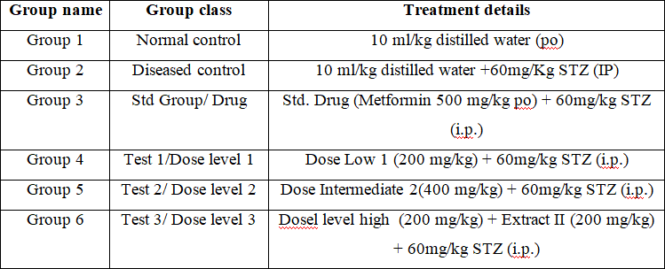

## Biochemical analysis

Blood glucose analysis before and after the administration of STZ.

## Histopathological studies

At the end of the study period, animals from experimental group were sacrificed liver andheart were collected. The transverse section of liver and heart were prepared using the usual techniques for preparation of permanent slides and these sections were observed for Histopathological changes in liver and heart cells. Histopathological analysis of liver and heart were examined under light microscope.

## Statistical analysis

Mean + Standard Error of the Mean is how the data was presented. Graph pad PRISM version 5.0 was used for statistical analysis, and a significance level of 0.05 was used for the results of the analysis of variance and the Dunnett's multiple comparison tests. **Result and discussion**

Extraction Process: The process of extraction started with the collection of 2 kilograms of plant material from each of the selected plants - Syzygium cumini and Helianthus annuus. The seeds were then subjected to a meticulous extraction process. Initially, the seeds were air-dried to remove any moisture content. After drying, the seeds were crushed into smaller fragments to increase the surface area for the subsequent extraction step. This crushing process was followed by another round of drying to ensure complete moisture removal. The dried and crushed seeds were then ground into a coarse powder, which was key to maximizing the yield of the extraction.

With the powdered plant material ready, the extraction process was initiated. The process employed was cold compression, an effective technique that does not involve the use of heat. This ensured that the heat-sensitive components of the seeds were not damaged or altered during the extraction process. The extraction was carried out

exhaustively to yield the maximum amount of oil.

**Table.2:** Properties of seeds of *Syzygiumcumini* and

*H .annus* extract

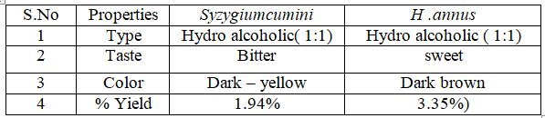

**Table.3:** Indicating the Moisture content in

*Syzygiumcumini*

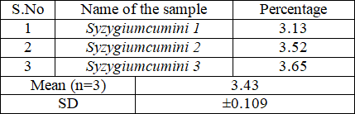

**Table.4:** Indicating the Moisture content in *H .annus*

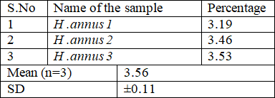

**Table.5:** Indicating Foreign matter values in

*Syzygiumcumini* crude drug

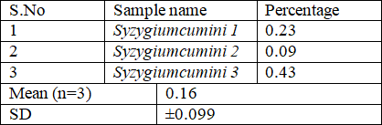

**Table.6:** Indicating Foreign matter values in *H .annus*

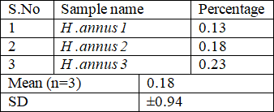crude drug

**Table.7:** Indicating Total Ash values of

*Syzygiumcumini*

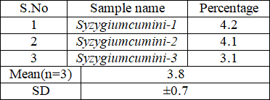

**Table.8:** Indicating Total Ash values of *H. annus*

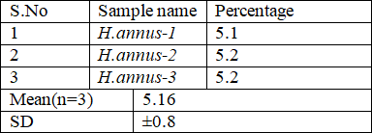

**Table.9:** Indicating Total Ash values of

*Syzygiumcumini*

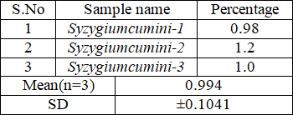

**Table.10:** Indicating water insoluble Ash values of *H*

*.annus*

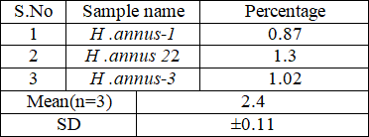

**Table.11:** Indicating acid insoluble of

*Syzygiumcumini* Acid

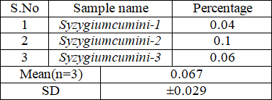

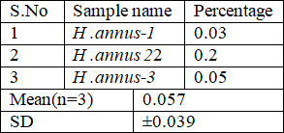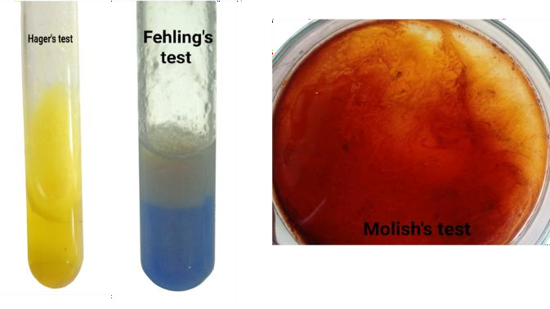**Table.12:** Indicating acid insoluble of *H .annus* Acid

**Table.13:** Indicating water soluble extractives values of *Syzygiumcumini* Acid

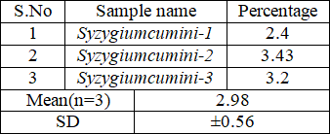

**Table.14:** Indicating water soluble extractives values of *H .annus*

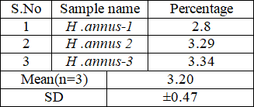

**Table.15:** Indicating methanol soluble extractives values *Syzygiumcumini*

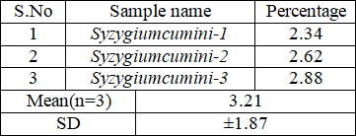

**Table.16:** Indicating methanol soluble extractives values *H .annus*

**Fig.1:** Showing the different Pharmacognostical test performed during the experiment

## Animal Study:

A reduction in food and water intake often signifies a decline in health or poor health status, typically leading to body weight loss. Variations in body weight have also been employed as a marker of the negative impact of pharmaceutical substances and chemicals. After a treatment period of 21 days, a significant weight gain was observed in the normal rats, those treated with Syzygium cumini and H.annus, and the group administered the standard drug. In contrast, the body weight of the diabetic control group rats declined. The investigation indicates that the oils are safe for use, as no substantial alterations were noted in the treated animals' behavior and body weight compared to the control group.

**Table.17:** Effect of *Syzygiumcumini and H .annus*

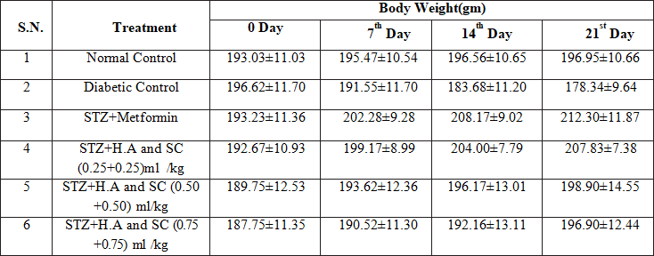on body weight

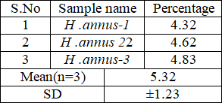

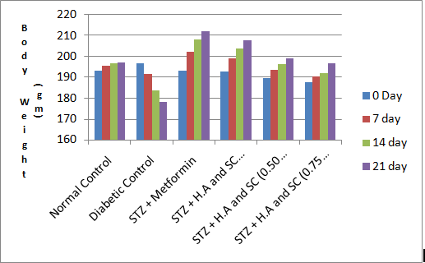

**Fig.2:** Indicating the effects of treatment on body weight

**Table.18:** Effect of treatments on Blood Glucose Level in the rats

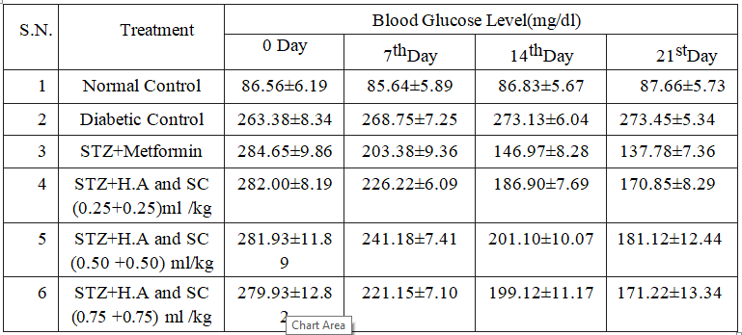

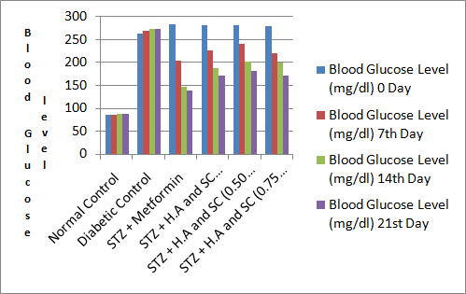

**Fig.3:** Effects of treatment on the blood glucose levels

**Table.19:** indicating the effects of treatments on lipid profile

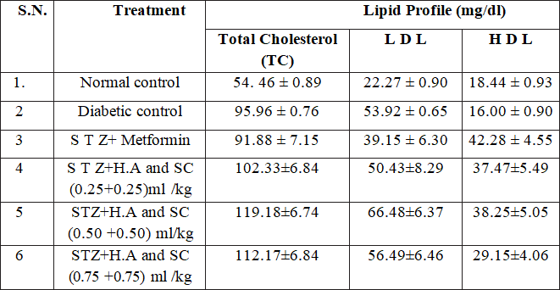

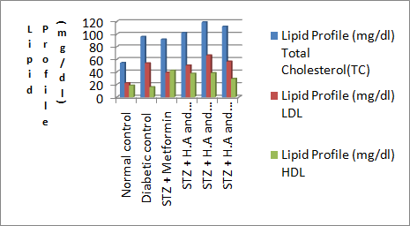

**Fig.4:** Effects of treatment on the Lipid profile Effect on SGOT, SGPT, ALP and Total Bilirubin

Experimental research showed that SGPT, SGOT, ALP, and Total bilirubin activities were significantly elevated in diabetic rats. The SGPT, SGOT, ALP, and Total bilirubin were considerably decreased after treatment with Syzygiumcumini and Helianthus annu us and Standard medication compared to diabetic control rats.

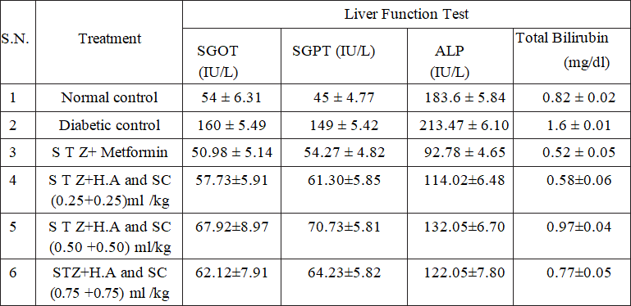**Table.20:** Effects of treatment on liver function test

## Histology of pancreas:

Histology analysis of the small pancreatic slices from rats revealed normal tissue in the vehicle control group. Acinar cells, islets of Langerhans, capillaries, adipose tissue, and interlobular and intra lobular ducts were among the features that could be seen. No one was inflamed. The layout and composition of the Langerhans Islands were regular and well-organised. Their distribution within the lobule was uneven. The STZ diabetic control group's inflamed pancreatic cells displayed a decrease in islet number, an increase in gap size, and a decrease in islet size. The ducts that link the lobes were visibly enlarged.

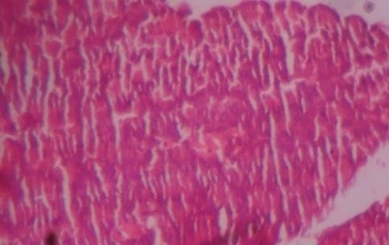

**Fig.5:** Regular regulation: Regular regulation: The Islets of Langerhans in the Normative control group

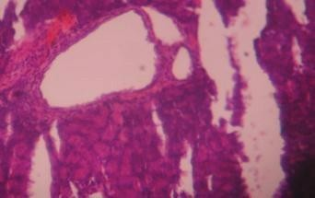

**Fig.6:** Histopathology of diabetic rats used as a model for the disease Manifest the increase in islet size and localized necrosis.

## Summary:

Diabetes Mellitus is a growing global health issue, prompting researchers to explore novel and effective treatment modalities. Among the different therapeutic avenues, medicinal plants have shown promise in managing this disease. This study will examine the potential anti-diabetic properties of Helianthus annuus (sunflower) seeds and Syzygium cumini (Java plum) using a relevant experimental model. Both plants have a history of use in traditional medicine

and preliminary studies suggest they might have anti- diabetic effects. The research will evaluate the effects of these plants on blood glucose levels, insulin resistance, lipid profiles, and oxidative stress markers. The findings could contribute valuable information to the ongoing search for effective, safe, and affordable plant-based therapies for diabetes, potentially leading to the development of new plant-derived anti-diabetic treatments.

## Reference:

* + 1. WHO. (2016). Global report on diabetes. World Health Organization.
    2. Roglic, G. (2016). WHO Global report on diabetes: A summary. International Journal of Noncommunicable Diseases, 1(1), 3.
    3. Eddouks, M., Bidi, A., El Bouhali, B., Hajji, L., & Zeggwagh, N. A. (2014). Antidiabetic plants improving insulin sensitivity. Journal of Pharmacy & Pharmacognosy Research, 2(3), 57-75.
    4. Patel, D. K., Prasad, S. K., Kumar, R., & Hemalatha, S. (2012). An overview on antidiabetic medicinal plants having insulin mimetic property. Asian Pacific Journal of Tropical Biomedicine, 2(4), 320-330.
    5. Martin, C. A., de Almeida, E. B., Ruiz, M. R., Visentainer, J. V., Matshushita, M., de Souza, N. E., & Visentainer, J. E. L. (2006). Fatty acid content of seeds of sunflower cultivars. Journal of Food Composition and Analysis, 19(6-7), 635-639.
    6. Lal, J., Chandra, S., Raviprakash, V., & Sabir, M. (1976). In vitro anthelmintic action of some indigenous medicinal plants on Ascardia galli worms. Indian journal of physiology and pharmacology, 20(2), 64-68.
    7. Sharma, B., Balomajumder, C., & Roy, P. (2008). Hypoglycemic and hypolipidemic effects of flavonoid rich extract from Eugenia jambolana seeds on streptozotocin induced diabetic rats. Food and Chemical Toxicology, 46(7), 2376-2383.
    8. International Diabetes Federation. (2019). IDF Diabetes Atlas (9th ed.). International Diabetes Federation.
    9. American Diabetes Association. (2018). 5. Lifestyle Management: Standards of Medical Care in Diabetes—2018. Diabetes Care, 41(Supplement 1), S38-S50.
    10. Newman, D.J., Cragg, G.M. (2012). Natural Products As Sources of New Drugs over the

30 Years from 1981 to 2010. Journal of Natural Products, 75(3), 311–335.

* + 1. Patel, D. K., Prasad, S. K., Kumar, R., & Hemalatha, S. (2012). An overview on antidiabetic medicinal plants having insulin mimetic property. Asian Pacific Journal of Tropical Biomedicine, 2(4), 320-330.
    2. Raju, M., Varakumar, S., Lakshminarayana, R., Krishnakantha, T. P., & Baskaran, V. (2007). Carotenoid composition and vitamin A activity of medicinally important green leafy vegetables. Food Chemistry, 101(4), 1598-1605.
    3. Sharma, B., Balomajumder, C., & Roy, P. (2008). Hypoglycemic and hypolipidemic effects of flavonoid rich extract from Eugenia jambolana seeds on streptozotocin induced diabetic rats. Food and Chemical Toxicology, 46(7), 2376-2383.
    4. Patel, D. K., Kumar, R., Laloo, D., & Hemalatha, S. (2012). Diabetes mellitus: an overview on its pharmacological aspects and reported medicinal plants having antidiabetic activity. Asian Pacific Journal of Tropical Biomedicine, 2(5), 411-420.
    5. Martin, C. A., de Almeida, E. B., Ruiz, M. R., Visentainer, J. V., Matshushita, M., de Souza, N. E., & Visentainer, J. E. L. (2006). Fatty acid content of seeds of sunflower cultivars. Journal of Food Composition and Analysis, 19(6-7), 635-639.
    6. Vuksan, V., Sievenpiper, J. L., Owen, R., Swilley, J. A., Spadafora, P., Jenkins, D. J.,

... & Vidgen, E. (2000). Beneficial effects of viscous dietary fiber from Konjac-mannan in subjects with the insulin resistance

syndrome: results of a controlled metabolic trial. Diabetes care, 23(1), 9-14.

* + 1. Sharma, B., Balomajumder, C., & Roy, P. (2008). Hypoglycemic and hypolipidemic effects of flavonoid rich extract from Eugenia jambolana seeds on streptozotocin induced diabetic rats. Food and Chemical Toxicology, 46(7), 2376-2383.
    2. Prakash1*, FORMULATION AND EVALUATION OF HERBAL ANTI-ACNE GEL Journal of Pharmaceutical Negative Results ¦ Volume 13 ¦ Special Issue 6 2022.
    3. *Satya Prakash1, To Study the Antiulcer Activity of Hydro Alcoholic Extract of Euphorbia Thymifolia on Absolute Ethanol Induced Ulcer in Rats. European Journal of Molecular & Clinical Medicine ISSN 2515- 8260 Volume 10, Issue 1 2023.
    4. Satya Prakash, et. al., 2022 Guidelines for Approval of Clinical Trials and Study Reports of SARS Covid-19 Vaccines. IJPRA, ISSN: 2456-4494.
    5. et al., S. P. (2019). FORMULATION AND EVALUATION OF FLOATING TABLET OF ZOLMITRIPTAN TABLET. International Journal of Advanced Science and Technology, 28(17), 82.
    6. Satya Prakash, et. al., 2023 Gold Nanoparticles for Targeted and Selective Delivery of Cancer Chemotherapeutics: A Review of the Literature (Eur. Chem. Bull. 2023, 12 (Special Issue 1), 2896-2901).